# A CRM Application to Handle the Clients and their Property Related Requirements

**Department of Computer Science and Engineering**

|  |  |  |
| --- | --- | --- |
| NM Id | (Team): | 4224582A19853839BBB4409FBE0BD706 |

**Team Members**

|  |  |  |
| --- | --- | --- |
| **S.No** | **Name** | **NM-ID** |
| 1 | Nandhini T | 4224582A19853839BBB4409FBE0BD706 |
| 2 | Carmal princy A | 4801F1749A0B590BA5942A3FC1B90254 |
| 3 | Ashiritha S | 4A99E958001A914BDC34EC698F983844 |
| 4 | Kirthana M | D5F1604B6269EE7BC174DAD602EB5FDA |

**Github link :** <https://github.com/Nandhini-nan/CRM-Project-Naan-Mudhalvan>

**Demo video link :** <https://youtu.be/WFnaaix2ju0?si=NkSIcOpVJd3aKGFm>

**TrailHead link :**

[https://www.salesforce.com/trailblazer/xj2khy4jl659txp2y8](https://www.salesforce.com/trailblazer/xj2khy4jl659txp2y8%20)

# A CRM Application to Handle the Clients and their

**Property Related Requirement**

## 1. CUSTOMER RELATIONSHIP MANAGEMENT

Customer Relationship Management (CRM) is a strategy for managing a company’s interactions with current and potential customers. It involves using technology to organize, automate, and synchronize sales, marketing, customer service, and technical support. The goal of CRM is to improve business relationships, streamline processes, and increase profitability. CRM systems compile customer data from various channels, including a company's website, telephone, email, live chat, and social media. These systems can give staff detailed information about customers' personal information, purchase history, preferences, and concerns. Effective CRM helps businesses understand customer needs, enhance customer satisfaction, and foster loyalty.

## 2. OVERVIEW

Dreams World Properties integrates Salesforce to streamline customer interactions. Website engagement triggers automated record creation in Salesforce, capturing customer details and preferences. Salesforce categorizes users as approved or non-approved, offering tailored property selections to approved users. This enhances user experience and efficiency, providing personalized recommendations and broader listings. Seamless integration optimizes operations, improving customer engagement and facilitating growth in the real estate market.

## 3. USE CASE

Dreams World Properties is embarking on a transformative journey by integrating Salesforce into their business operations to streamline customer interactions. With the aim of enhancing user experience and efficiency, the company seeks to automate its processes seamlessly. One of the primary objectives is to establish a seamless connection between their website and Salesforce platform.

Upon a customer expressing interest on the website, an automated system will trigger the creation of a corresponding record within the Salesforce database. This record will serve as a comprehensive profile capturing essential details about the prospective customer and their expressed preferences.

Furthermore, Through Salesforce's robust capabilities, Dreams World Properties intends to categorize users into two distinct categories: approved and non-approved. Approved users will enjoy privileged access to a

curated selection of properties tailored to their preferences and requirements. On the other hand, nonapproved users will still have access to a broader range of property listings but may not benefit from the personalized experience offered to approved users.

## 4. INTRODUCTION TO SALESFORCE

Salesforce is game-changing technology, with a host of productivity-boosting features, that will help you sell smarter and faster. As you work toward your badge for this module, we’ll take you through these features and answer the question, “What is Salesforce, anyway?”.

**WHAT IS SALESFORCE?**

Salesforce is your customer success platform, designed to help you sell, service, market, analyse, and connect with your customers. Salesforce has everything you need to run your business from anywhere. Using standard products and features, you can manage relationships with prospects and customers, collaborate and engage with employees and partners, and store your data securely in the cloud.

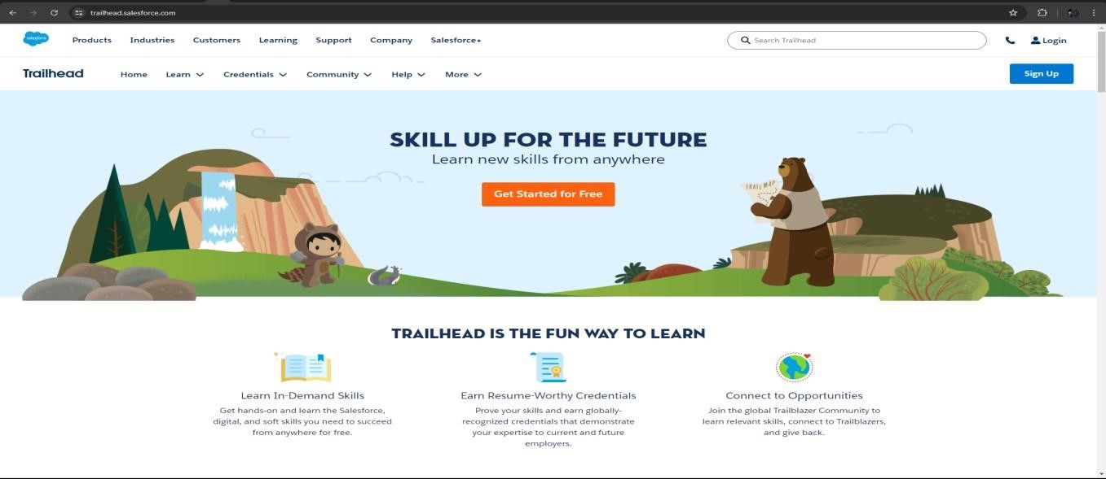

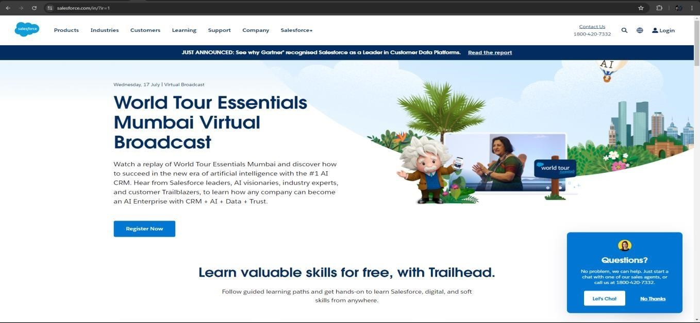

## 5. REQUIREMENTS: -

**i. Website Integration Requirements:**

Implement a form on the website for users to express interest in property listings. Ensure the form captures essential details such as name, contact information, preferred property type, location, budget, etc. Set up validation rules to ensure data accuracy and completeness. Integrate the form submission process with Salesforce. **ii. Salesforce Configuration Requirements:**

Set up Salesforce objects and fields to store customer data. This includes fields for name, contact information, preferences, approval status, etc. Define workflows or processes to automate the creation of records when a user submits the form on the website. Implement validation rules and data integrity checks to maintain data quality. Configure Salesforce security settings to control access to customer records based on approval status. **iii. Approval Process Requirements:**

Define criteria for categorizing users as approved or non-approved based on specific parameters such as budget, property preferences, etc. Implement an approval process in Salesforce to review and approve users. Set up email notifications or alerts to notify relevant stakeholders when a user is approved or rejected. Ensure that approved users are granted access to curated property listings tailored to their preferences. **iv. User Experience Requirements:**

Design user interfaces in Salesforce for managing customer records, approval processes, and property listings. Ensure a seamless user experience for both customers and internal users interacting with Salesforce. Provide training and documentation for internal staff on how to use the Salesforce system effectively.

**v. Integration Testing and Quality Assurance Requirements:**

Conduct thorough testing of the integration between the website and Salesforce to ensure data is accurately captured and transferred. Perform end-to-end testing of the approval process to verify that users are categorized correctly and granted appropriate access. Identify and resolve any issues or bugs encountered during testing.

## 6. PROJECT IMPLEMENTATION: -

**Step 1: Creating a Developer Org Account.**

* Go to [https://developer.salesforce.com/signup.](https://developer.salesforce.com/signup)

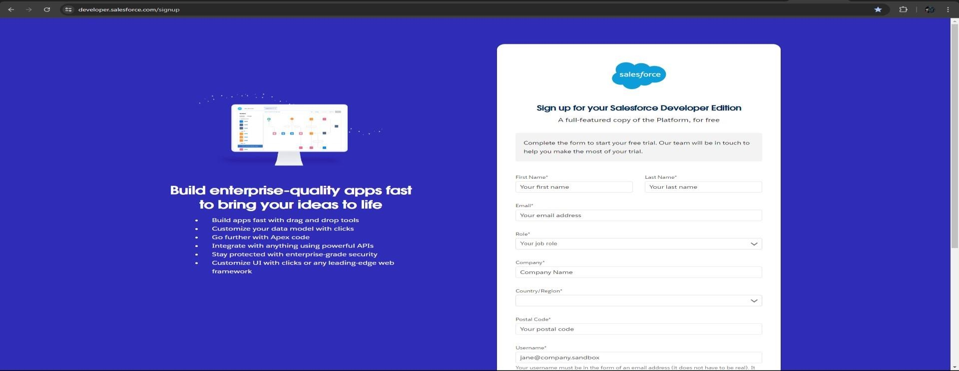

* Fill the details to create a Developer Org Account.
* All the details are must to ensure seamless experience for creating a Developer Org Account.
* One Point to Note that Username must be unique, and you can create any number of accounts using the same E-mail address.

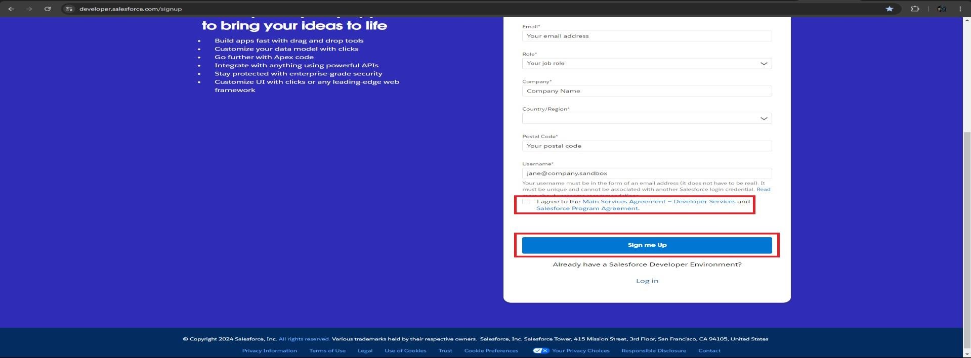

* After Entering the Details proceed with accepting the Terms and Conditions and click on Sign me Up button as shown in above picture.

**Step 2: Activation of Developer Org Account.**

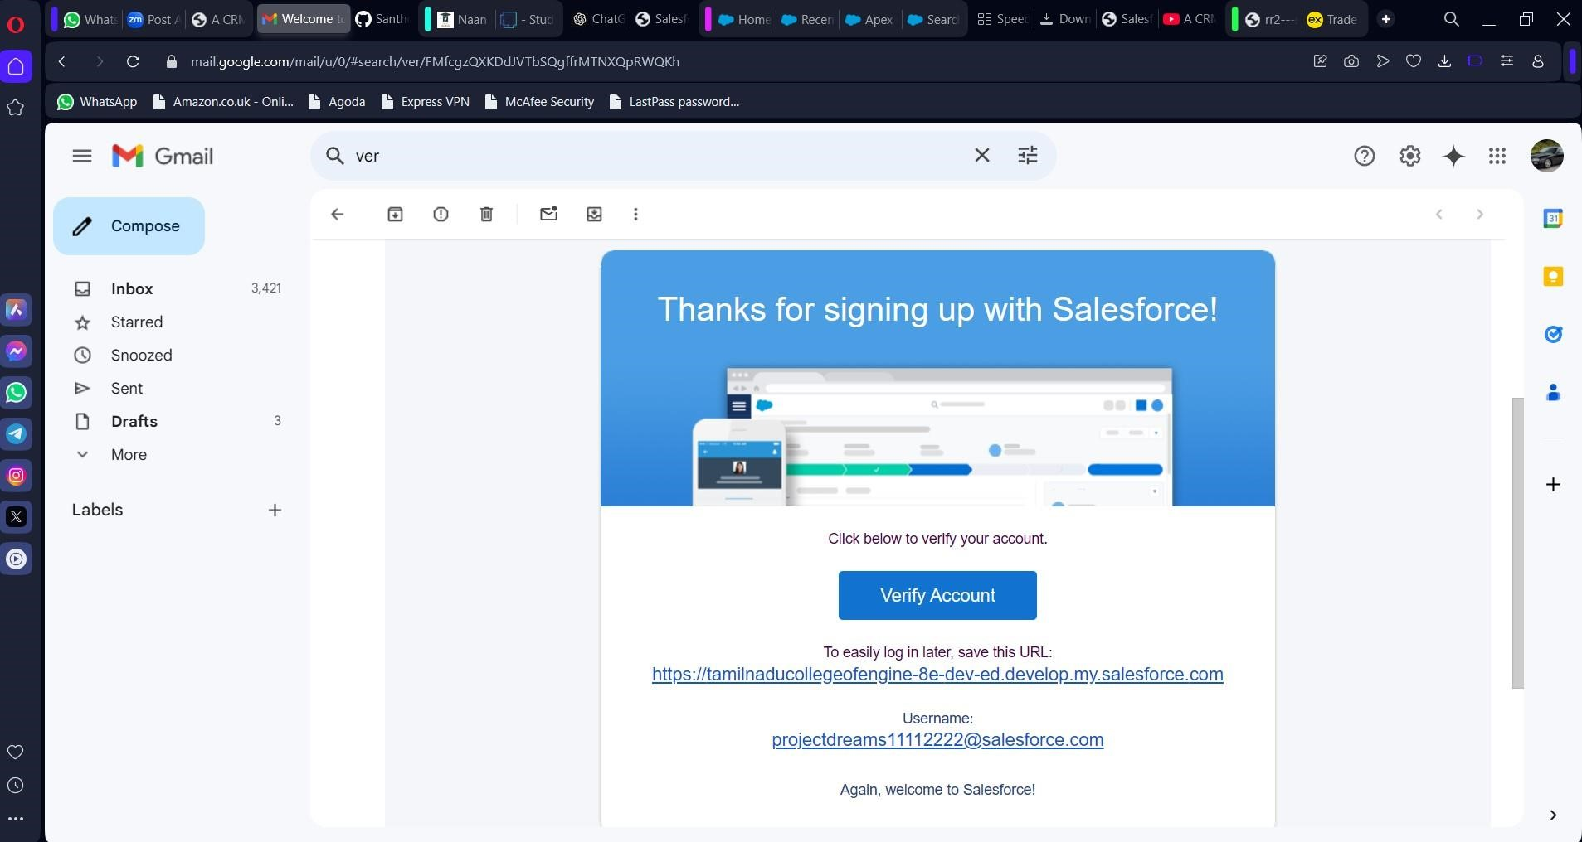

* After clicking on Sign me Up button it will re-directs to page where it shows that account has created.
* Go to the registered email address inbox that you used while signing up. The activation of account email could take 10-15 minutes to receive to the registered email address.

* Click on the verify account to activate your account.
* Give a password and answer a security question and click on change password.
* Then you will be re-directed to login page to login into Salesforce Developer Org.

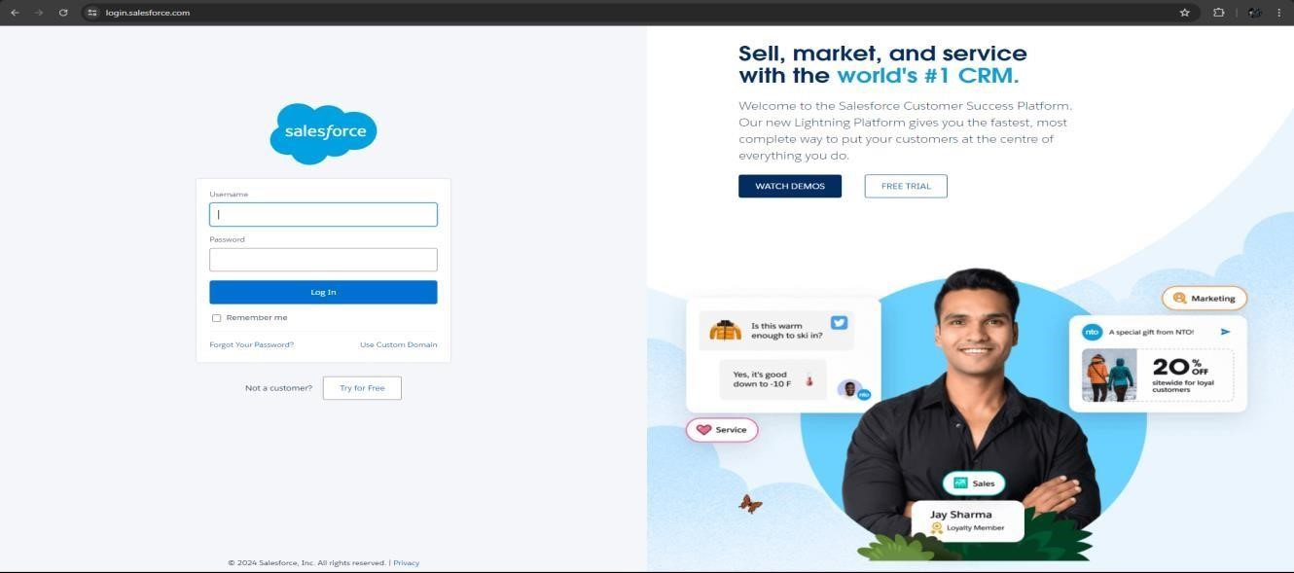

**Step 3: Create a jotform and integrate it with the org to create a record of customers automatically.**

* Go to [https://www.jotform.com/.](https://www.jotform.com/)

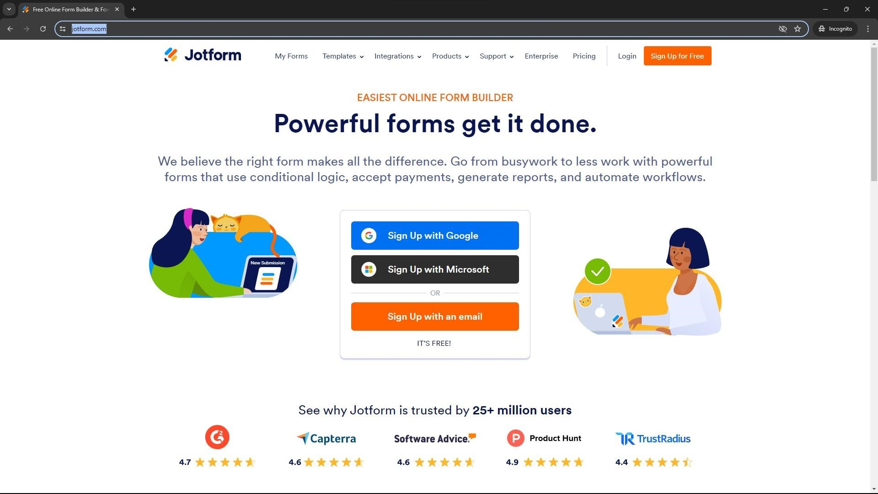

* Create an account using your credentials.
* After creating an account create a form that looks like below picture.

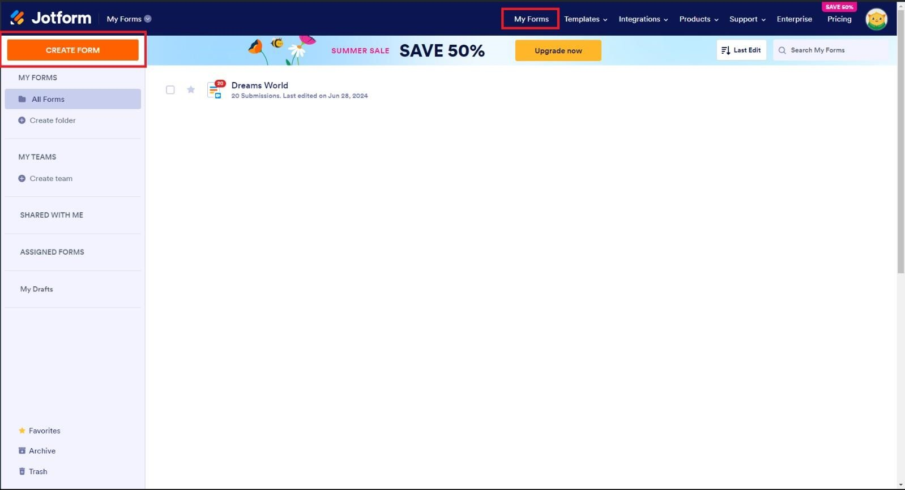

* Click on the “Start from Scratch” button to create a form as shown in the figure below.

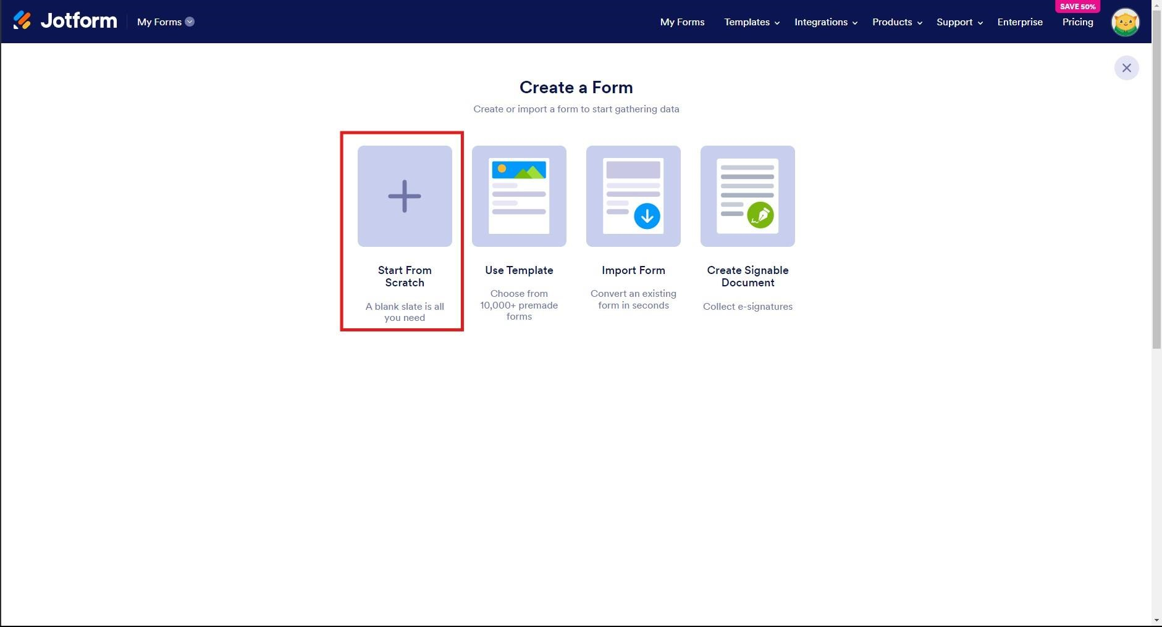

* Click on “Classic form” button as shown in the figure below.

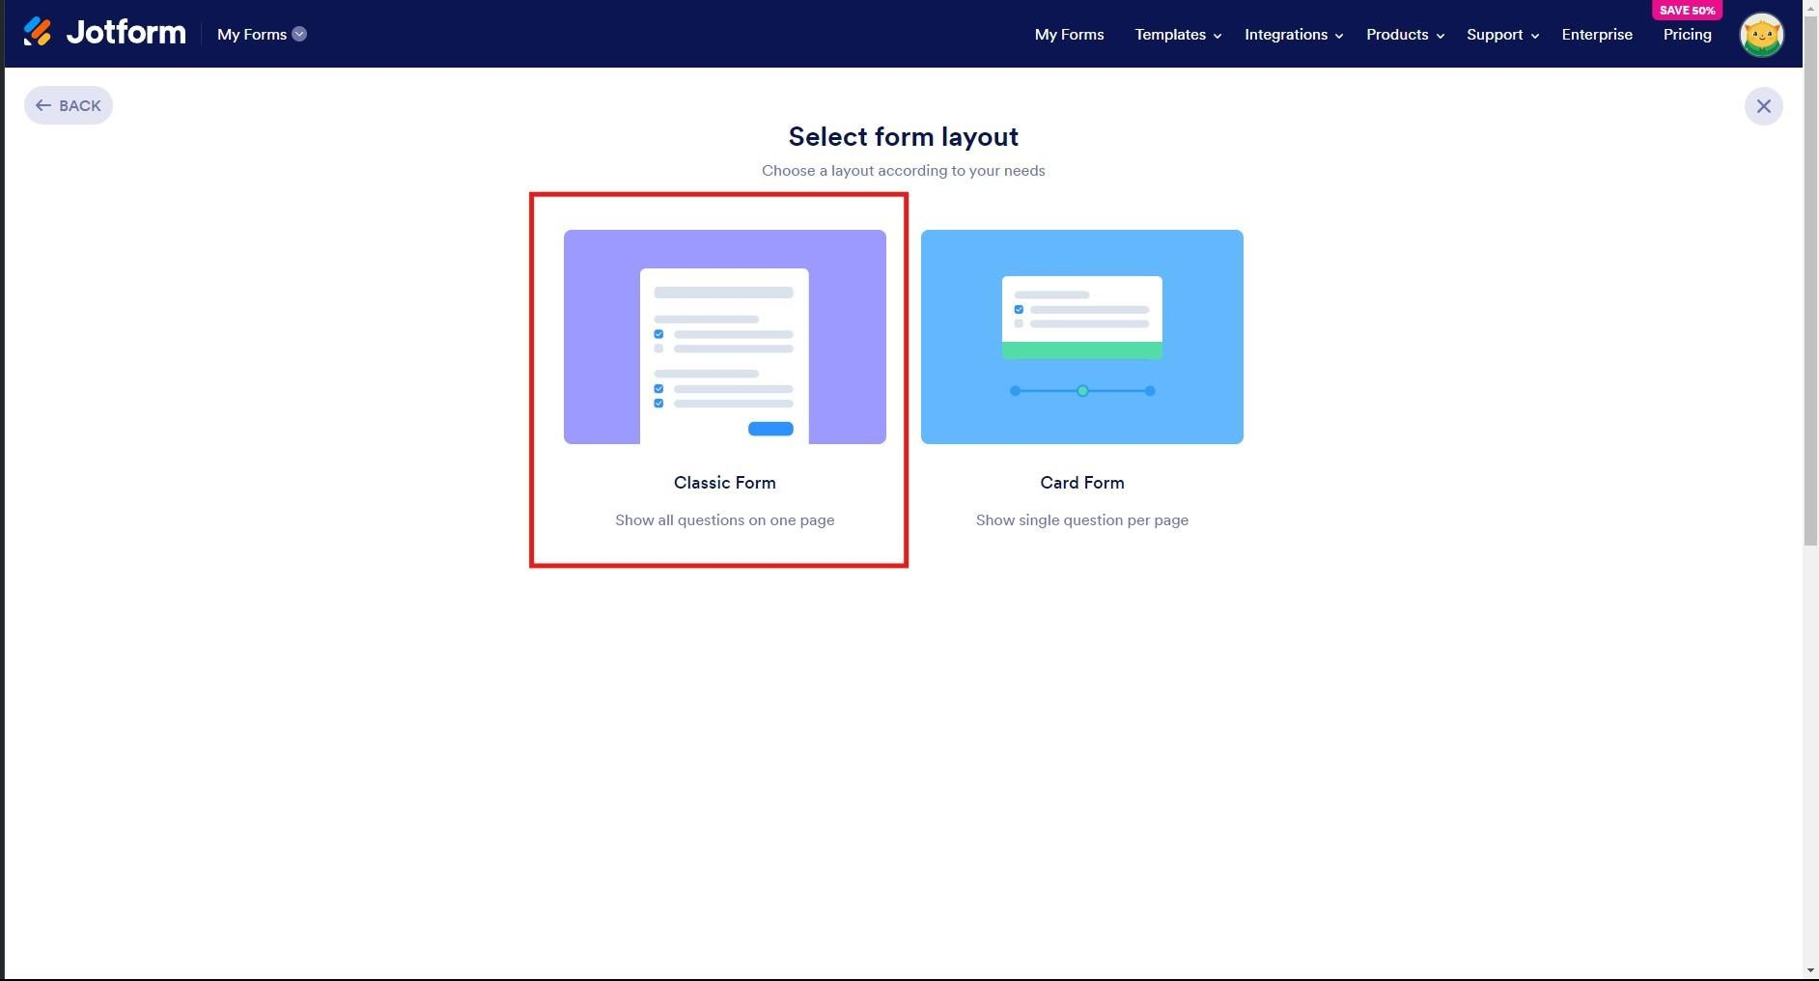

* Click on the “Add Form Element” button as shown in the below figure.

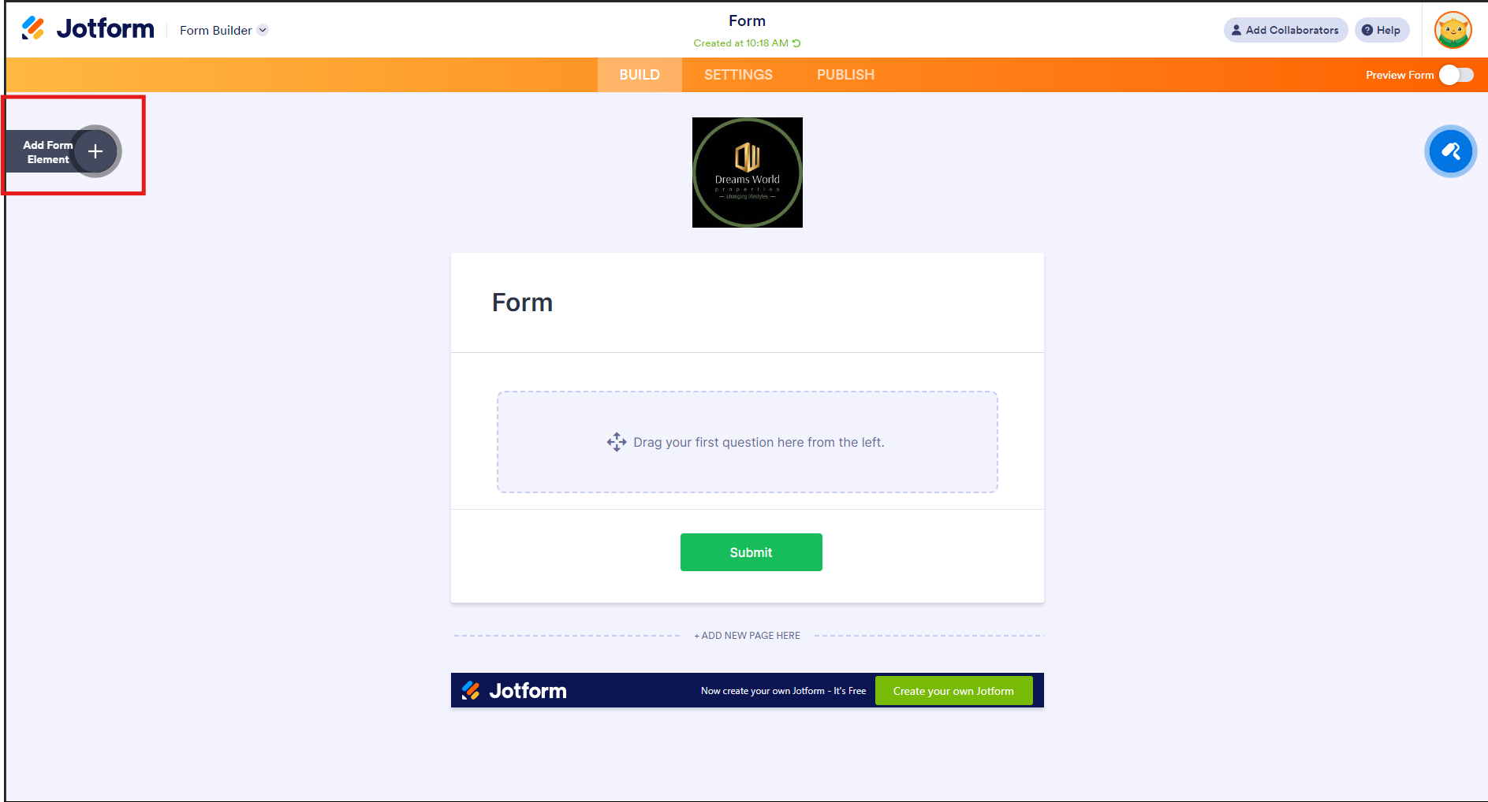

* Drag and drop the required elements to create the Jotform to gather the customer details like name, phone number, address, email address etc.
* Click on the publish button and copy the link to access the form.

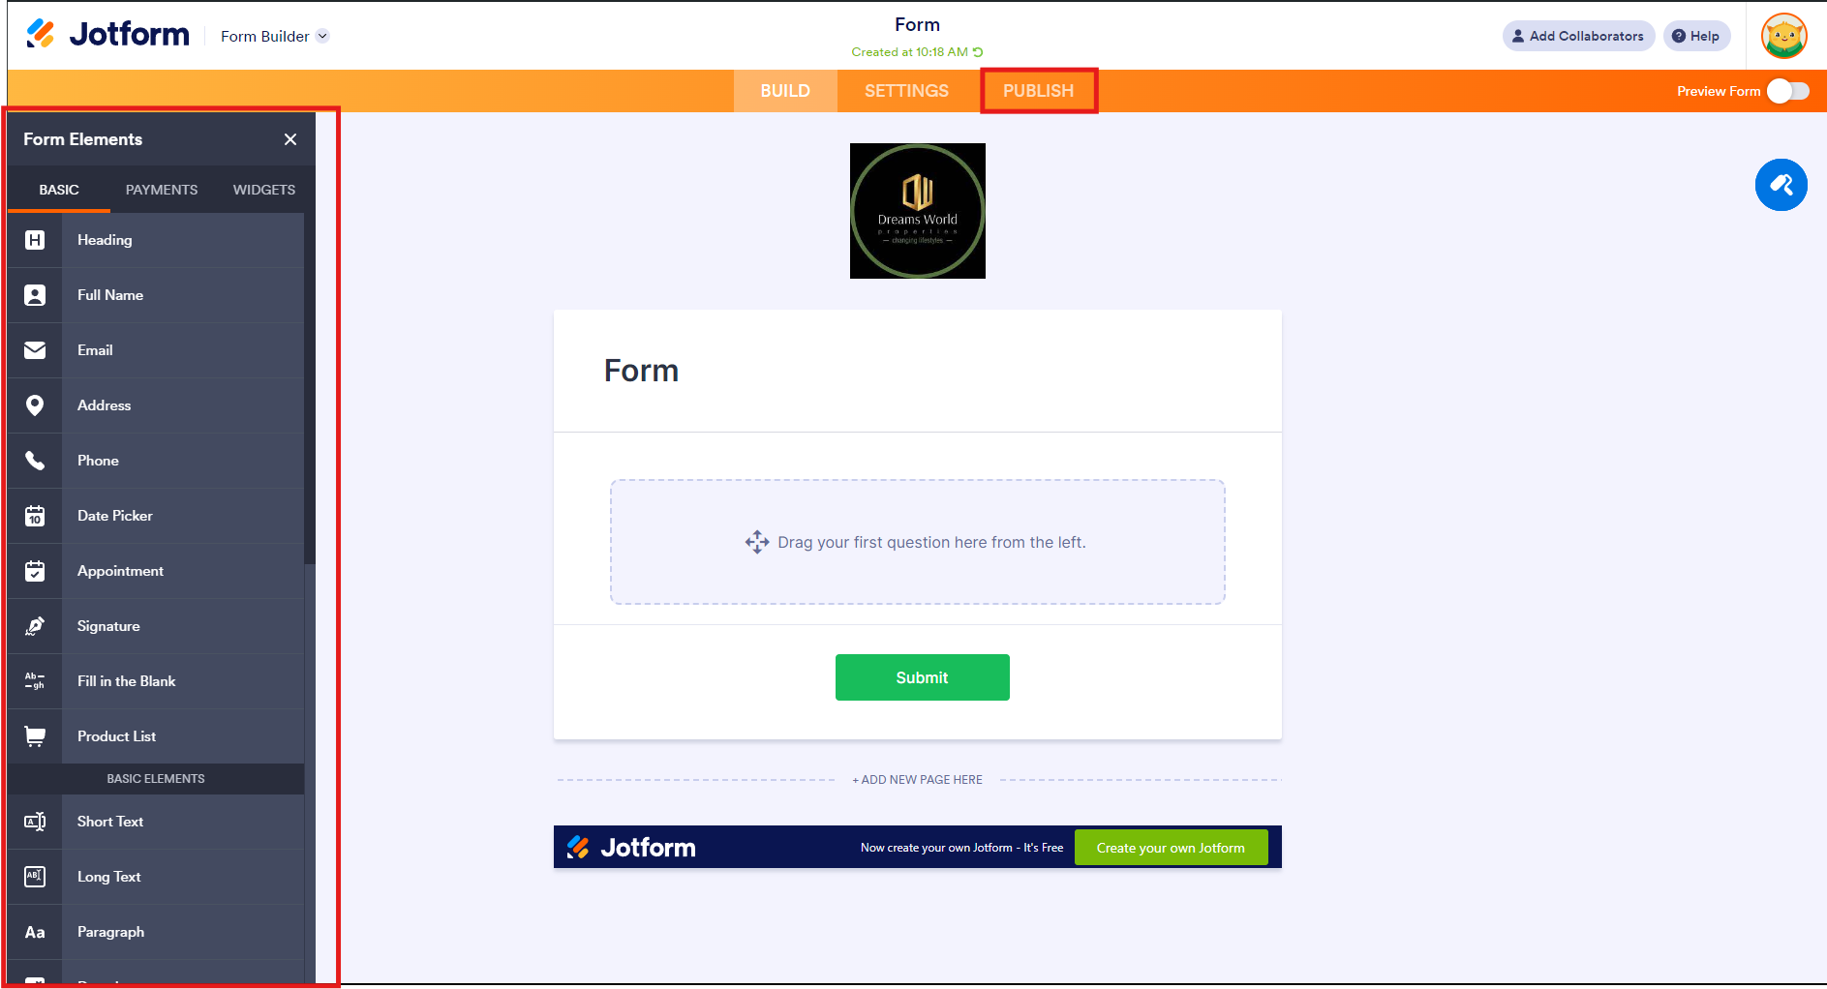

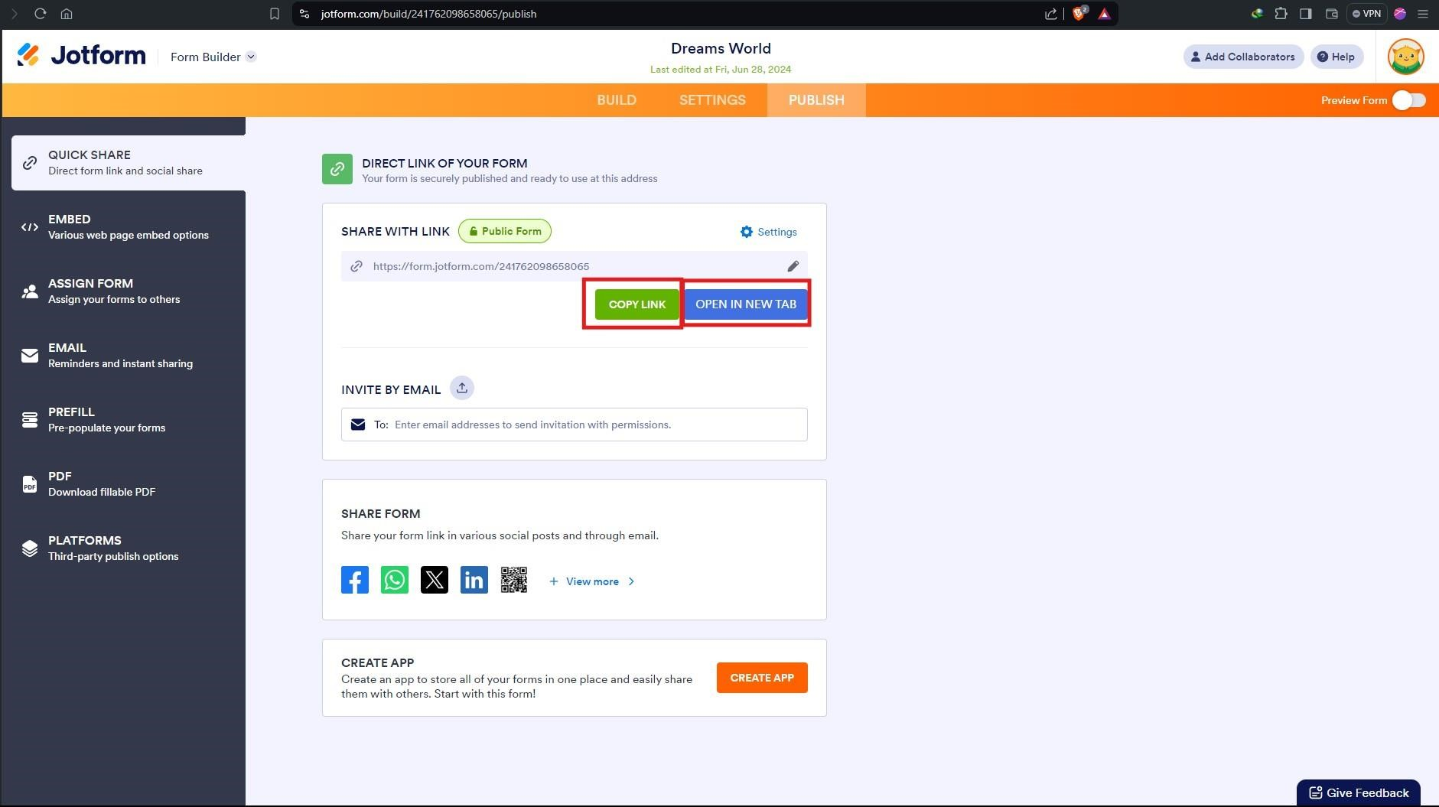

* The below figure is the result of the Jotform after dragging the elements.

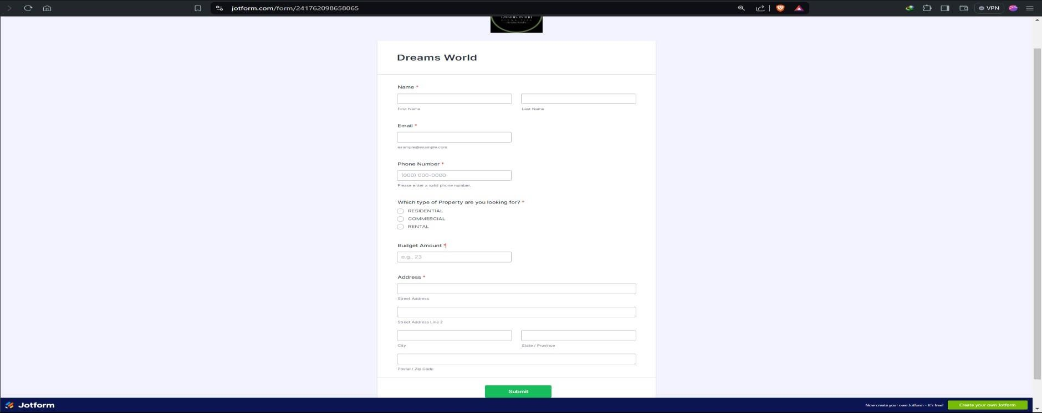

* Here is the reference link for the above Jotform: https://www.jotform.com/build/243174968049064

**Step 4: Create Objects from Spreadsheet.**

**A. Creating customer Object.**

* I have created **Customer** object using the spreadsheet link: [customer.](https://docs.google.com/spreadsheets/d/1OnrKr4zVsbXrGvU6r0edgB6XOUlp4eCpfzHMSj8MN78/edit?gid=0#gid=0)
* After downloading the spreadsheet, go to Salesforce developer Org and login into the account you have created.



•



Click on gear



icon



and



Click on Setup.

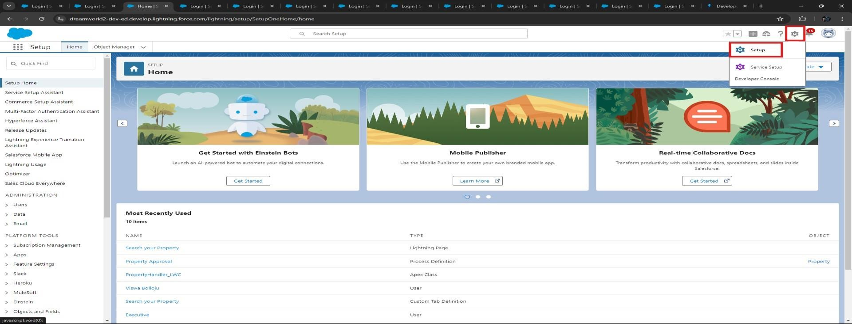

* Click on “**Object Manager**” and click on “**Create**” and click on “**Custom Object from Spreadsheet**” as shown in the below figure.

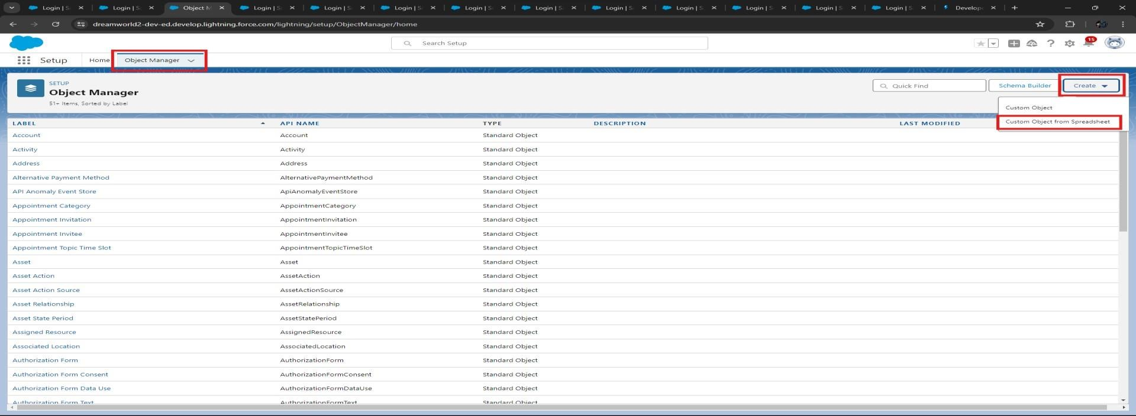

* Click on the “Upload” to upload the customer spreadsheet “[customer”](https://docs.google.com/spreadsheets/d/1OnrKr4zVsbXrGvU6r0edgB6XOUlp4eCpfzHMSj8MN78/edit?gid=0#gid=0) you have downloaded.

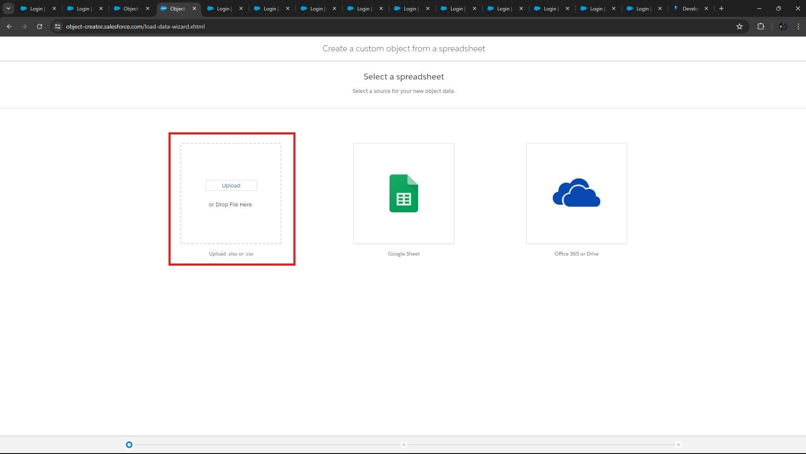

* Check all the fields that are mapped correctly and click on next.

**Note:** Do not Change any fields type in the “**Salesforce Field Type**” as it won’t upload all the records from the Spreadsheet. If you do change the field type, then the records won’t upload and leads to manual creation of records after the Object Creation.

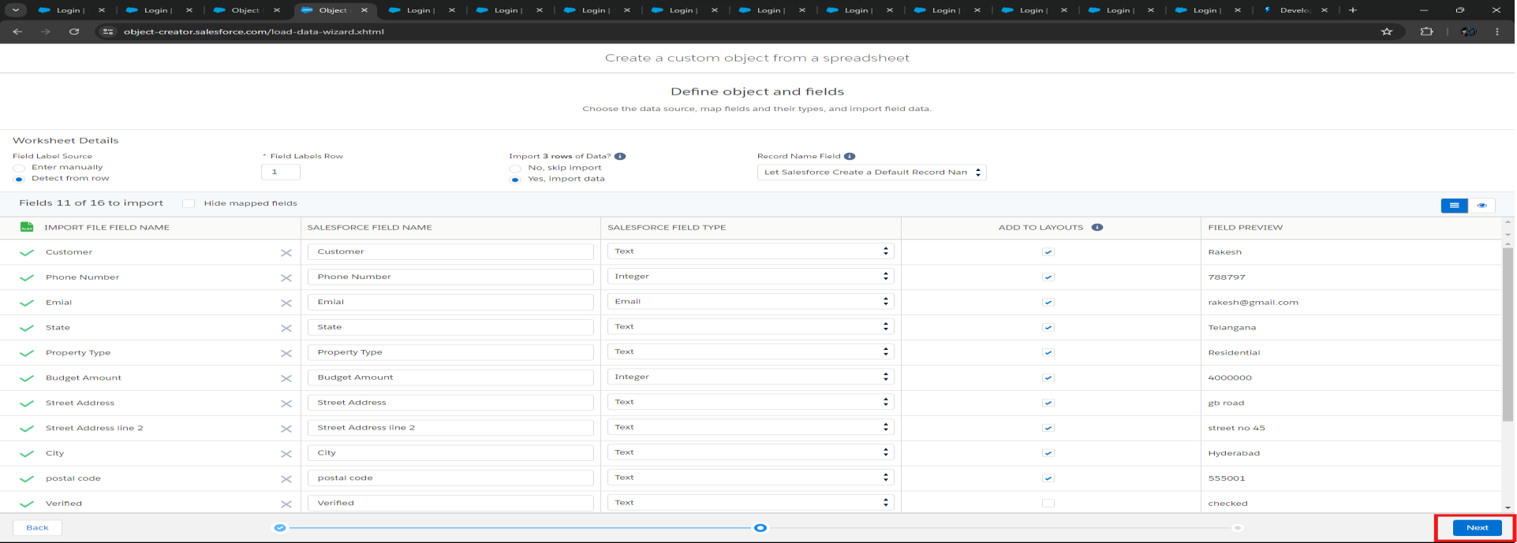

* After reviewing the fields that are mapped to salesforce fields click on “**Next**” and review the “**Label**” and “**API Name**”. Click on “Finish” to create the “customer” object.

**Label:** customer

**API Name:** customer

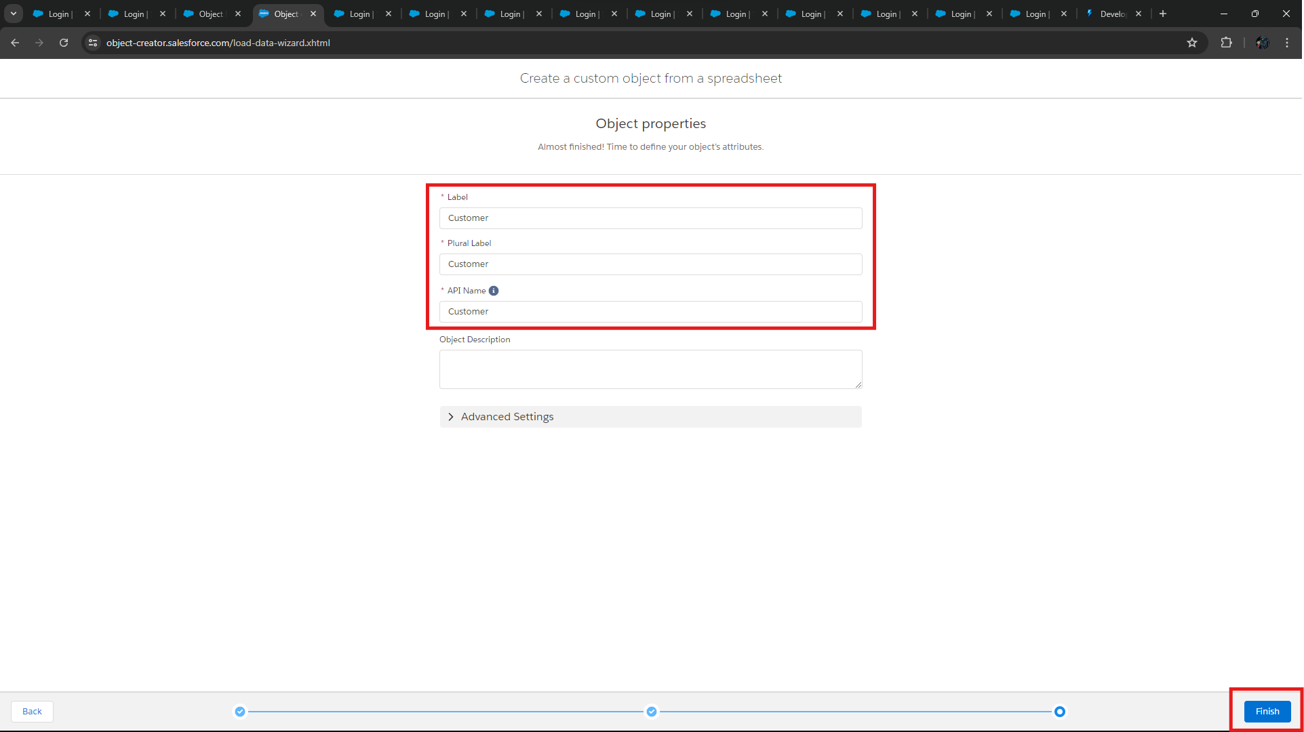

### B. Creating Property Object

* In the same way as “customer” Object create the property Object.
* Property Object Spreadsheet: [Property.](https://docs.google.com/spreadsheets/d/1biFjB6xNxRItKb6CT6NHNNujHVVY9DTdXOkN2RL_hbY/edit?gid=0#gid=0) Download the spreadsheet and do the same procedure as the customer object.
* After reviewing the fields that are mapped to salesforce fields click on “**Next**” and review the “**Label**” and “**API Name**”. Click on “Finish” to create the “customer” object.

**Label:** property

**API Name:** property

* Do remember the **Note** while creating the “property” object.

**C. Changing the Custom Object Fields type in “customer” and “property” object.**

* Click on “**Object Manager**” and search the for objects you have created.

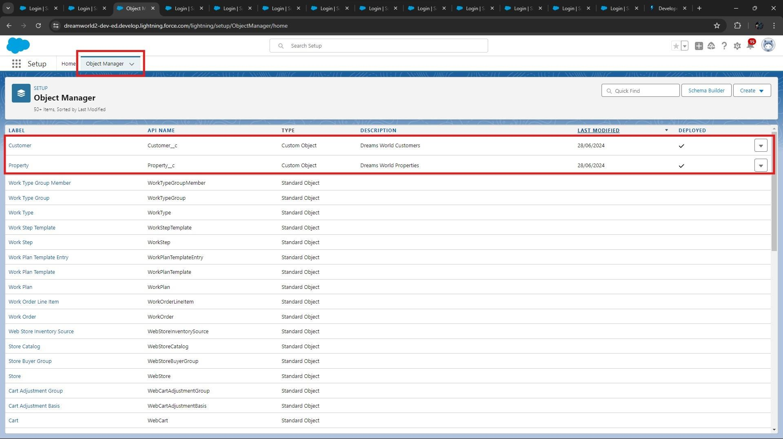

* Go to **customer** object and click on “**Fields and Relationships**” and change all the fields to the marked fields as shown in the figure below.

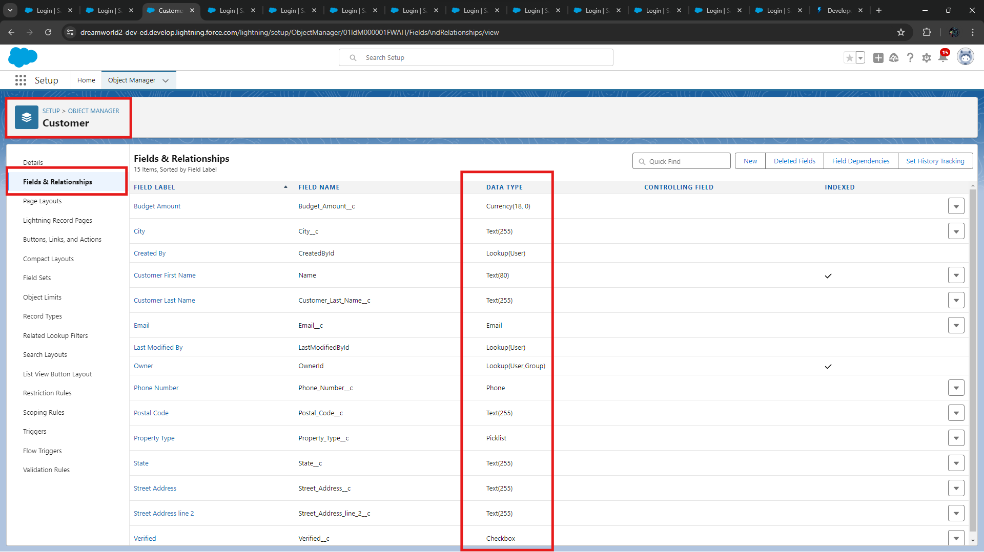

* In the same way change the field type in **property** object.

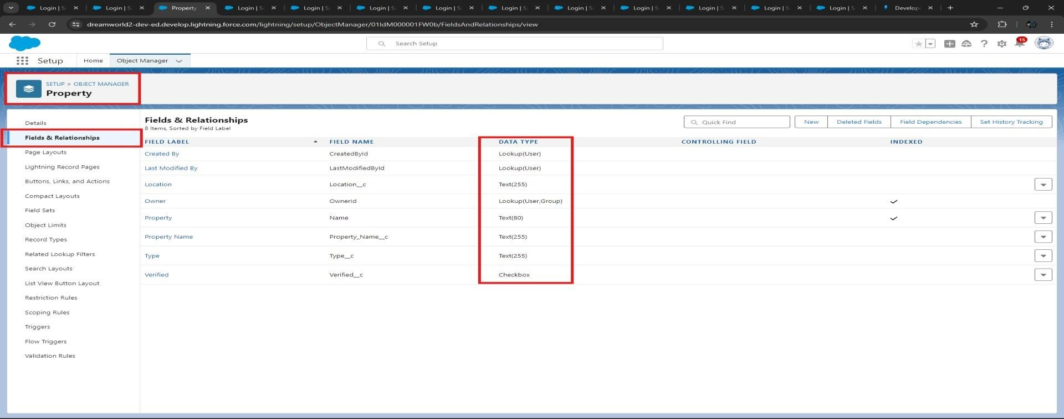

**Step 5: Integrate Jotform with Salesforce Platform.**

* Log in to Jotform account and click on “**My Forms**” and click on “**Integrations**” and select “**CRM**”

option and click on “**Salesforce**” as shown in the below figure.

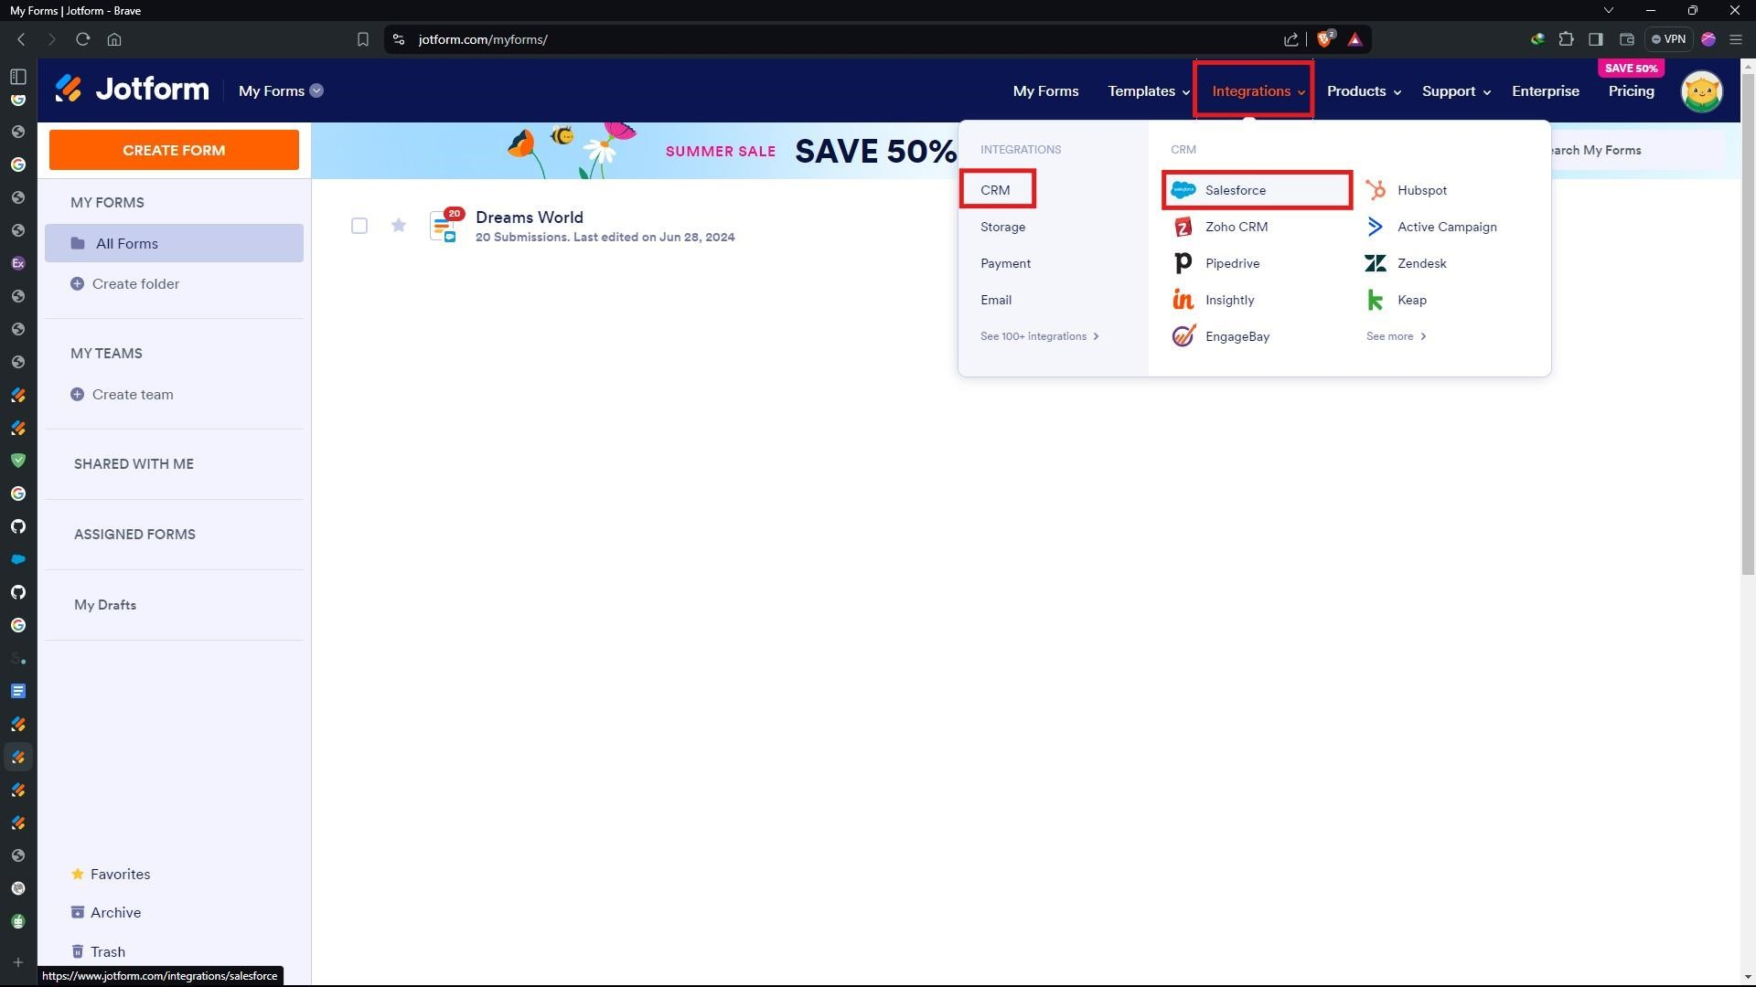

* Click on “**Use Integration**” and go to “**Add to Form**”.

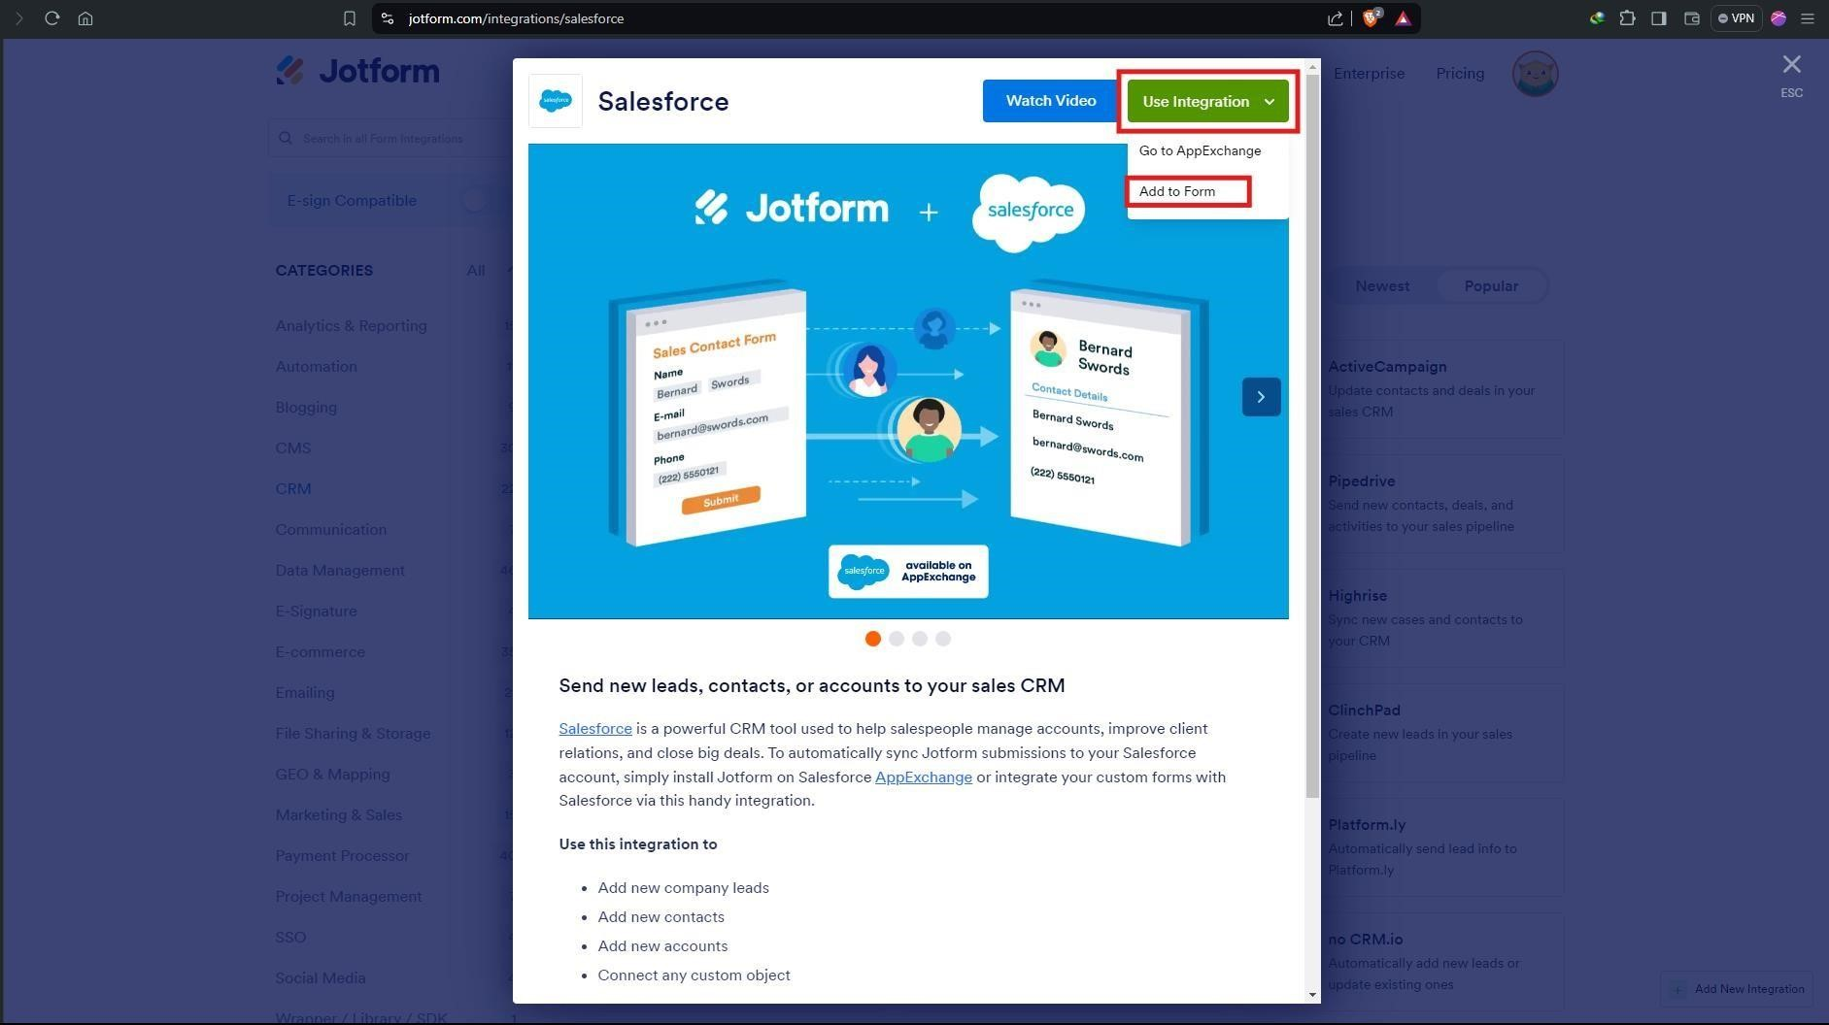

* Click on **“Select a Form”.**

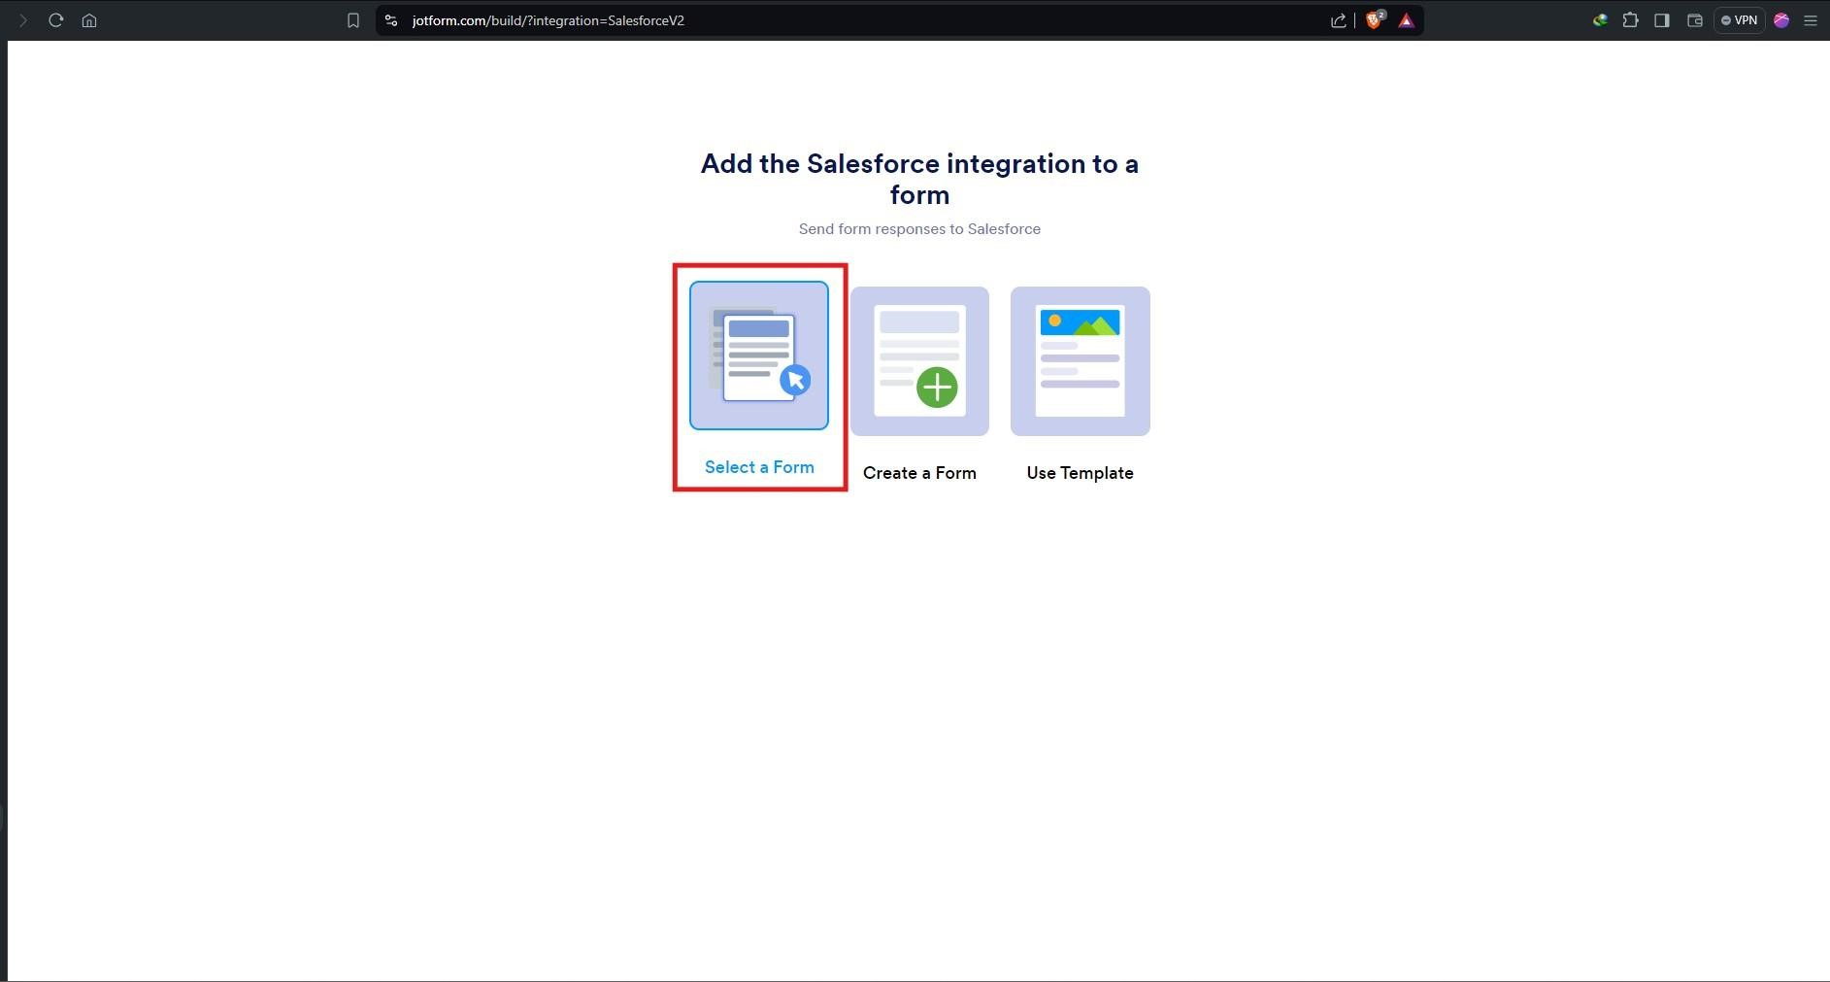

* Select the form that you have created using “**Step - 3**”.

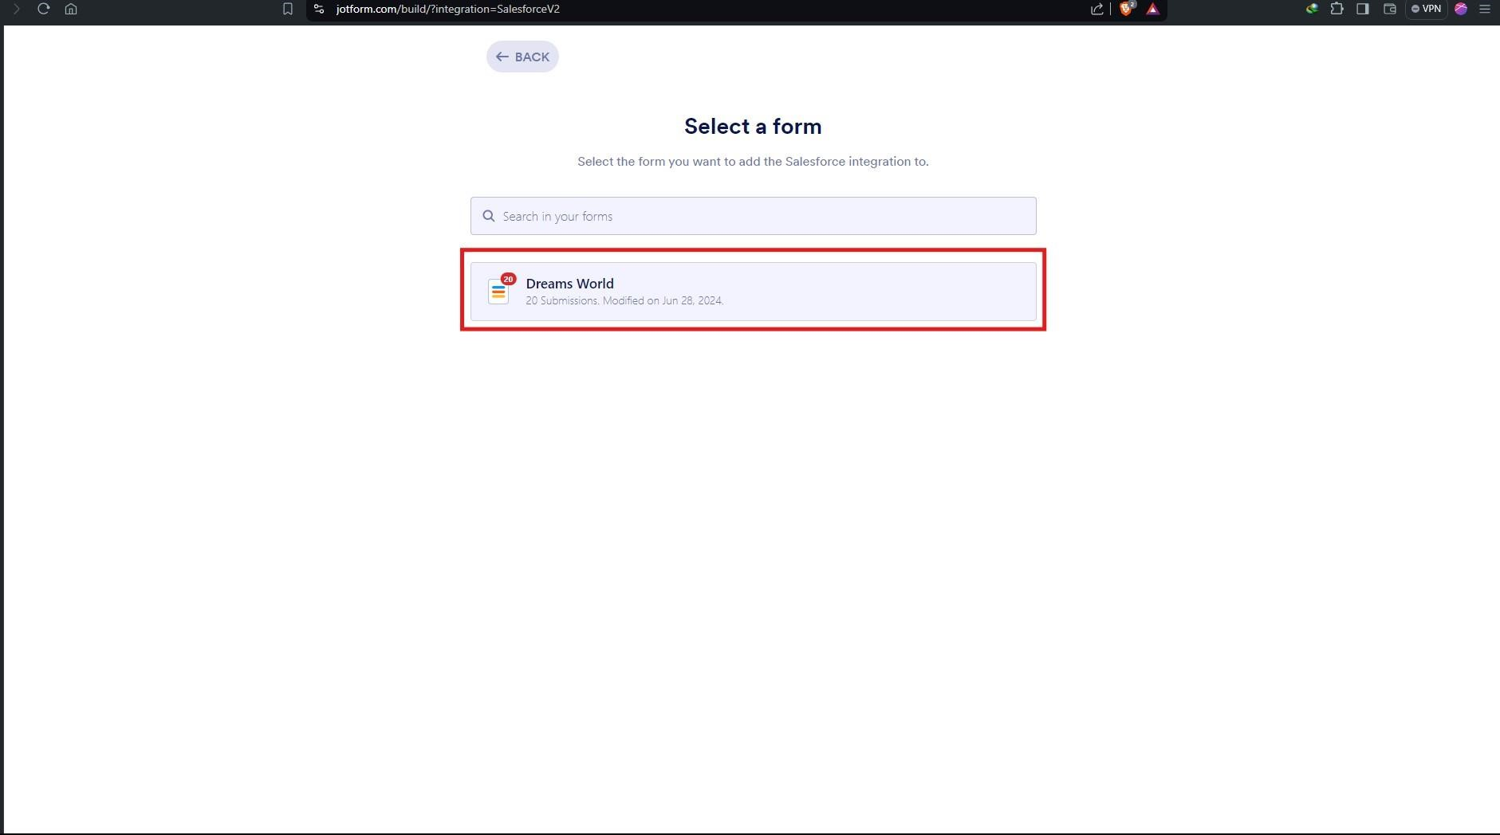

* Scroll down and click on “**Authentication**” and login into Salesforce Developer Org using your credentials and select your account which you want to integrate the Jotform.

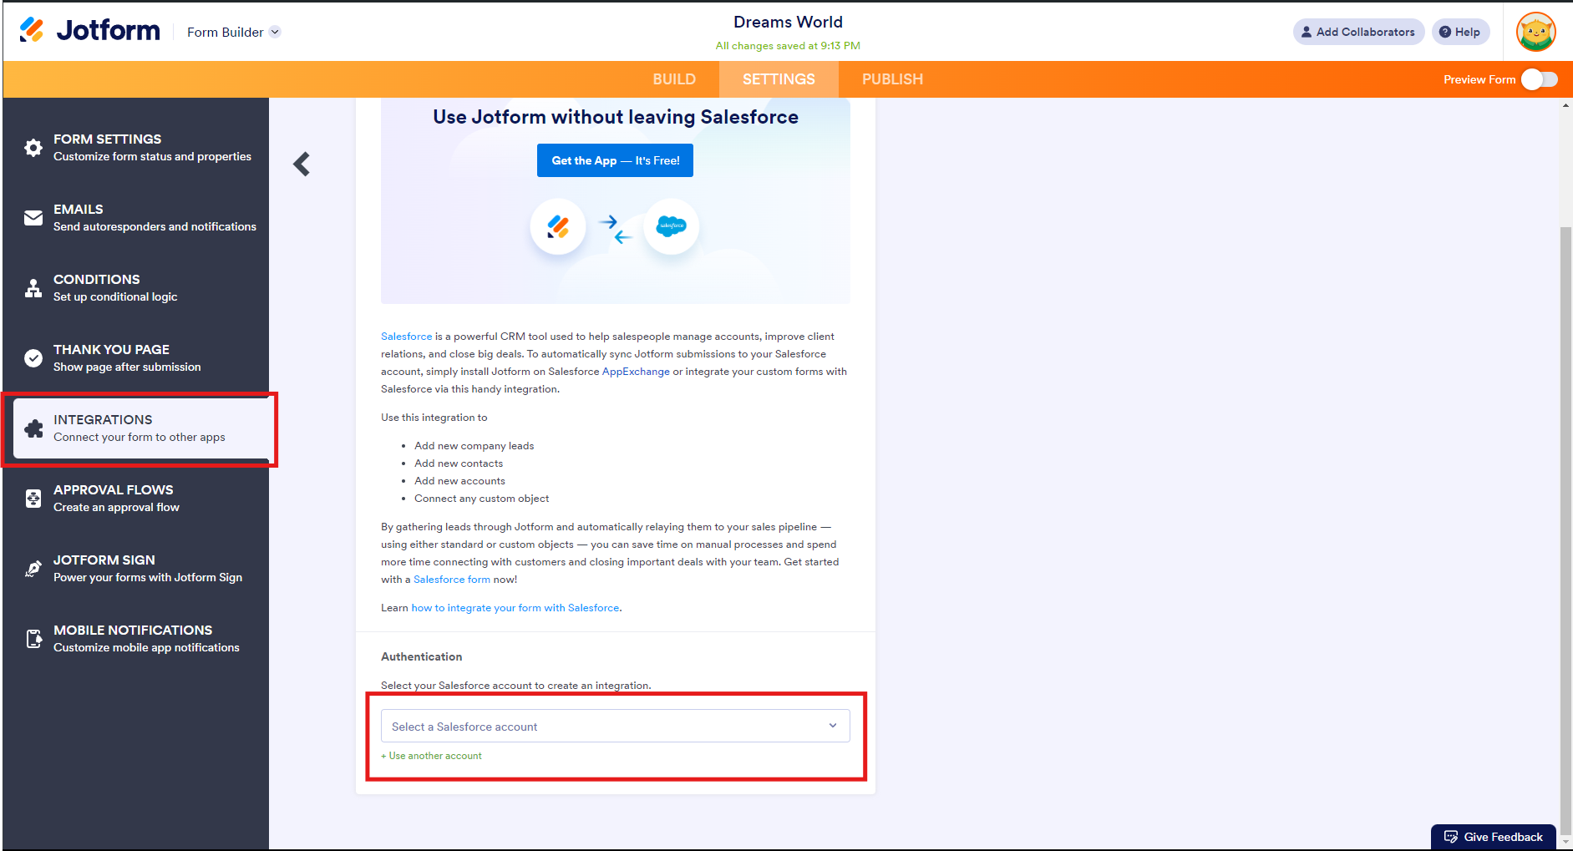

* Select the Options as shown in the below figure and “**Select a Salesforce Object**” type “**Customer**” to get customer object.

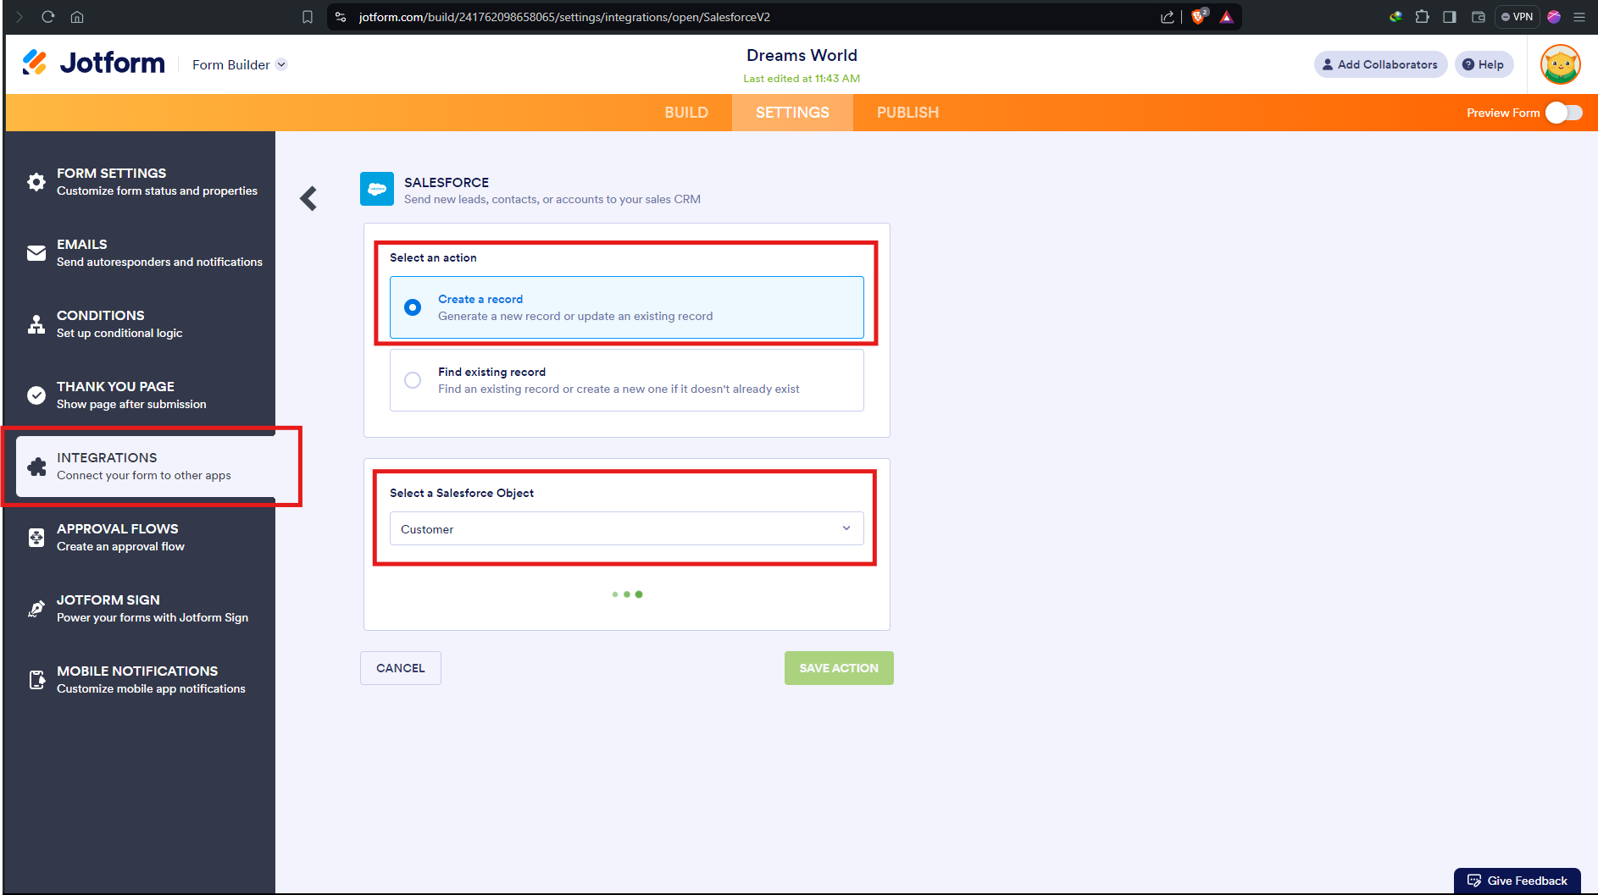

* Map the fields as shown in the figure below and click on “**Save Action**”.

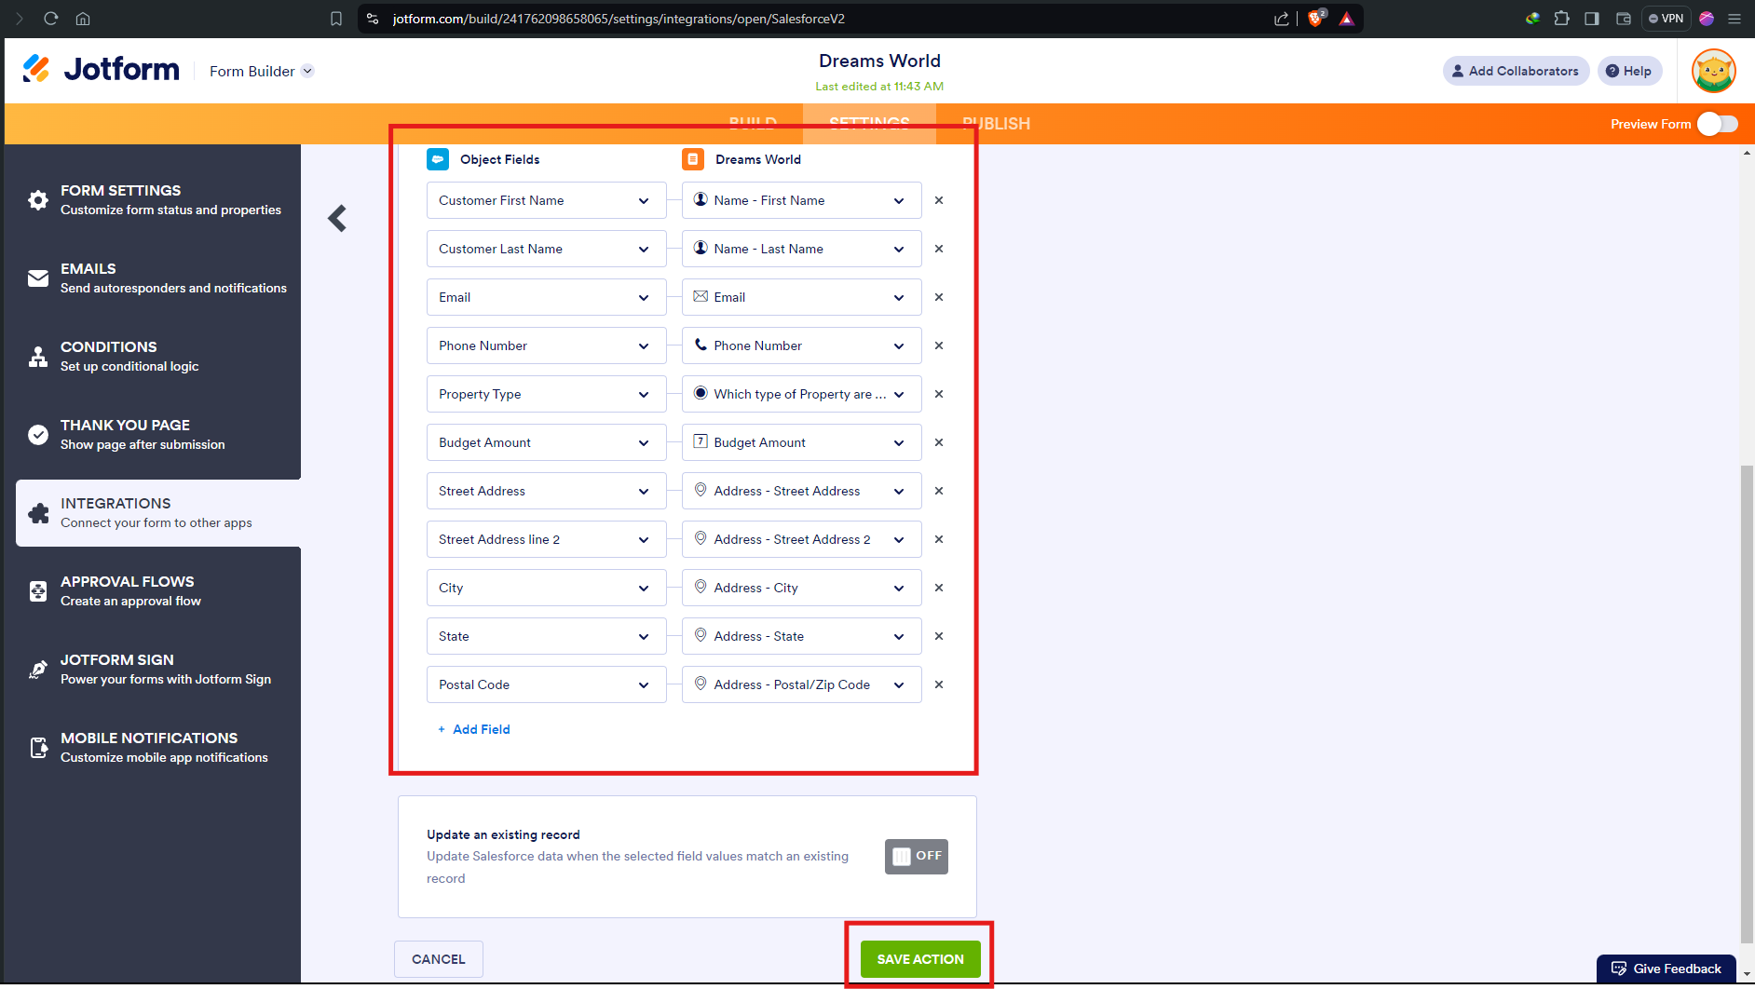

* Click on the “**Save Integration**” button to Integrate the Jotform into the Salesforce.

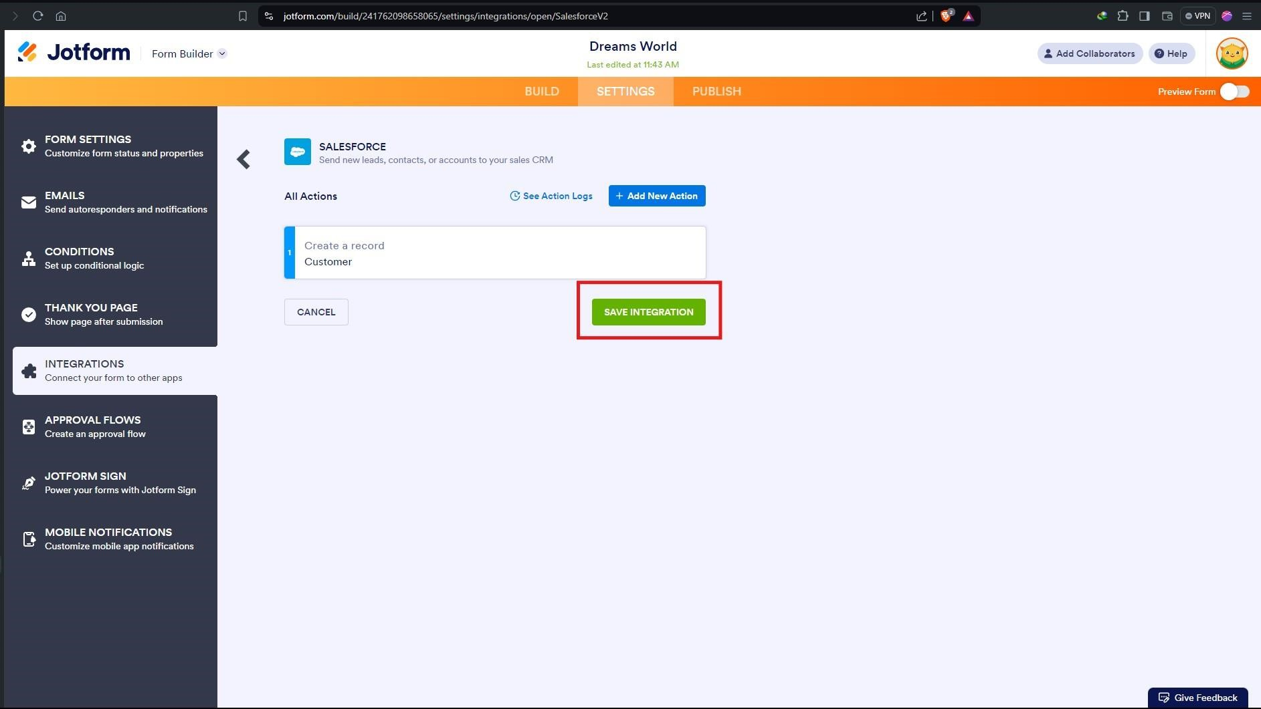

* Click on “**Finish**”.

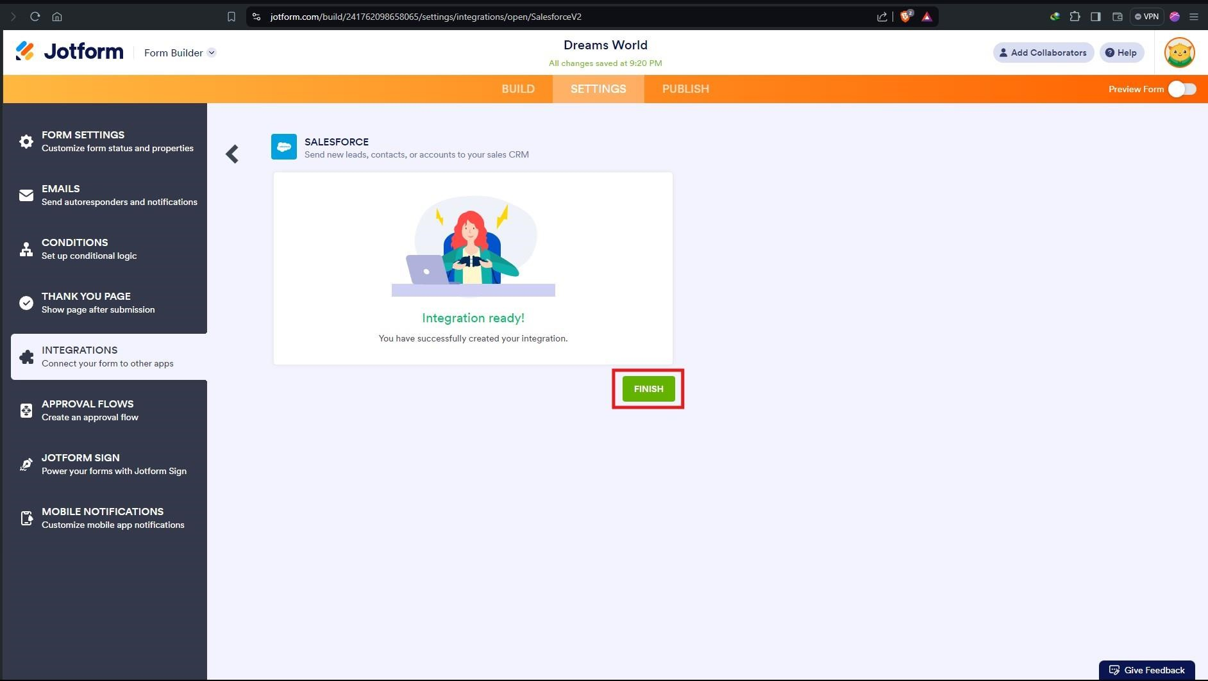

### Step 6: Create Roles



•



Click on gear icon



and Click on Setup.



* Click on “**Home**” and search in “**quick Find**” search box and search for “**Roles**”.

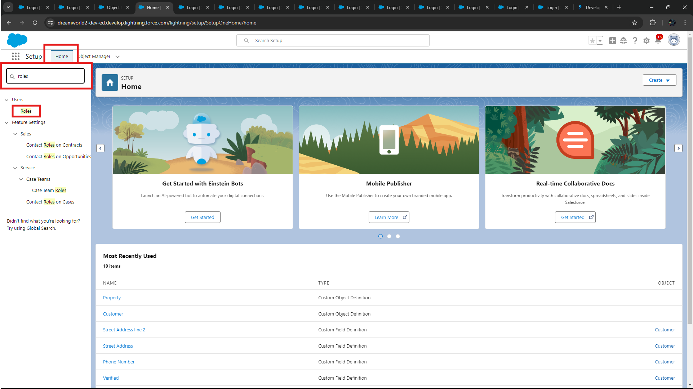

* Click on “**Set Up Roles**” as shown in the figure below.

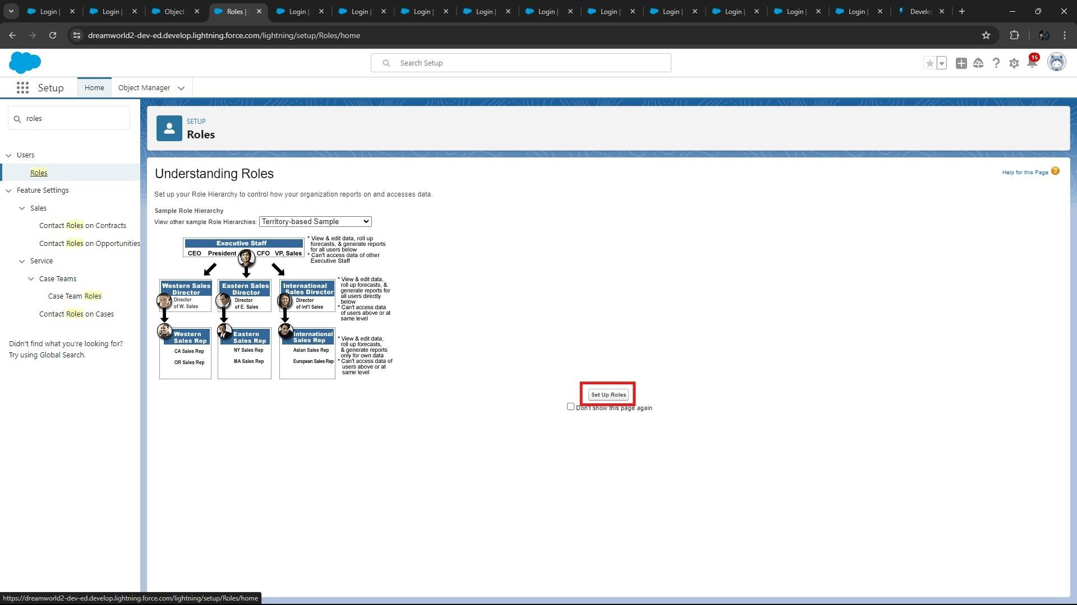

* Click on Expand all and Add a Role just below the Sales Representative.

**Note:** If you don’t find “**Sales Representative**” Role, create on yourself and make sure it has “**System Administrator**” Profile.

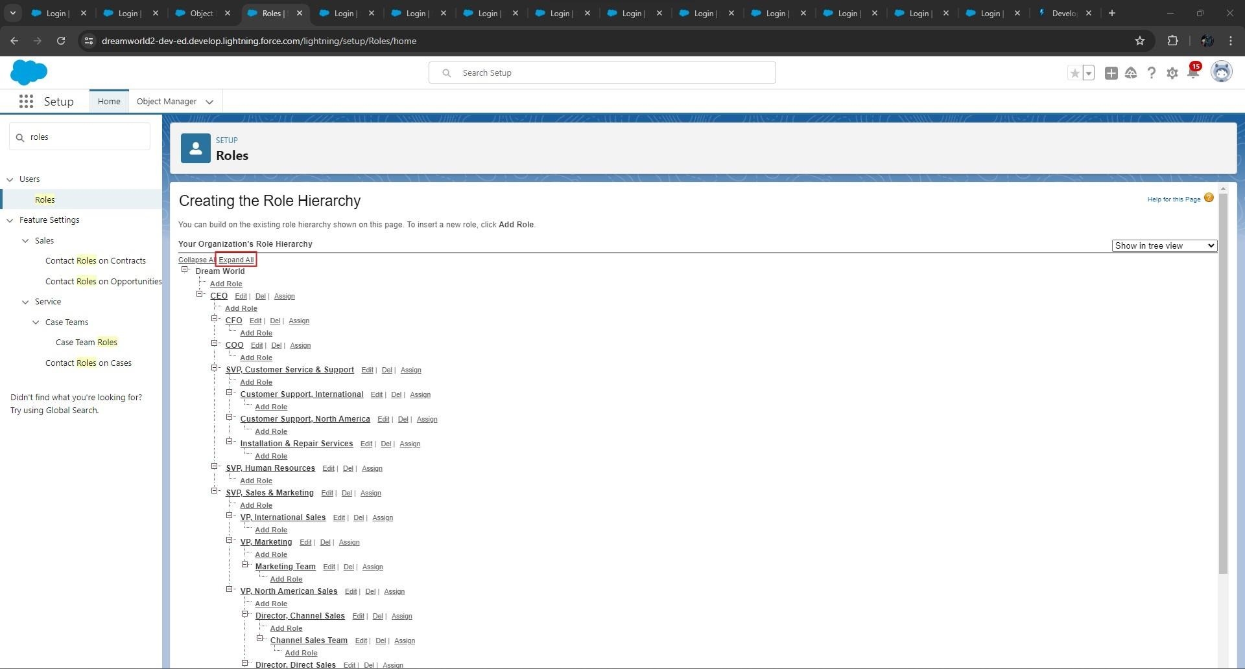

* Click on “**Add Role**” and enter the details and click on “**Save**” and create the roles as shown in the figure below.

Label: **Sales Executive** and Reports to: **Sales Representative**.

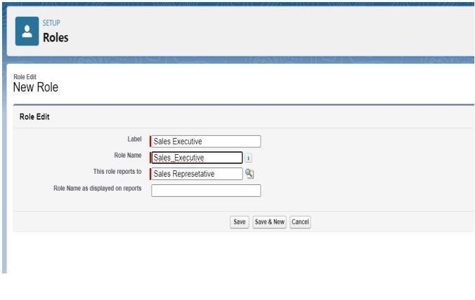

* Similarly Create a Role Name “**Sales Manager**” below **Sales Executive** which reports to **Sales Executive**, Also Add a Role below **Sales Manager** labeled as “**Customer**” which reports to **Sales Manager**.
* The below figure shows result after creating the roles.

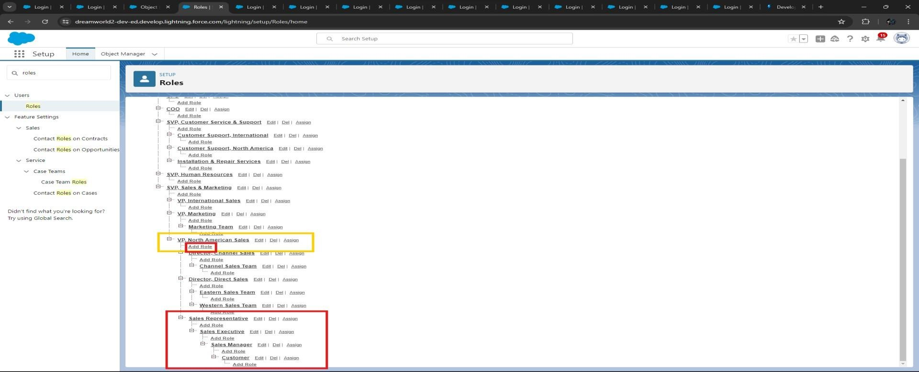

### Step 7: Create a Property Details App

* From Setup, go to “**App Manager**” and click on “**New Lightning App**” and Name it as “**Property**

**Details**” and add “**Customer**” and “**Property**” Object.

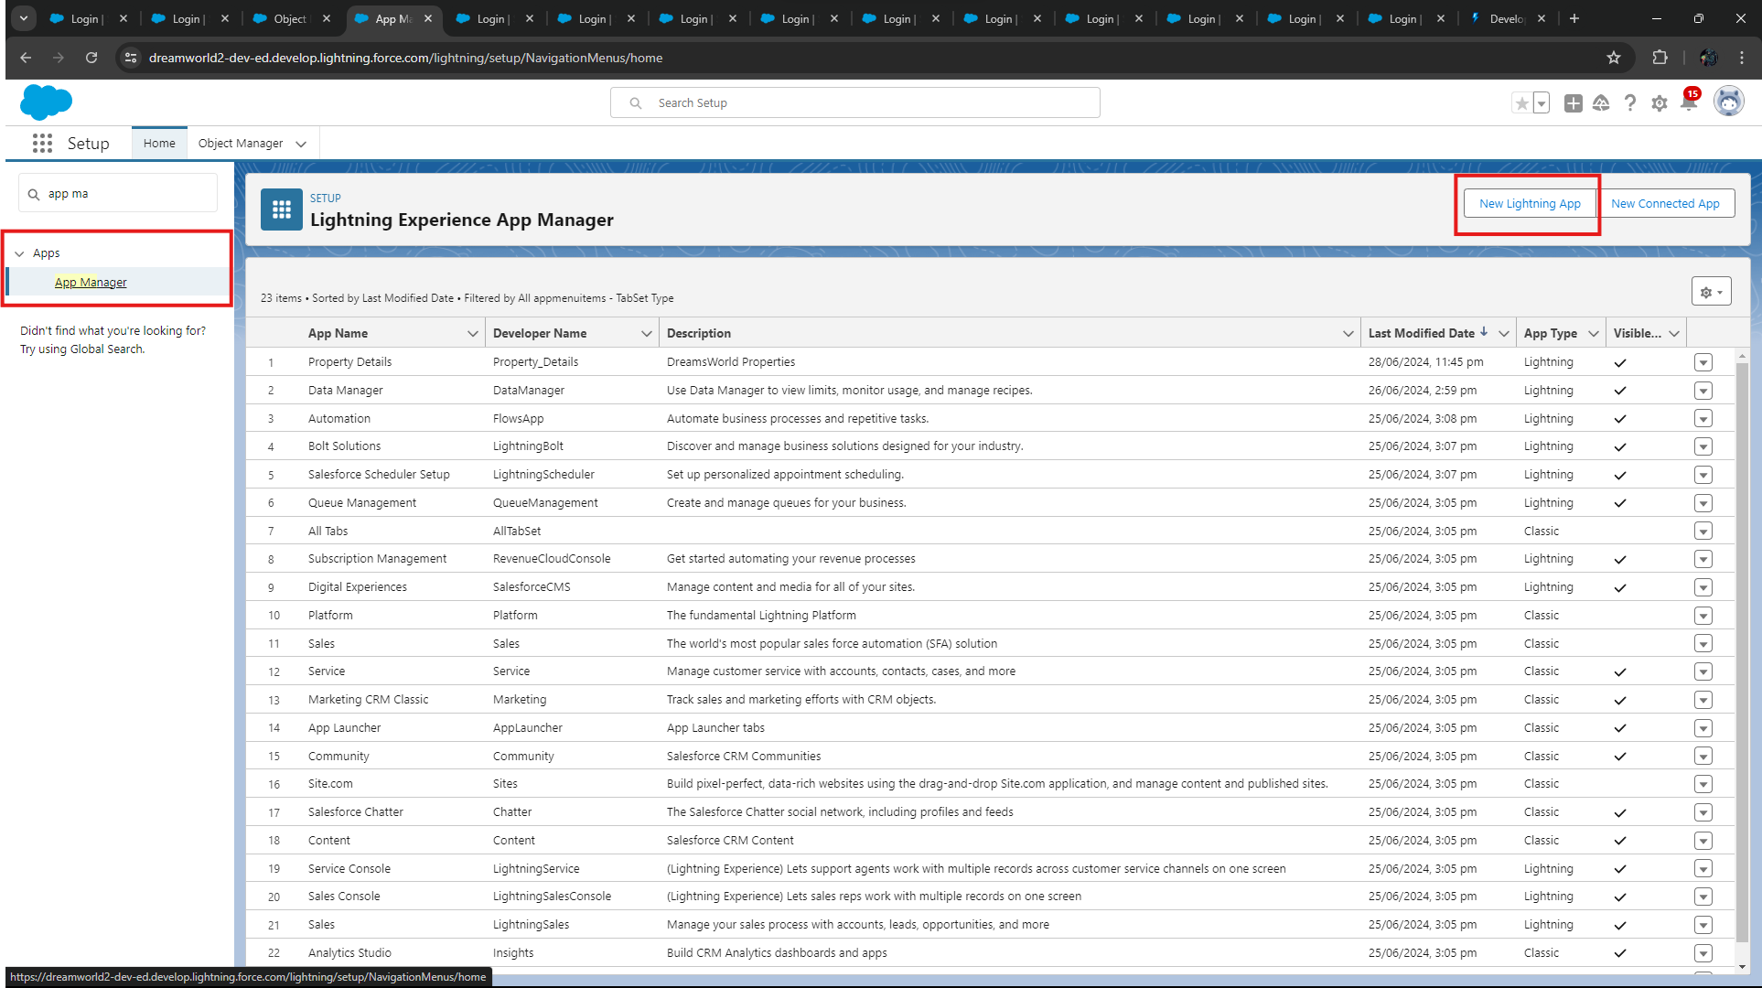

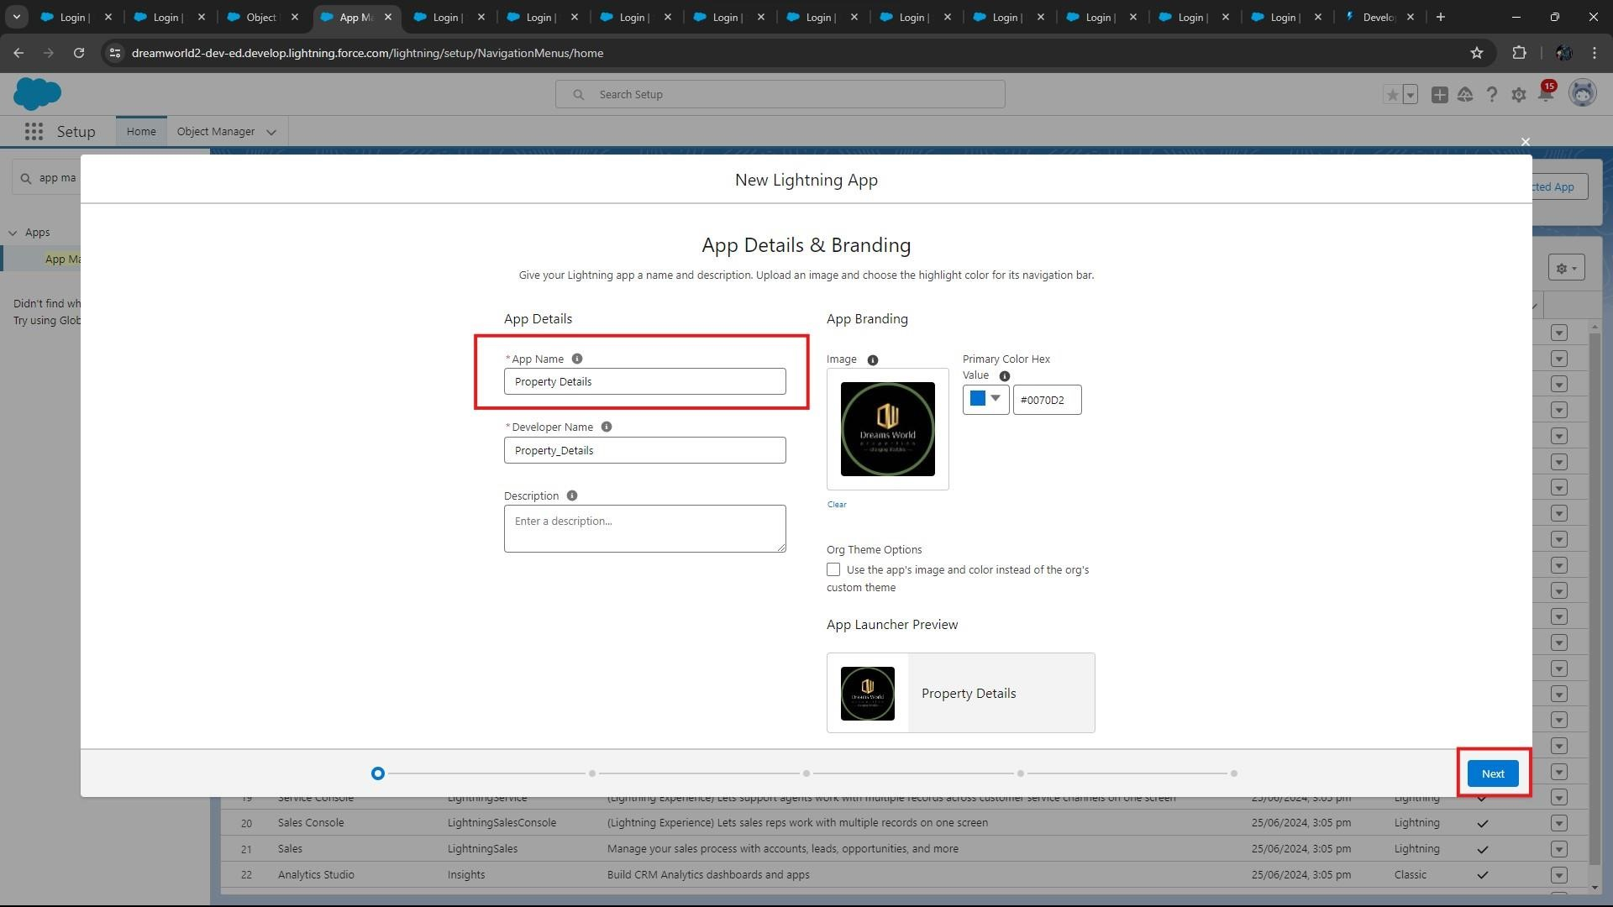

* Click Next→ Next → and add Navigation items and Save and Add “**System Admin**” Profile.

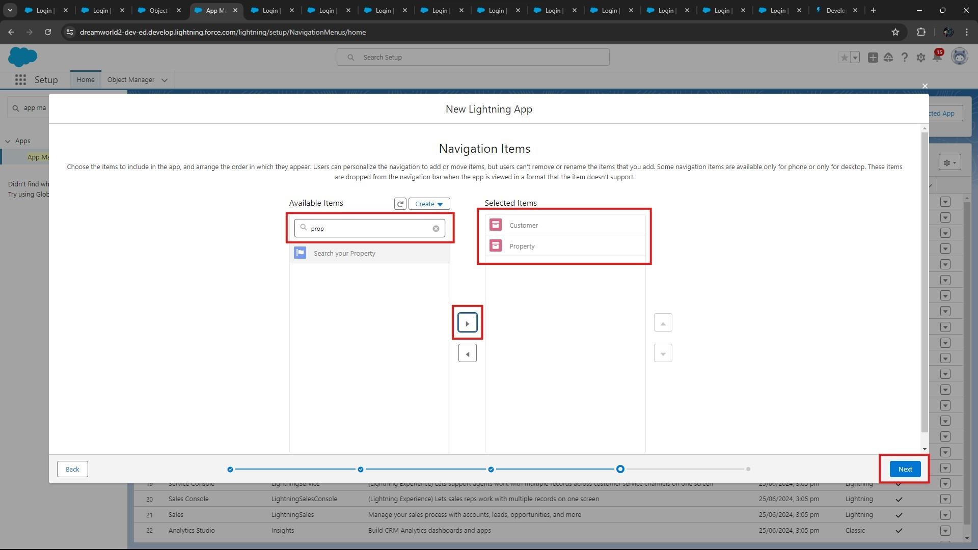

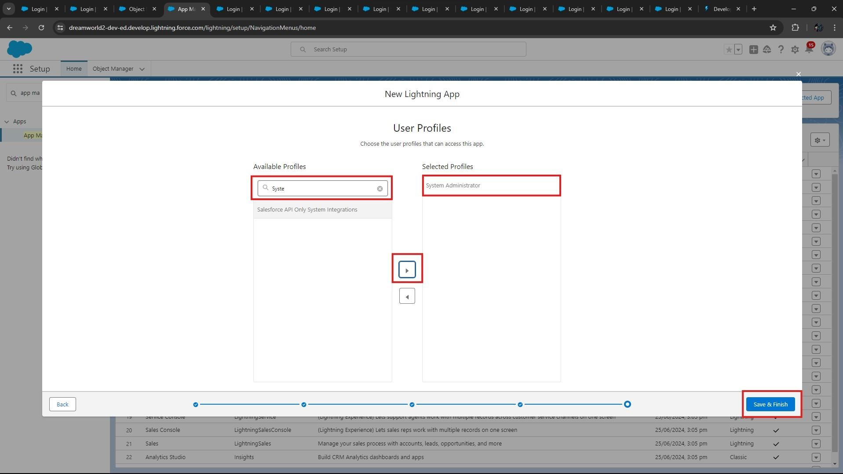

* Click on “**Save and Finish”** to create Lightning App.

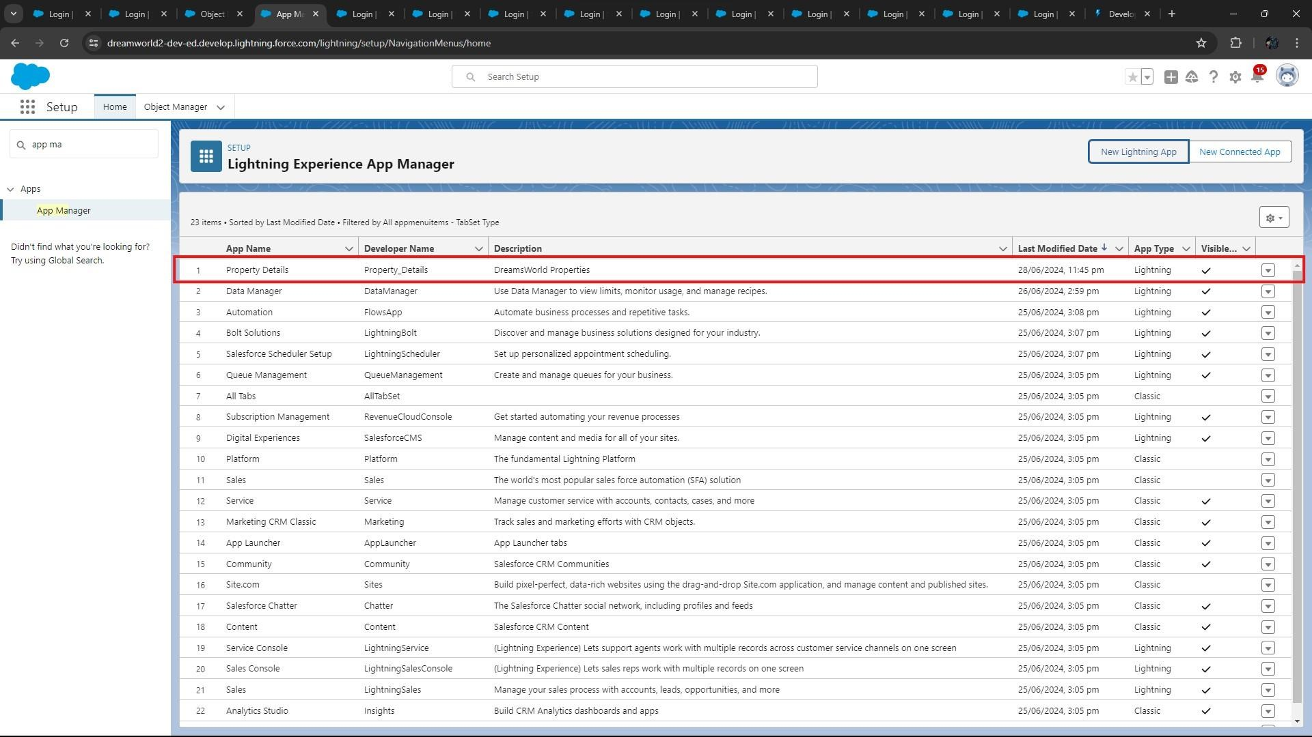

* The above figure shows the result of creating the Lightning App. **Step 8: Create Profiles**

### A. Create Customer Profile

* From Setup → Go to “**Profiles**” and Clone Salesforce Platform User and Name it “**Customer**”.

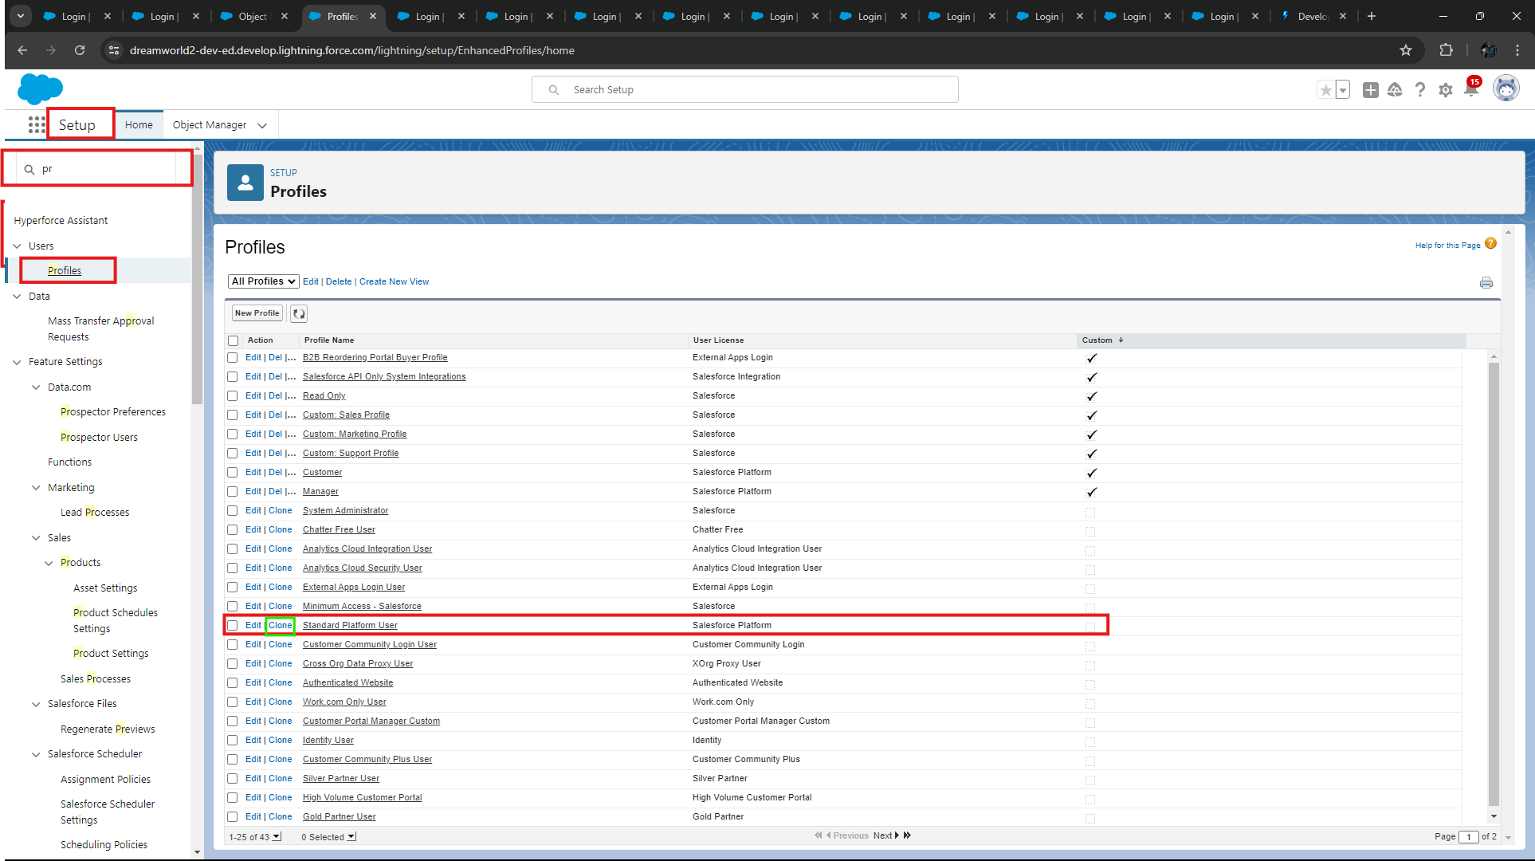

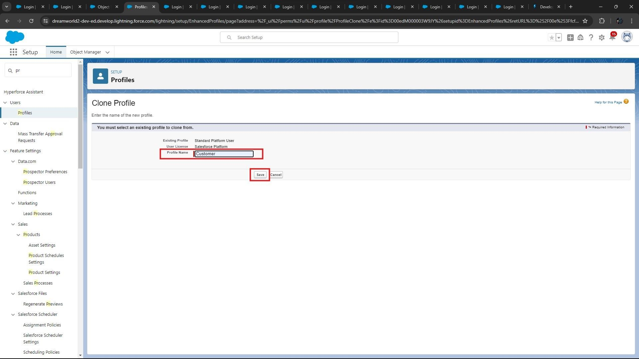

* Uncheck all the **Custom Objects** and Check only **Property Details** from Custom App Settings.

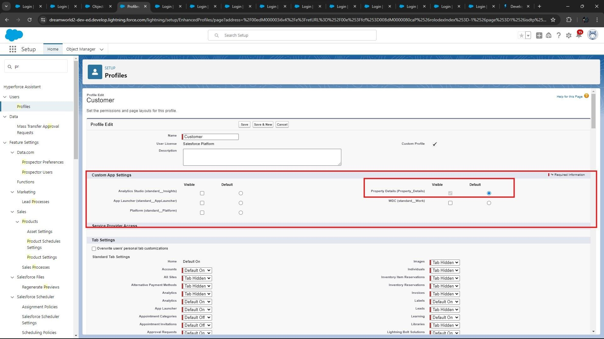

* Also Remove all the **Standard Object Permissions**.
* Uncheck all the **Custom Object Permissions** and check **read** and **view** all in “**Property**”

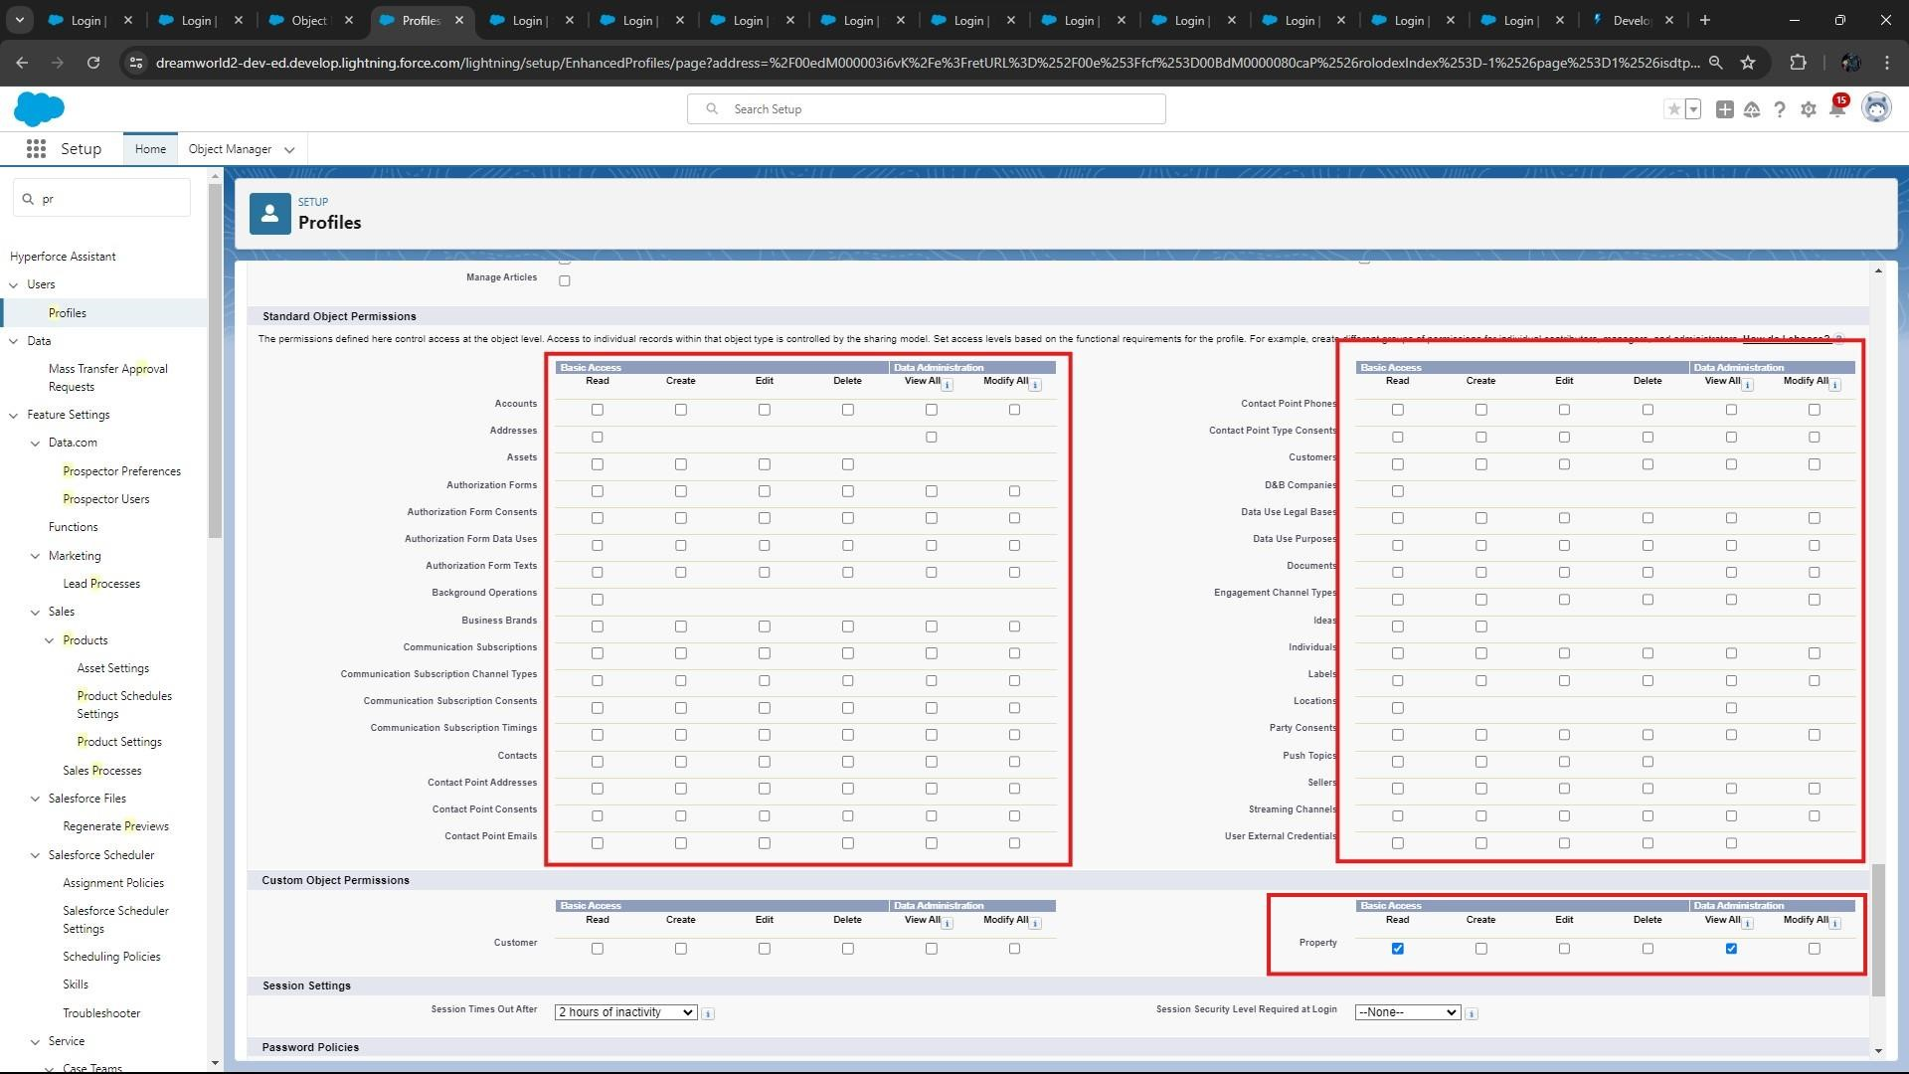

* Click on “**Save**”.

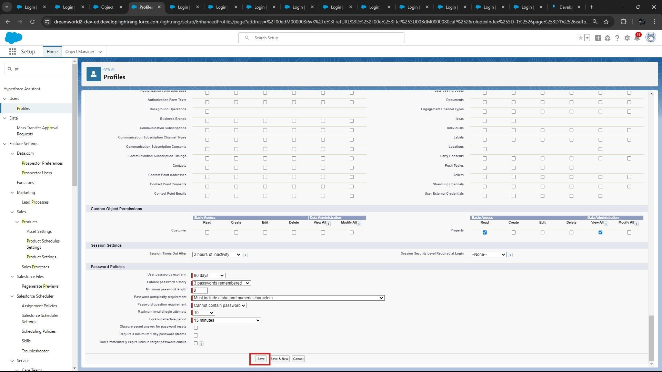

### B. Create Manager Profile

* From Setup → Go to **Profiles** and Clone Salesforce Platform User and Name it “**Manager**”.
* Uncheck all the **Custom Objects** and Check only “**Property Details**” from Custom App Settings.

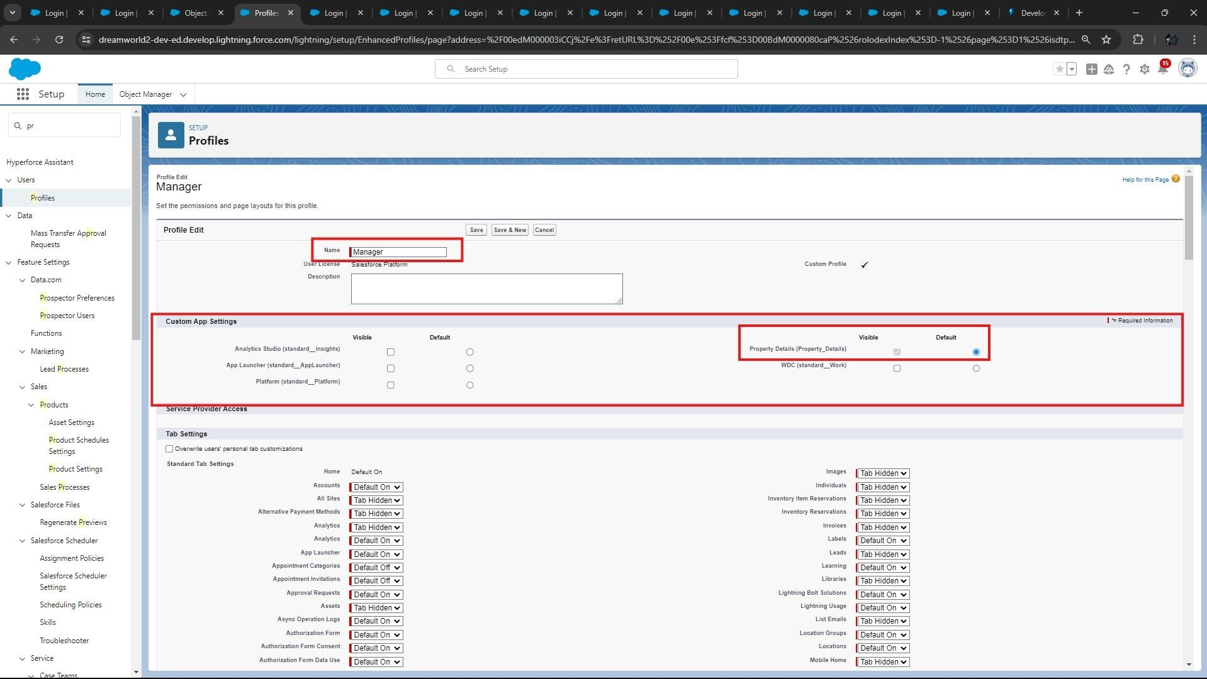

* Make sure custom tab settings are “**Default on**” for both “**Customer**” & “**Property**”.

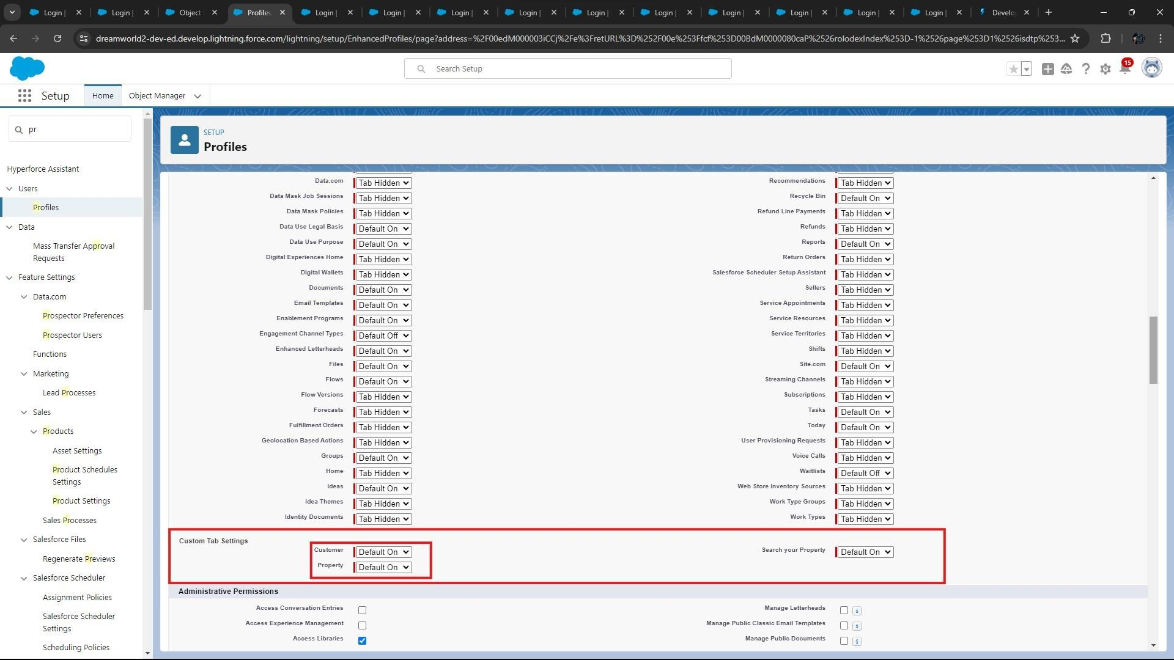

* Also Remove all the **Standard Object Permissions**.
* Uncheck all the **Custom Object Permissions** and check only “**modify all**” from “**Property**” and “**Customer**”**.**

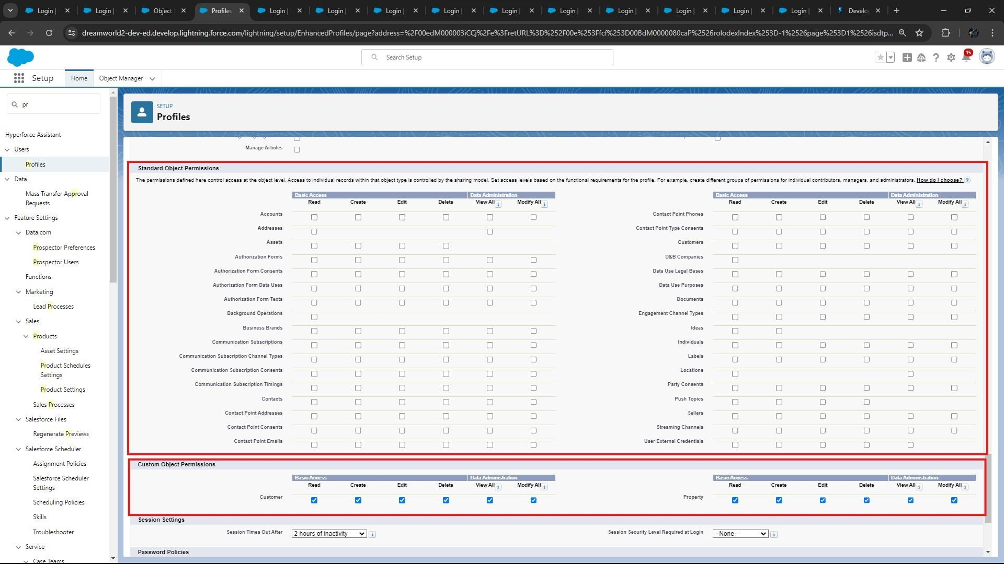

* Scroll down and click on “**Save**”.

### Step 9: Create a CheckBox field on user

* **Setup** → **Object Manager** → Search for **“User”** → **Fields and Relationships**.

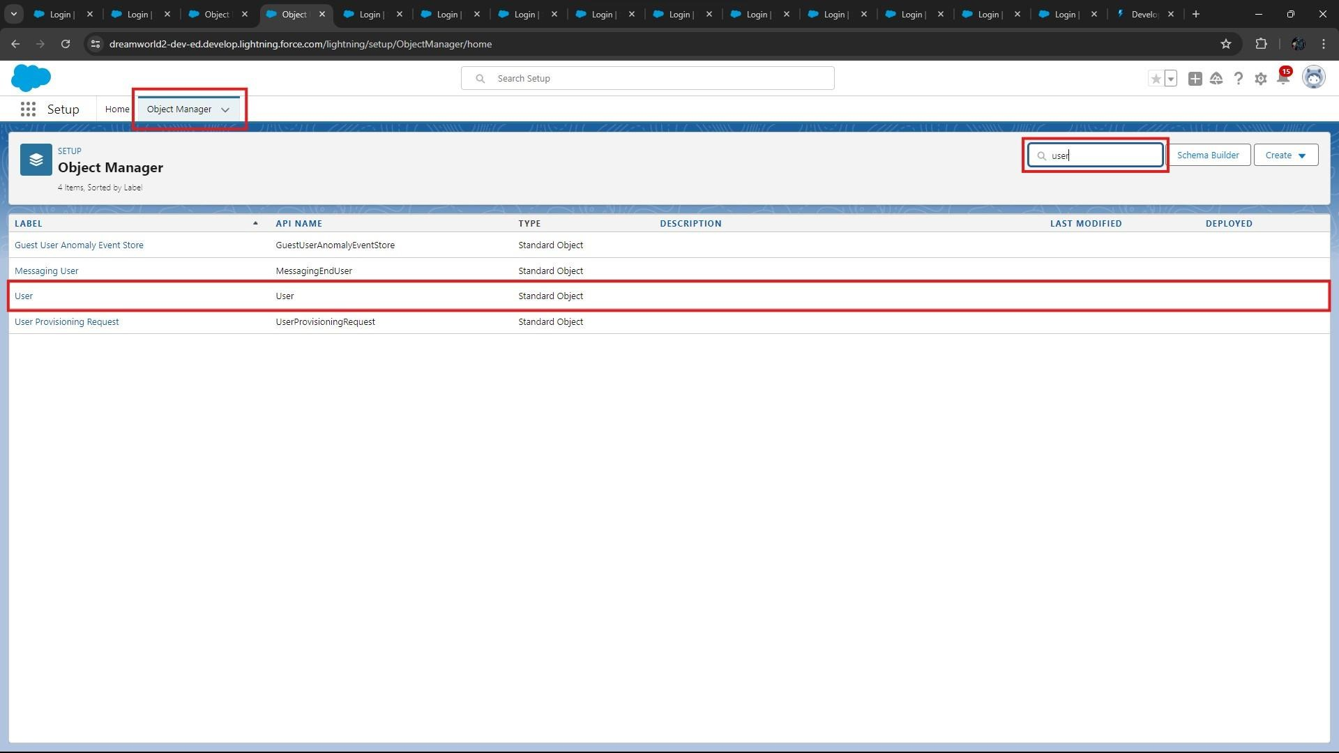

* Click on “**New**” to create a new Field.

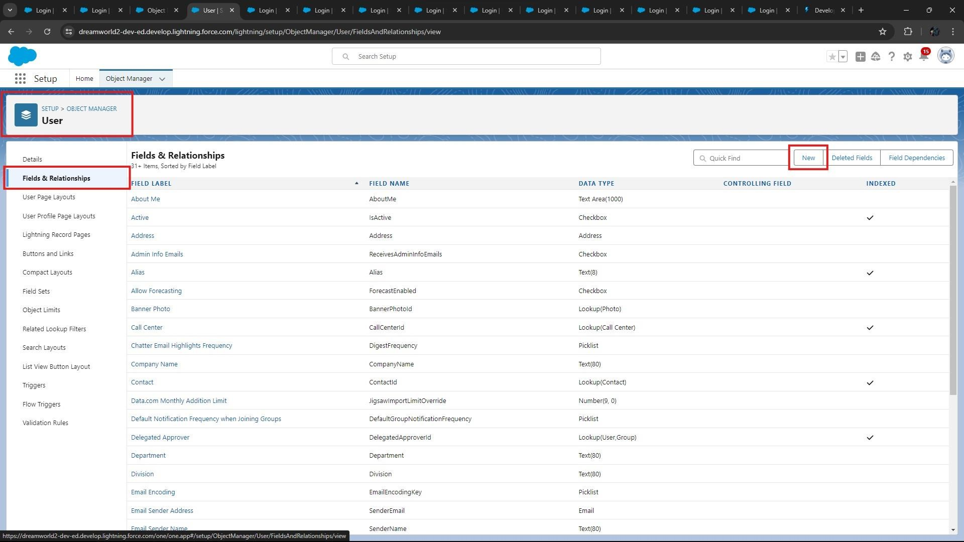

* Create new Field Named as “**Verified**” as Data type “**CheckBox**”.

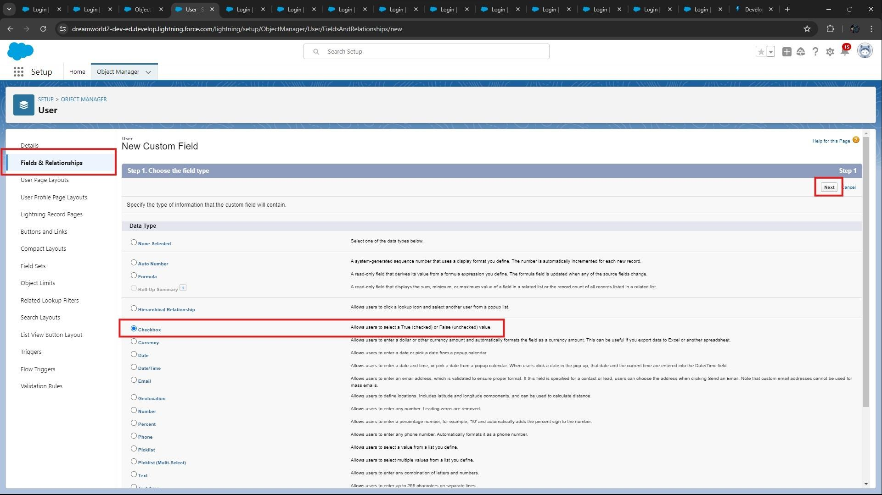

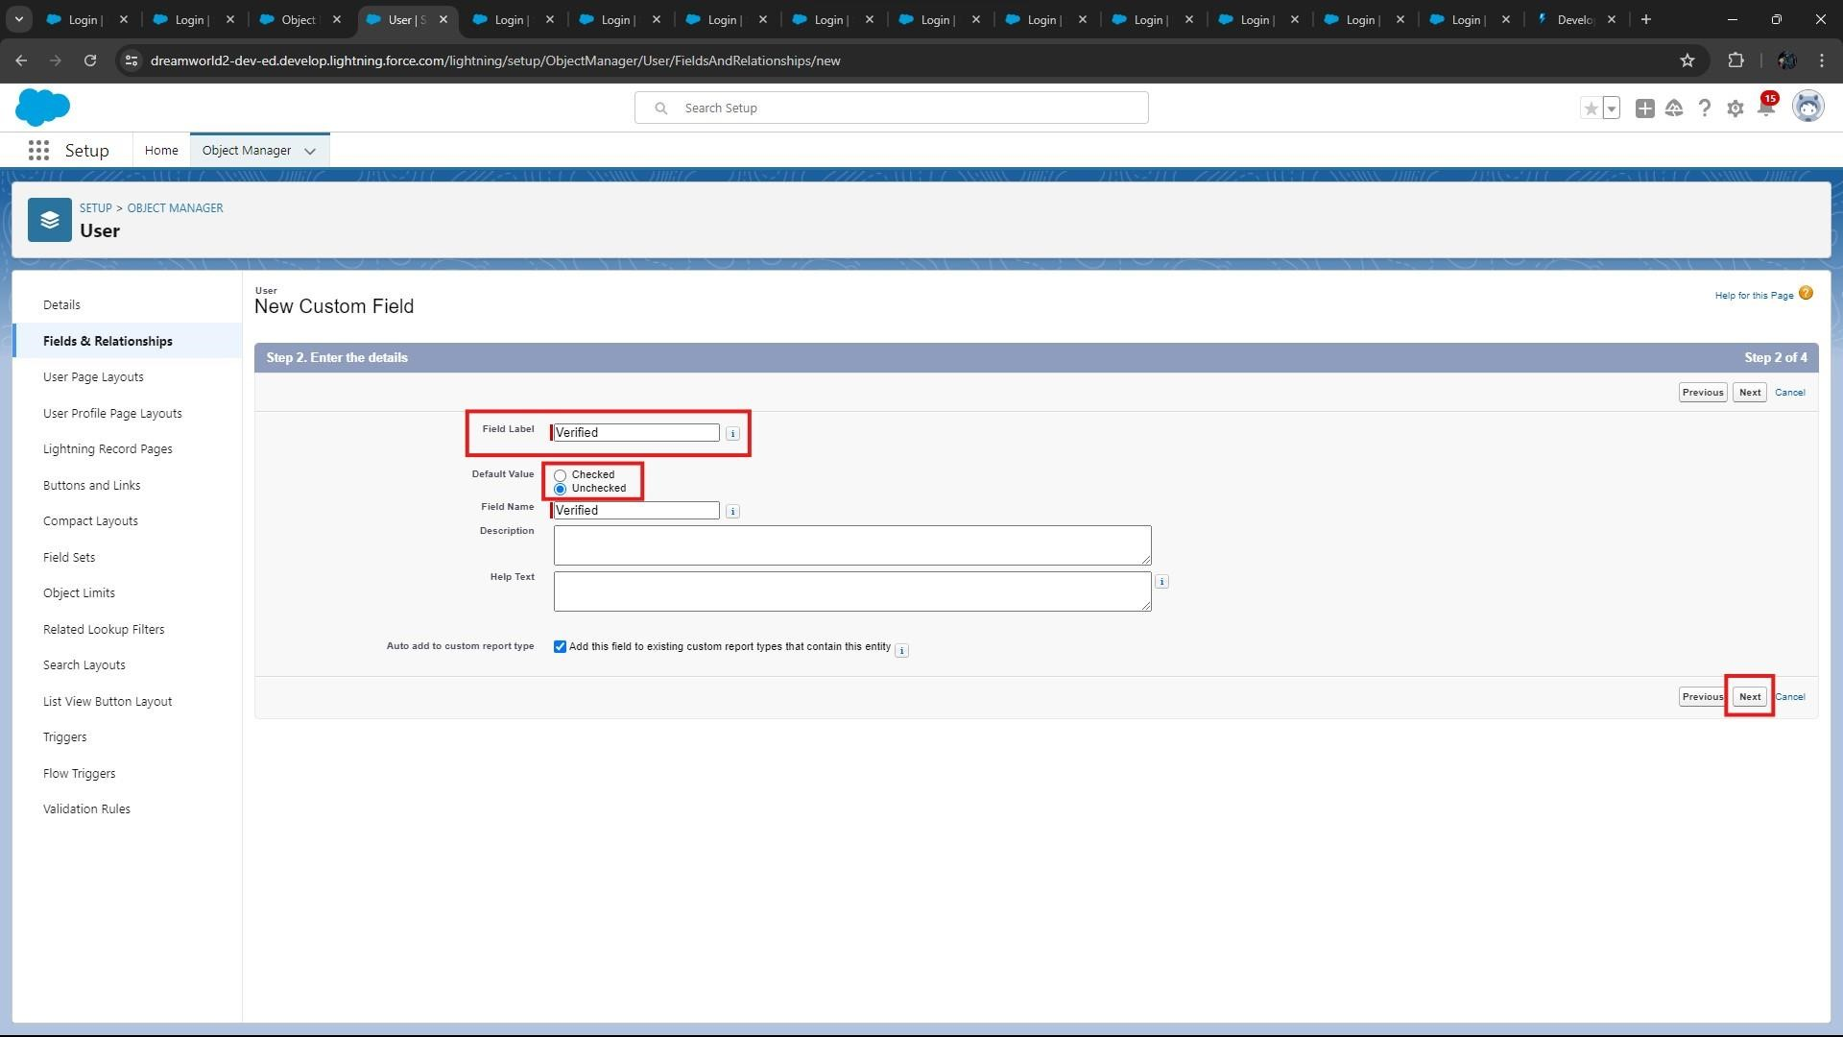

* After clicking “**Next**”, Select “**Visible**” Option and click on “**Next**” and “**Next**” and “**Save**”.

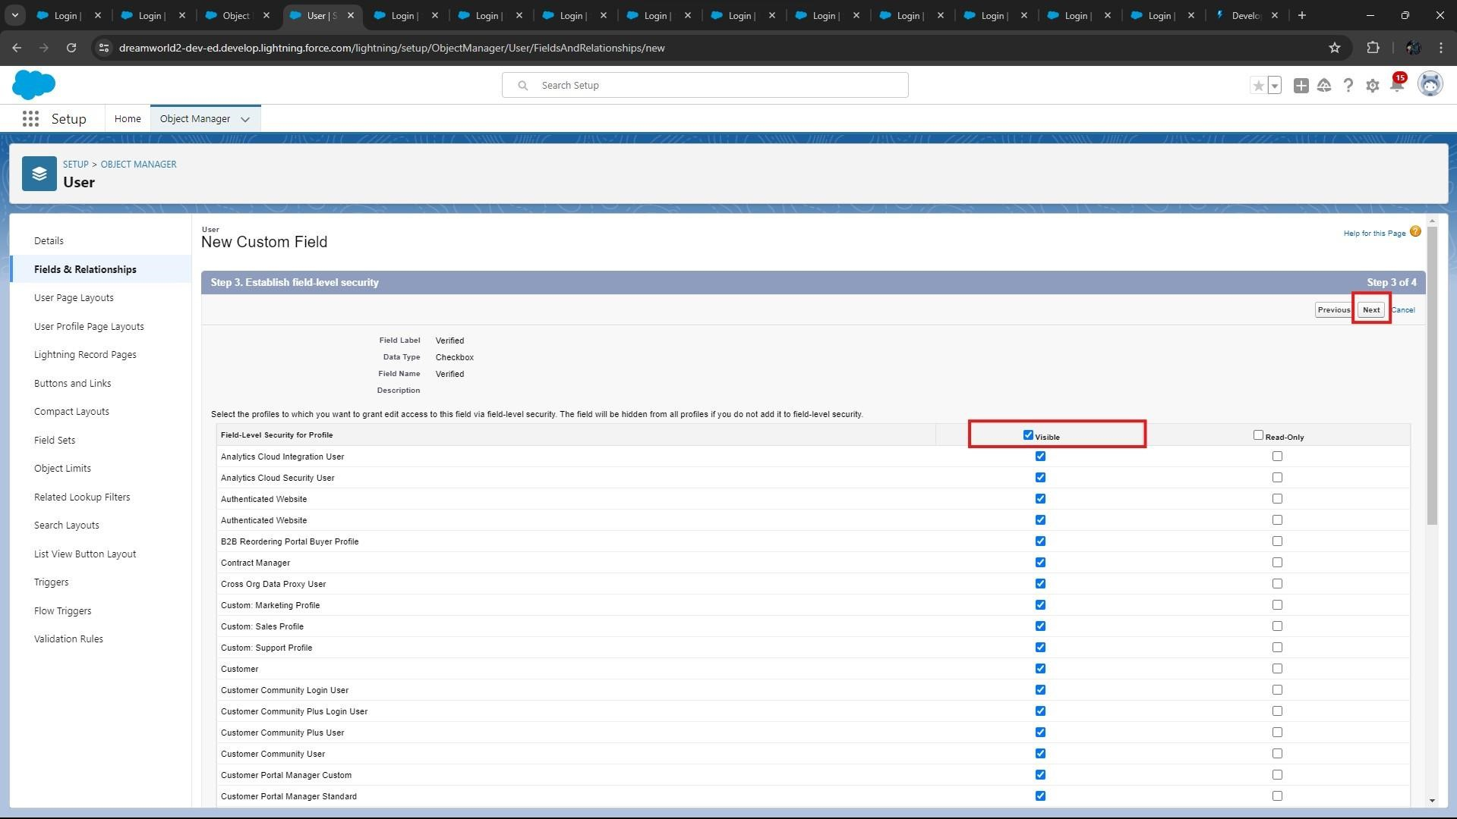

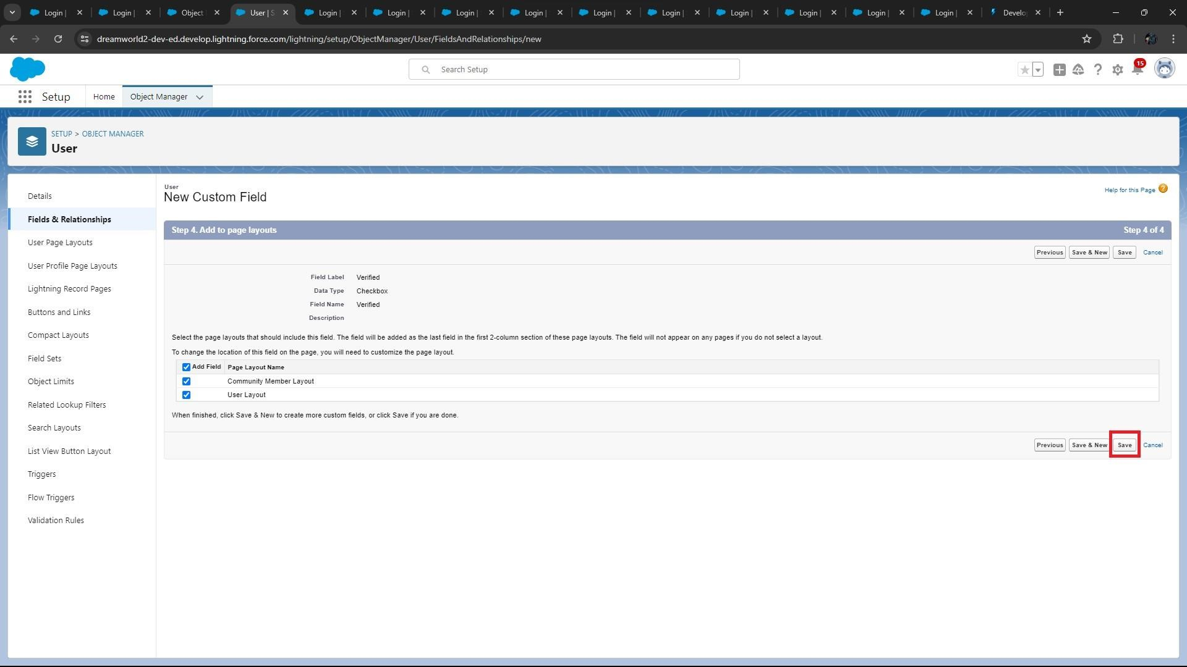

### Step 10: Create Users

* Create three different users with three different Roles and profiles as we have mentioned above.

o **User 1: -**

* 1. Go to Setup → Quick Find “**Search box**” → Users → New User
  2. LastName – **Executive**
  3. Role - **Sales Executive**
  4. License – **Salesforce**
  5. Profile - **System Administrator**
  6. Save
* To create a “**User**”, click on “**New**”.

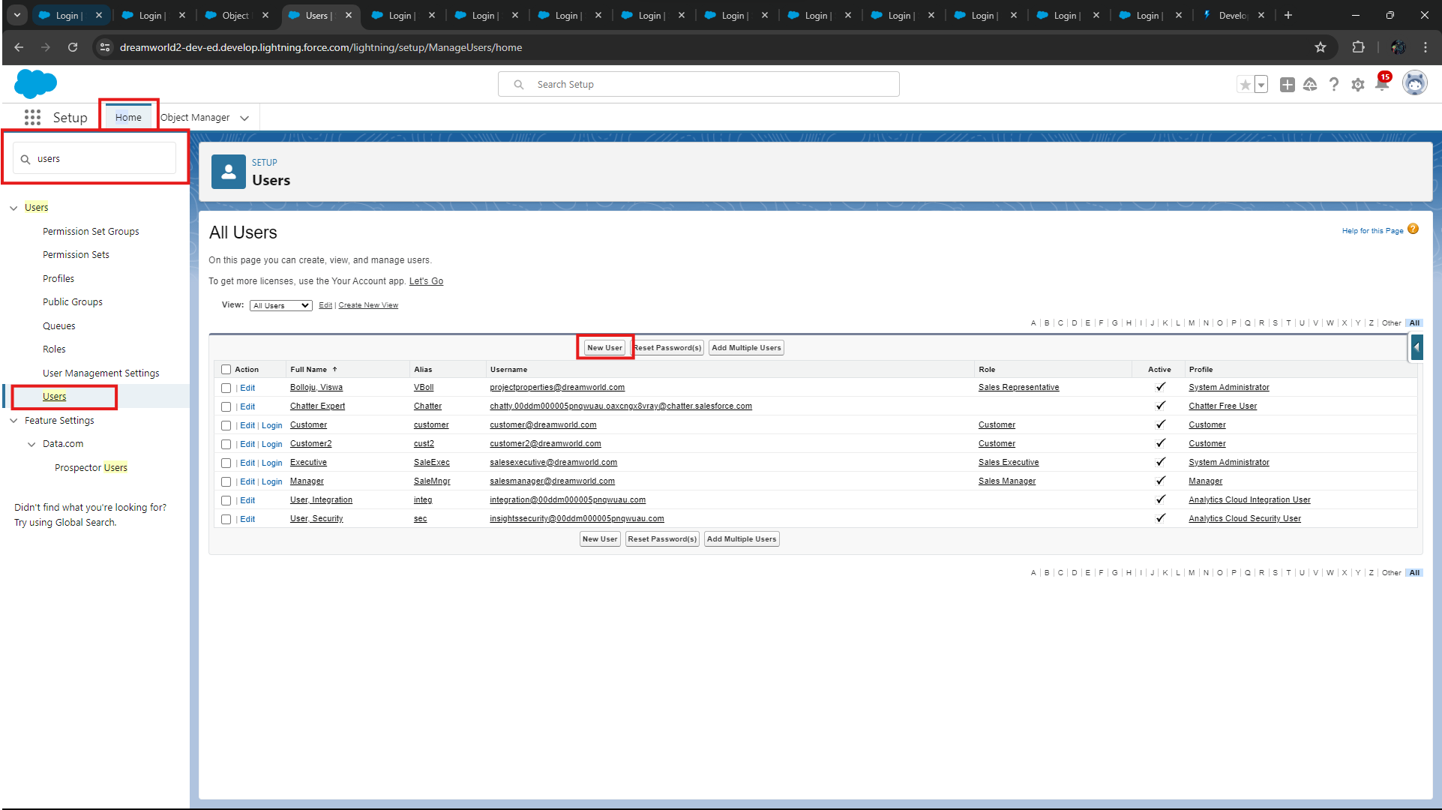

* Fill in the details of “**User 1**”.

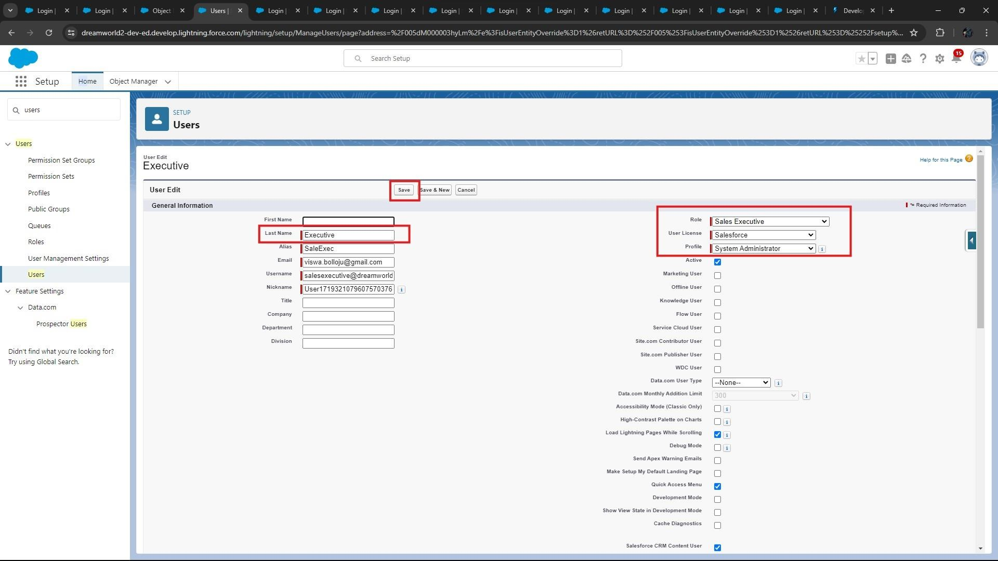

* Click on “**Save**”.



* Do the same with **User 2, User 3, User 4** o  **User 2: -** 
  + 1. Go to Setup → Quick Find “**Search box**” → Users → New User
    2. LastName - **Manager**
    3. Role - **Sales Manager**
    4. License - **Salesforce Platform**
    5. Profile - **Manager**
    6. Save o **User 3: -**
  1. Go to Setup → Quick Find “**Search box**” → Users → New User
  2. LastName - **Customer**
  3. Role - **Customer**
  4. License - **Salesforce Platform**
  5. Profile - **Customer**
  6. Make Sure the verified check box is “**Unchecked**”.

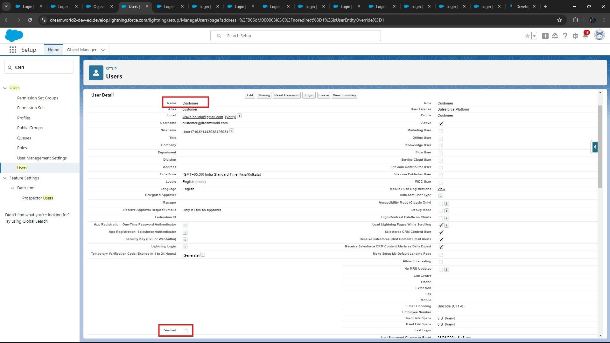

* 1. Save o **User 4: -**

1. Go to Setup → Quick Find “**Search box**” → Users → New User
2. LastName - **Customer2**
3. Role - **Customer**
4. License - **Salesforce Platform**
5. Profile - **Customer**
6. Make Sure the verified check box is “**checked**”.

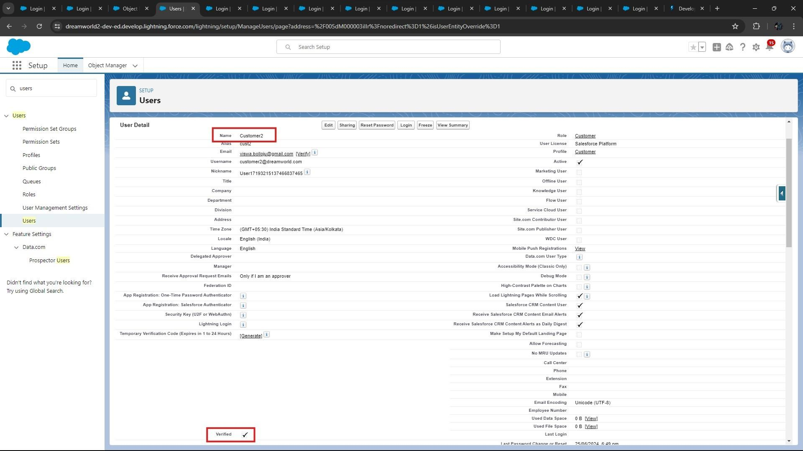

1. Save

• Result after creating the Users

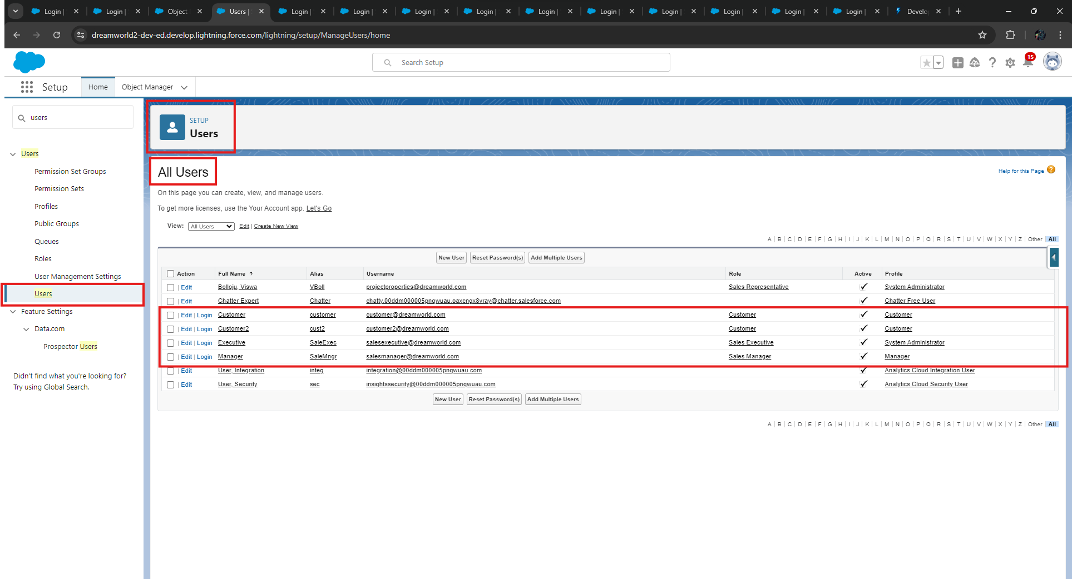

### Step 11: Create an Approval Process for Property Object

* From **Setup** → **Process Automation** → **Approval Process.**

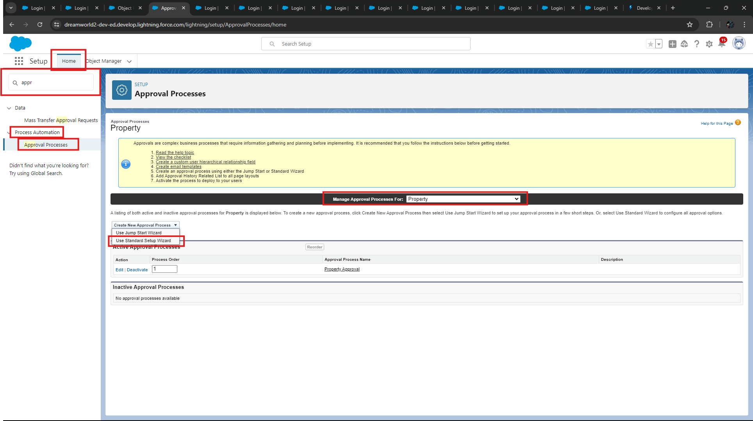

* Select “**Property**” and Choose “**Use Standard Setup Wizard**”.
* Enter Process Name – “**Property Approval”.**

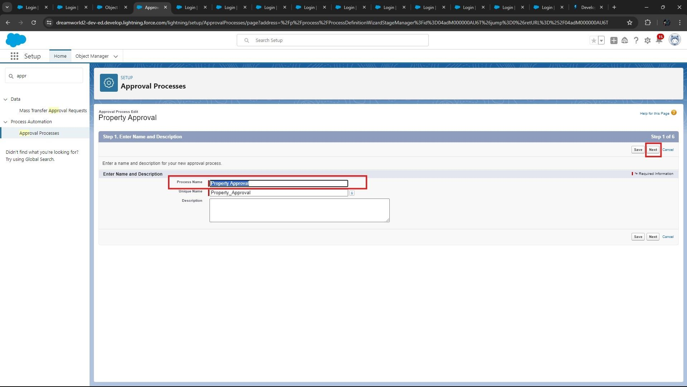

* Give 2 criteria →

1) **Location** is not equal to **blank**, 2) **Verified** Equals **false**.

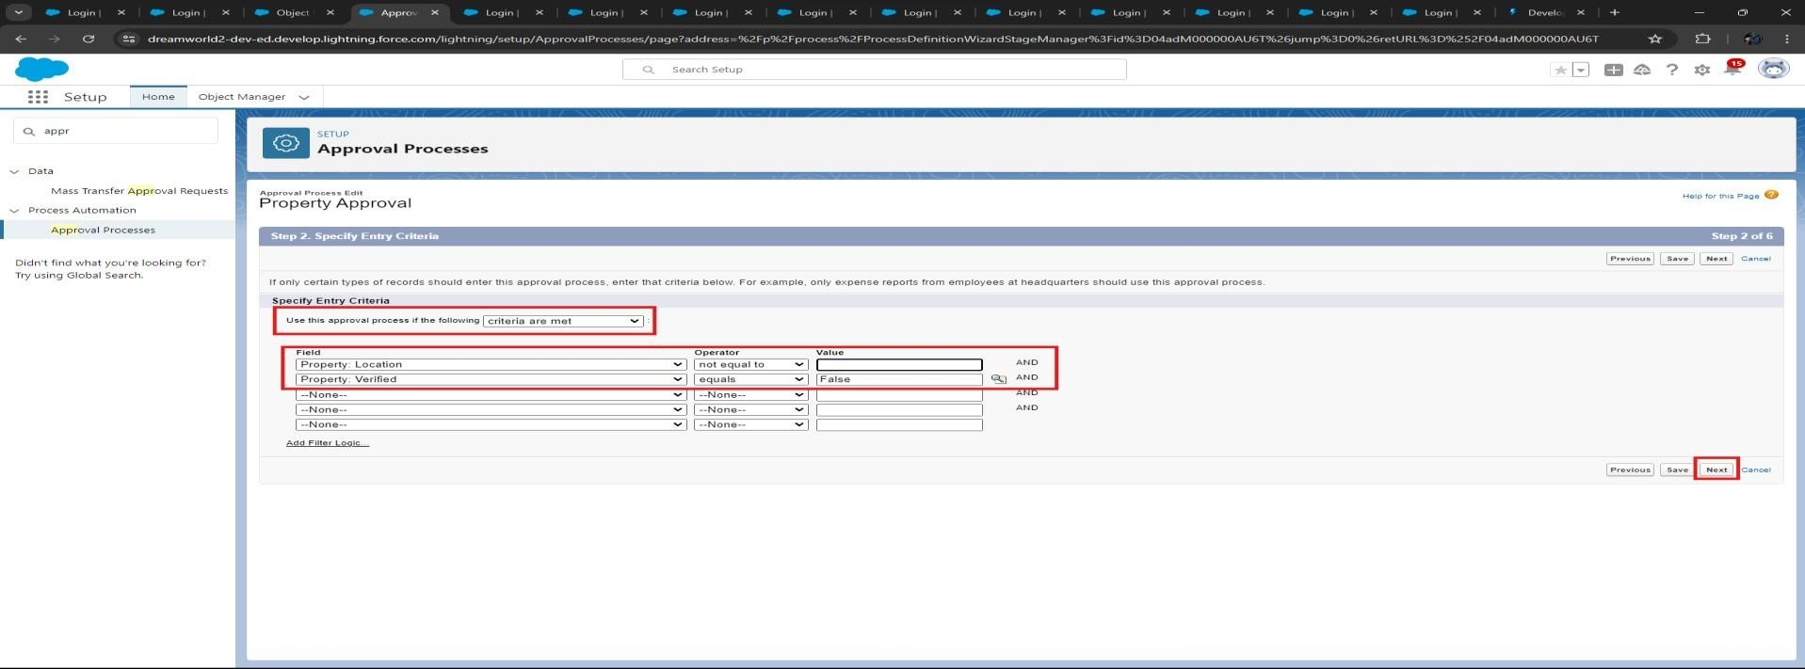

* Click **next** and “**Next Automated Approver Determined By**” → Select “**Manager”.**
* From **Record Editability Properties** → Click on **Administrators OR the currently assigned approver can edit records during the approval process**.

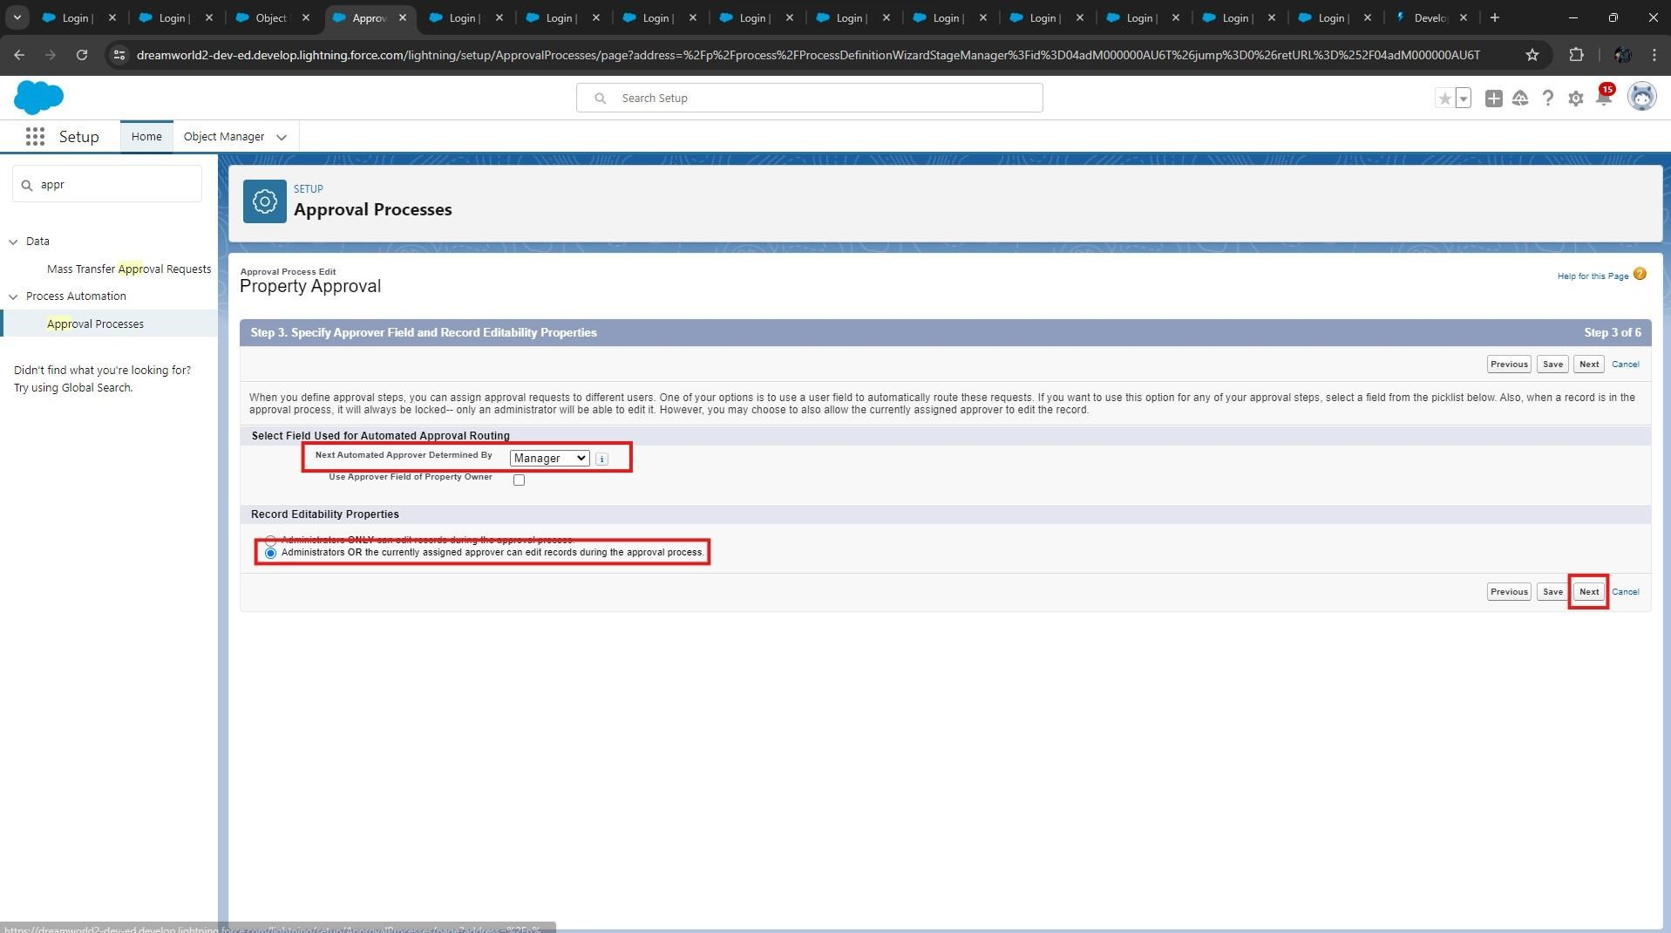

* From Step 5. Select **Fields** to **Display on Approval Page Layout** select **Property, Owner, Location, Type** and click **Next**.

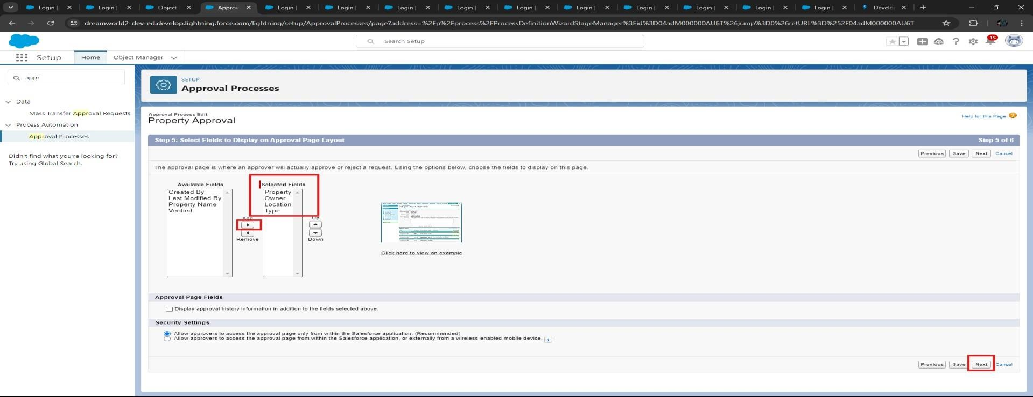

* Click Next and Select the **initial Submitters** →
  1. Owner → **Property Owner**
  2. Roles → **Sales Manager** • Click on “**Save**”.

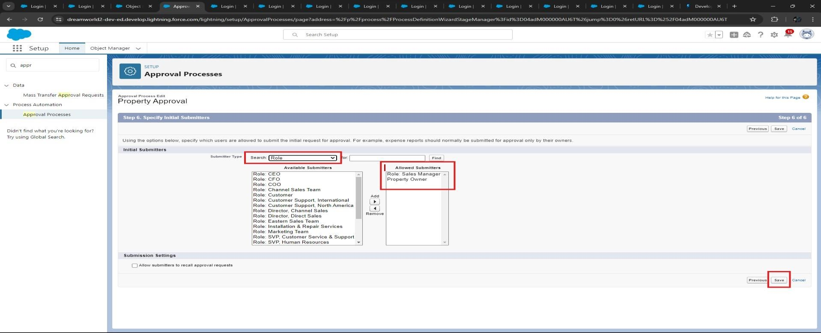

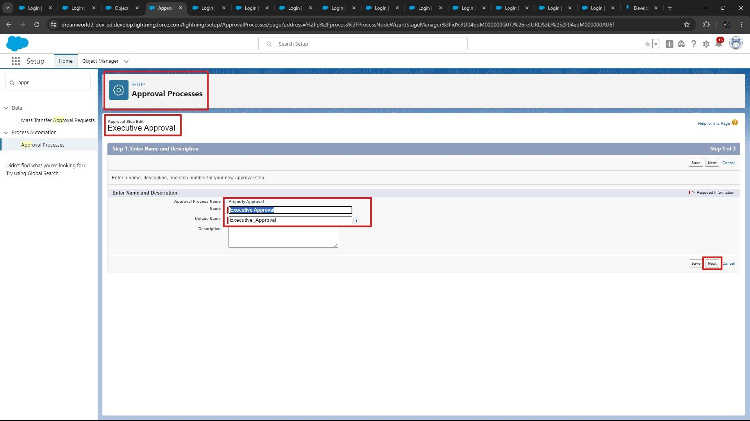

* Add an approval step name “**Executive Approval**”.

* Specify the Criteria → **All record should enter**

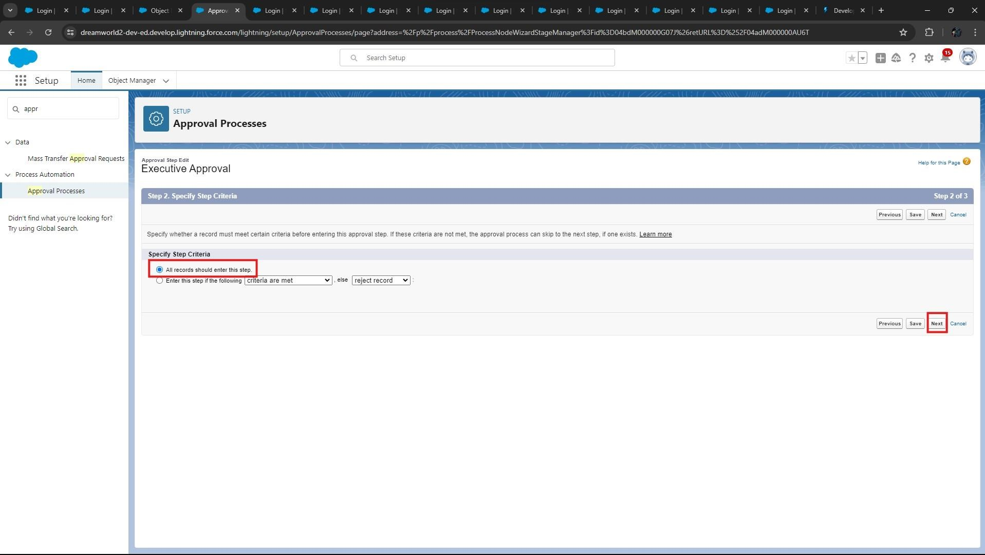

* Click **next** and select the Approver as “**Sales Executive**” and “**Save**”

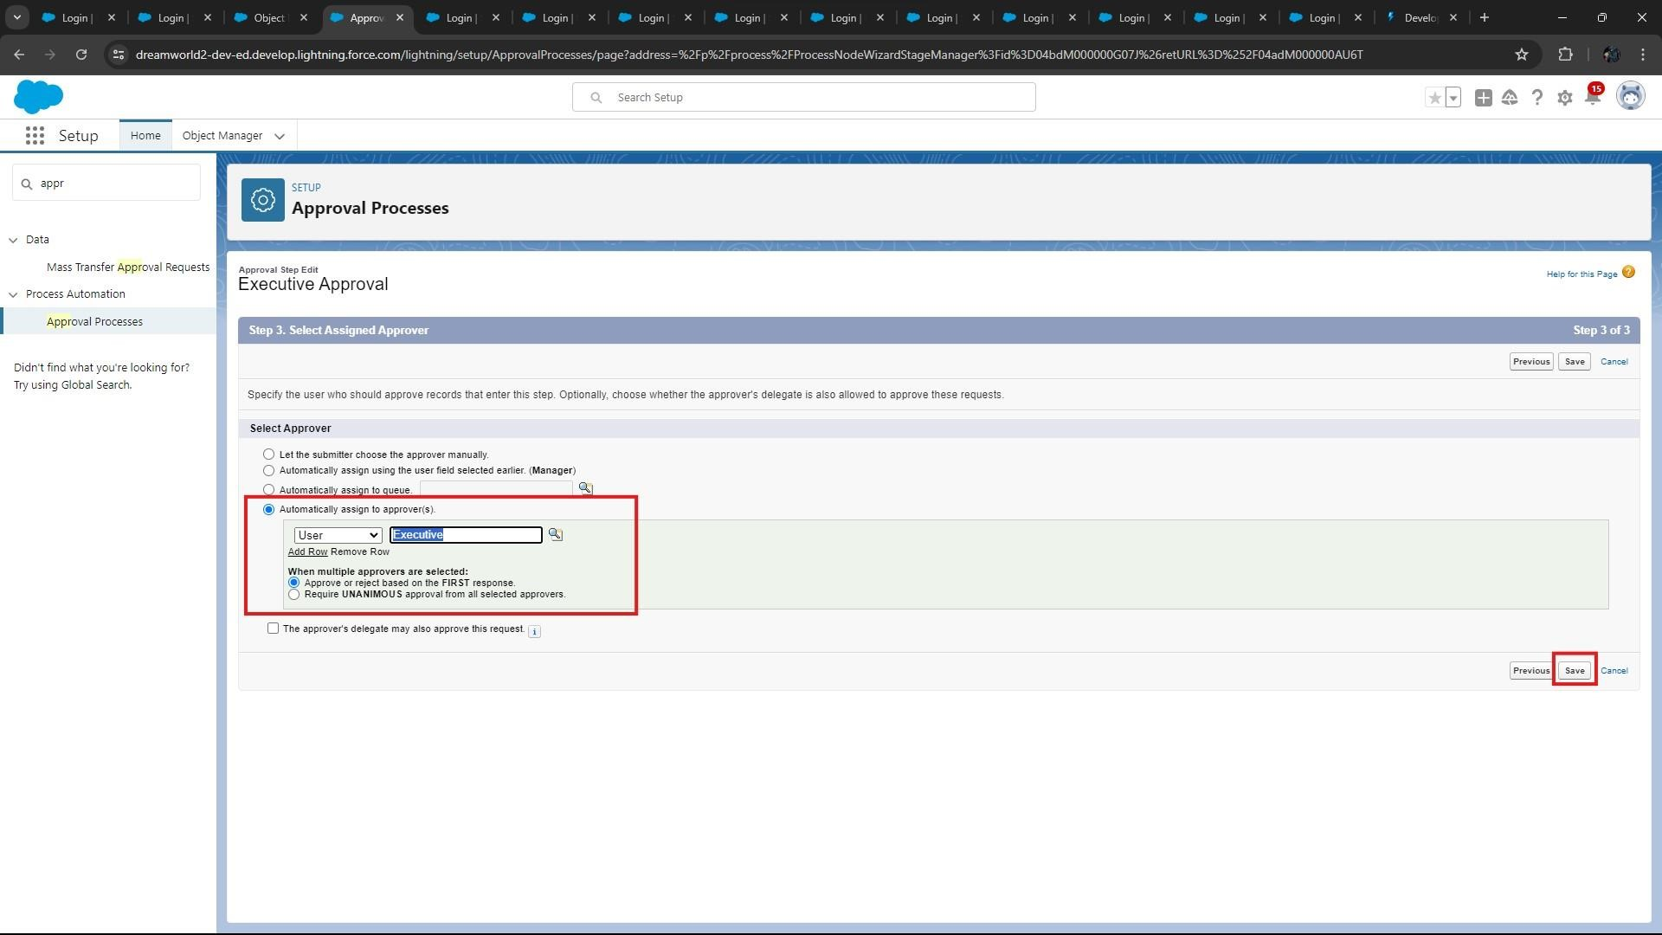

* Click on “**Add New**” and click on “**Field Update**”.

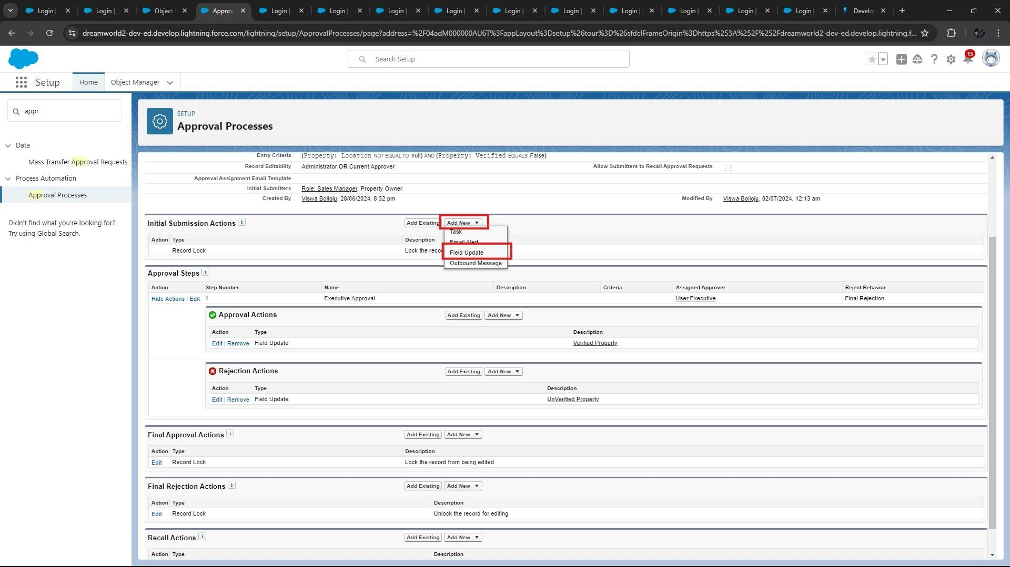

* Add One field Update as “**Verified Property**”
  + 1. Select Object → **Property**
    2. Field to Update → **Verified**
    3. Field Data Type → **CheckBox**
    4. Select CheckBox Option as “**True**” 5) Save.

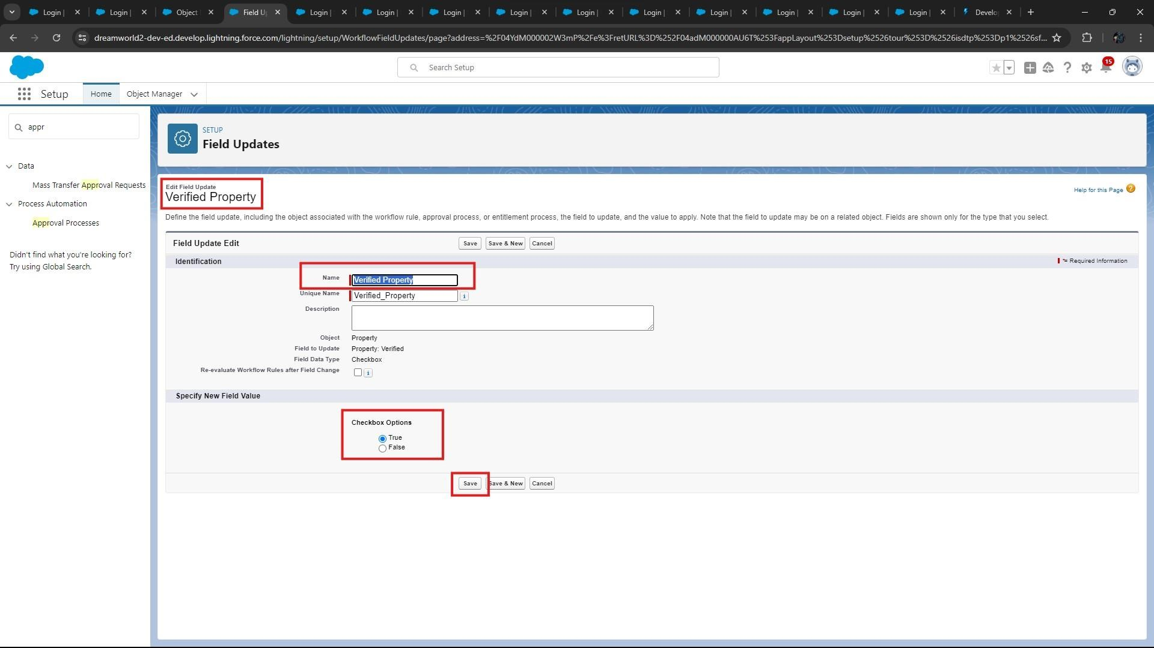

* Add One field Update as “**UnVerified Property**”
  + 1. Select Object → **Property**
    2. Field to Update → **Verified**
    3. Field Data Type → **CheckBox**
    4. Select CheckBox Option as “**False**”
    5. Save.

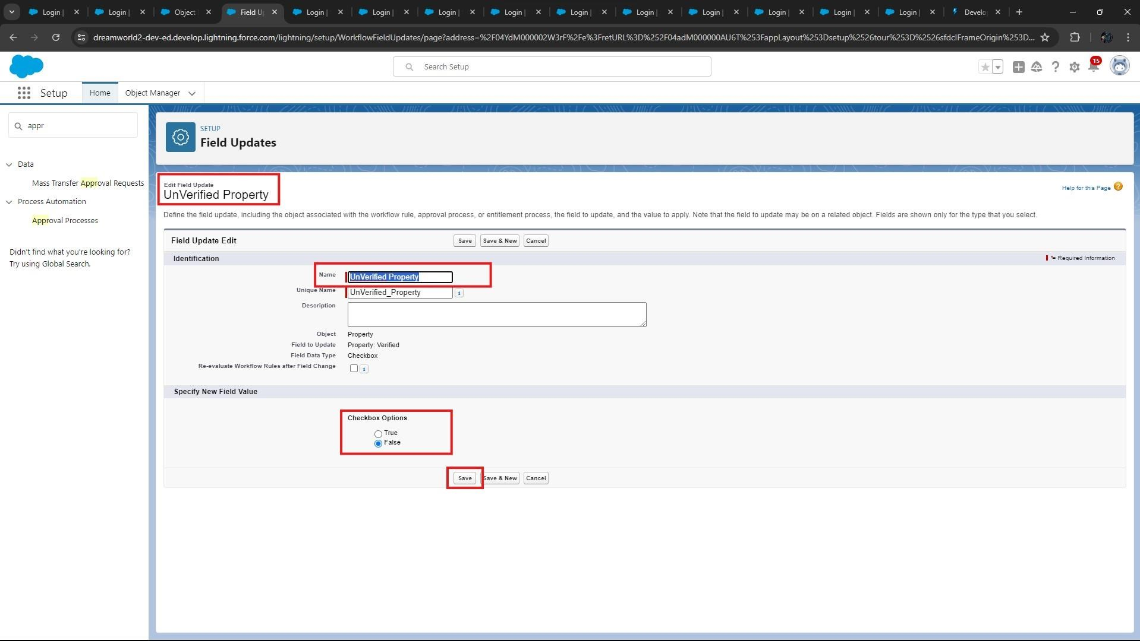

* Activate the Approval Process and below picture shows the result.

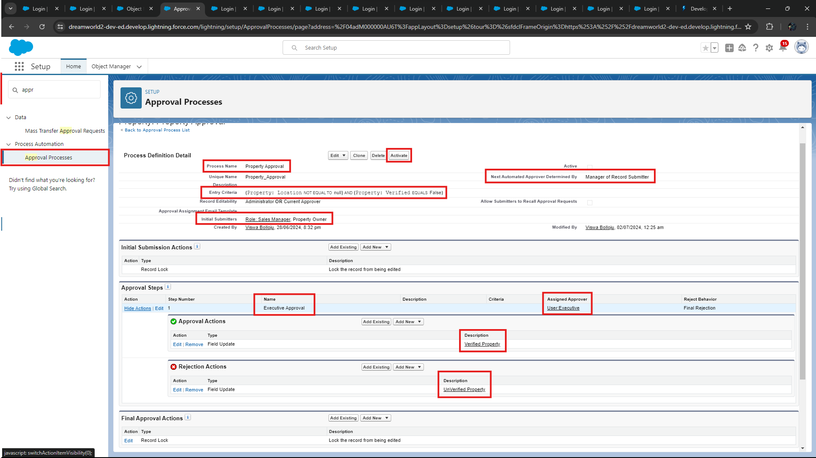

**Step 12: Create a Record trigger flow to submit the Approval Process Automatically.**

* 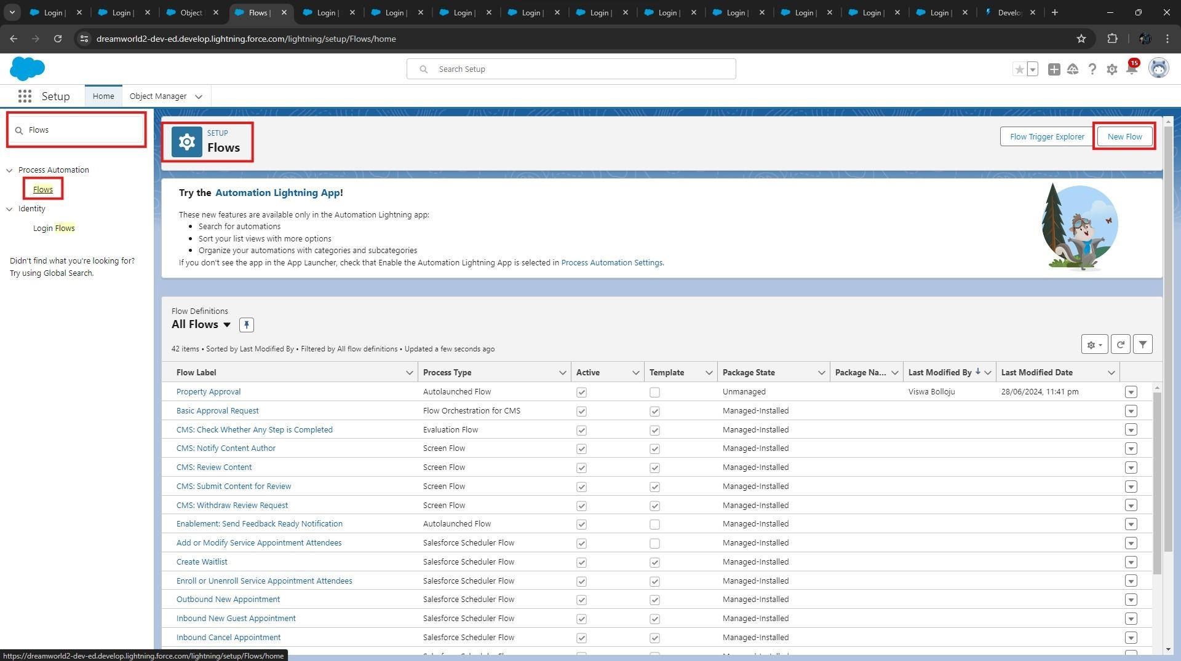From Setup → Search for Flows → Click on New and Select “Start From Scratch”.

•

Click on next.

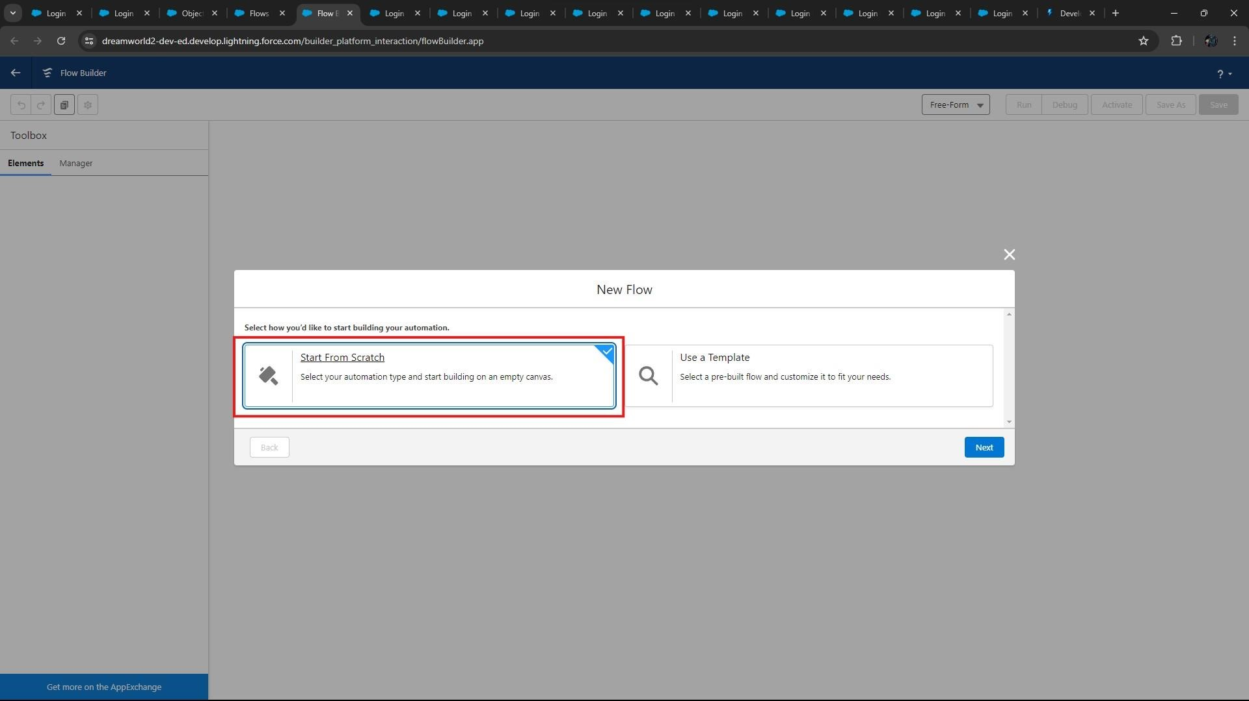

* Click on “**Record-Triggered Flow**” and click on “**Create**”.

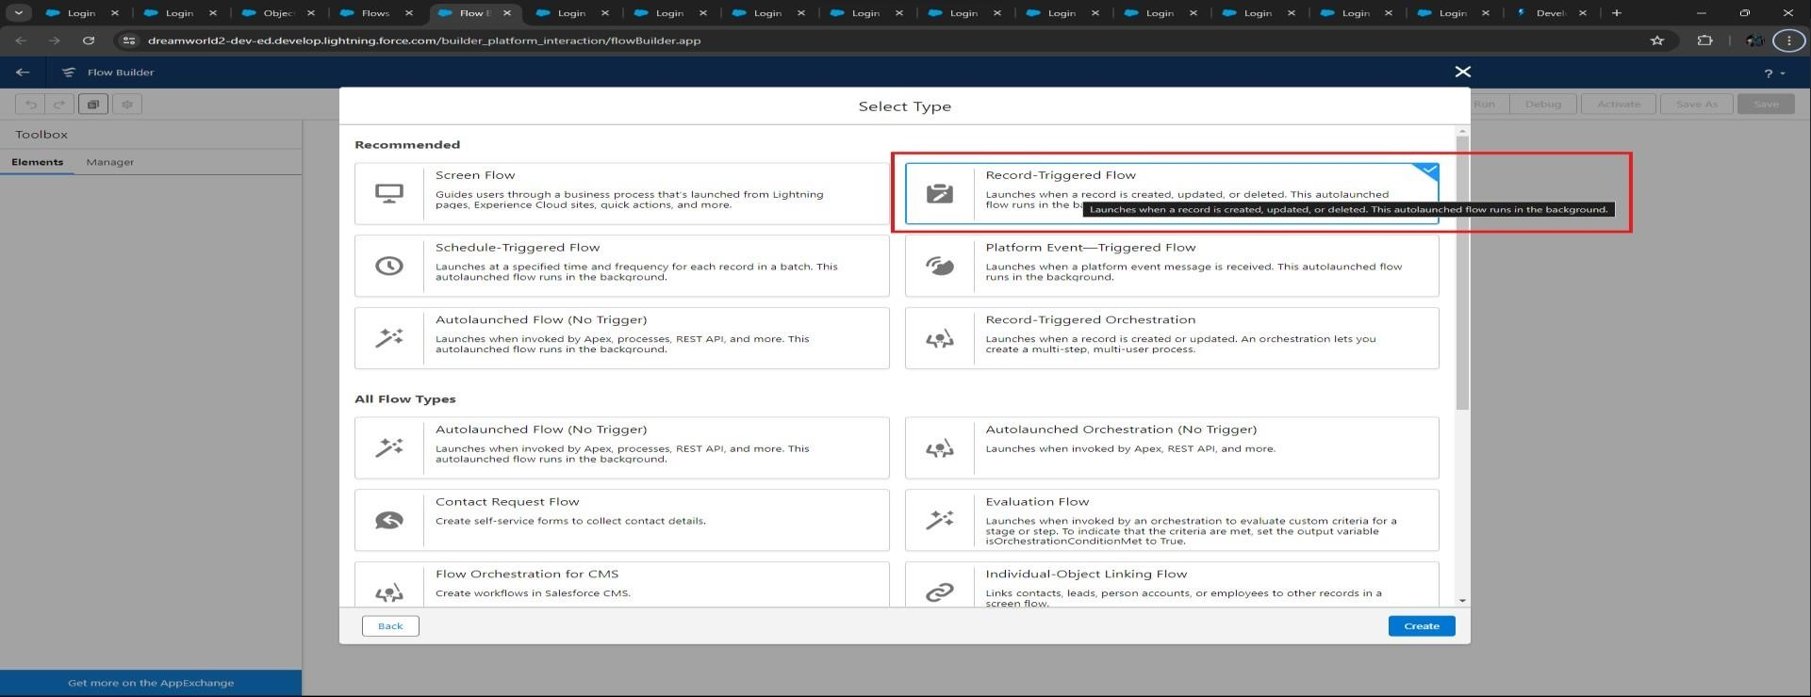

* Select **Object → Property**
* Select “**Trigger the flow when**” → “**A record is created**” • Set Entry Conditions → “**None**”

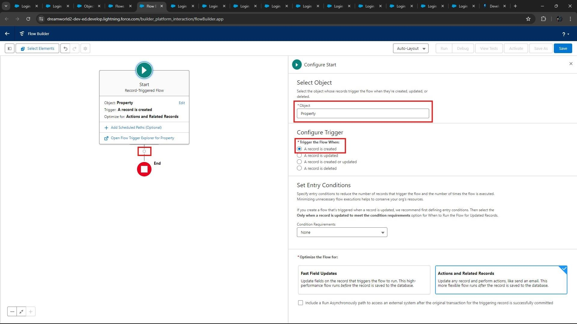

* Click on “**Add Element**” and add “**Action**” element.

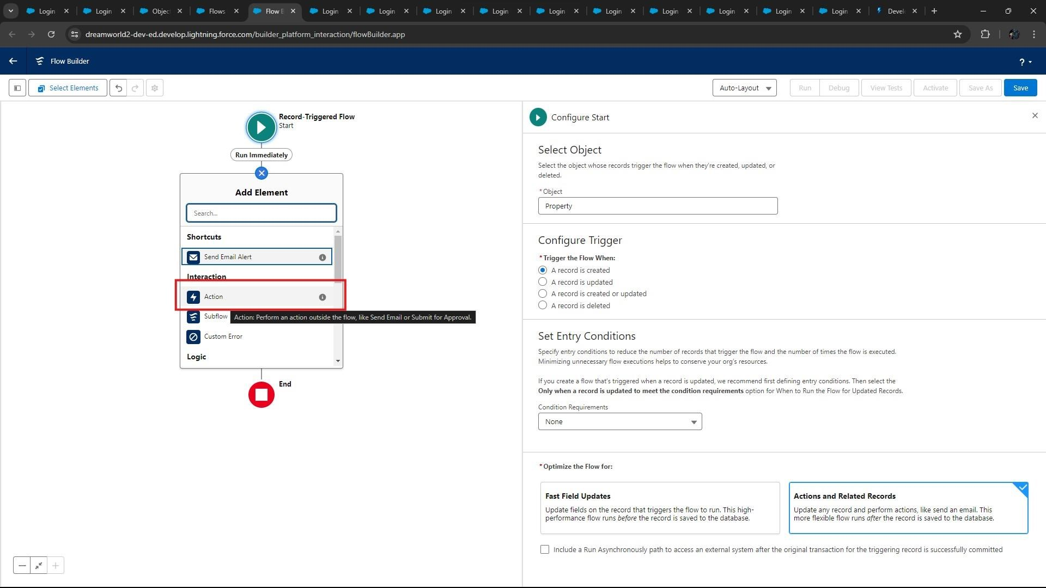

* Search for “**Submit for Approval**” action and select it.

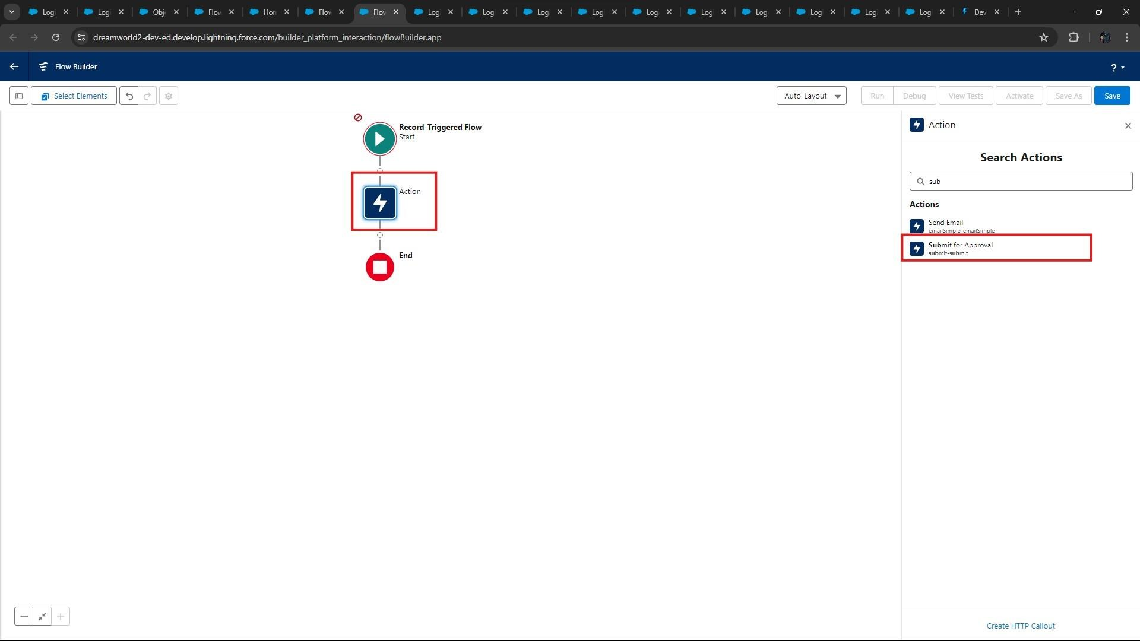

* Give Label Name: “**Approval for property**”.
* Select Record Id → Triggering Property__c > Record ID.

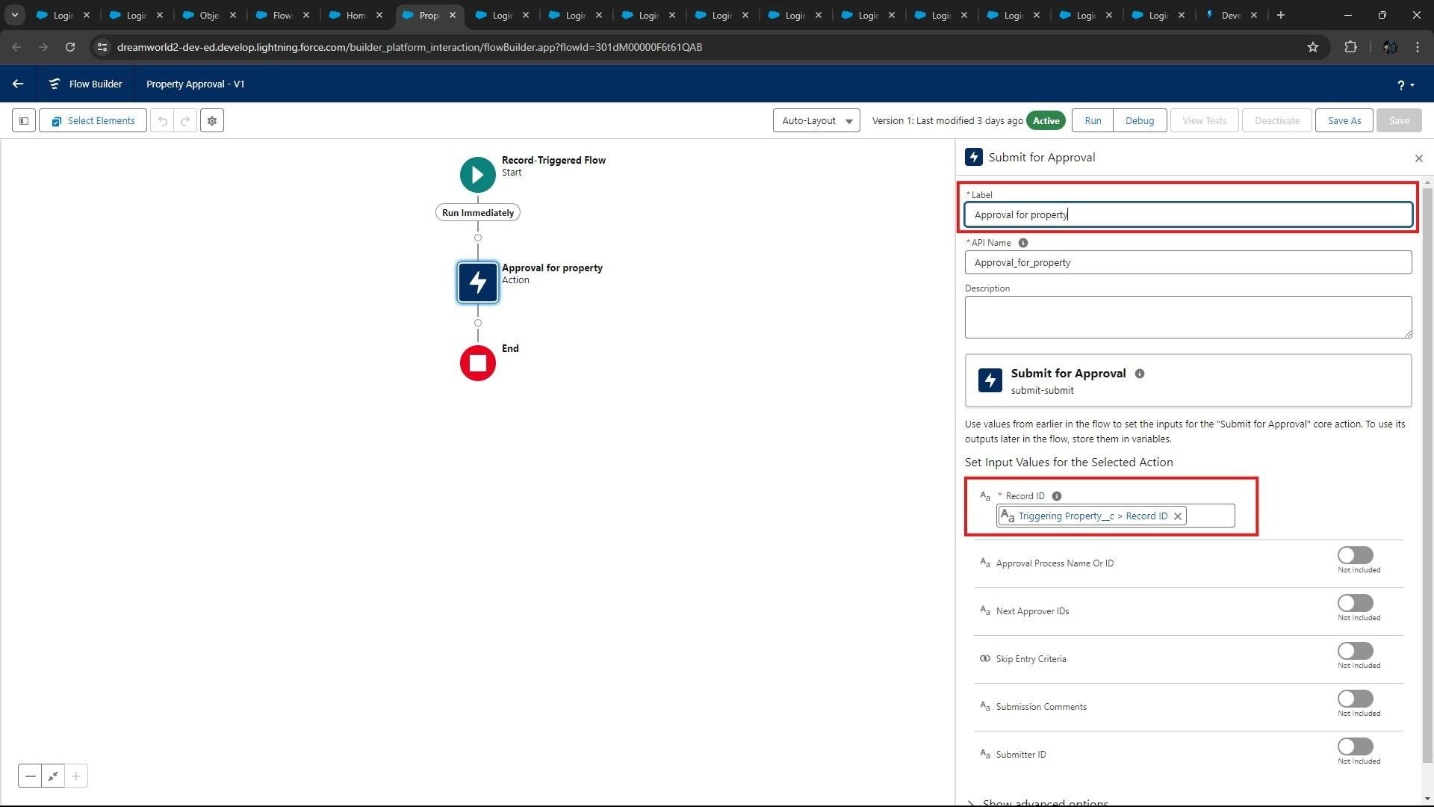

* Click on “**Save**”.
* Save the Flow and Give label as → **“Property Approval”** and **“Activate”.**

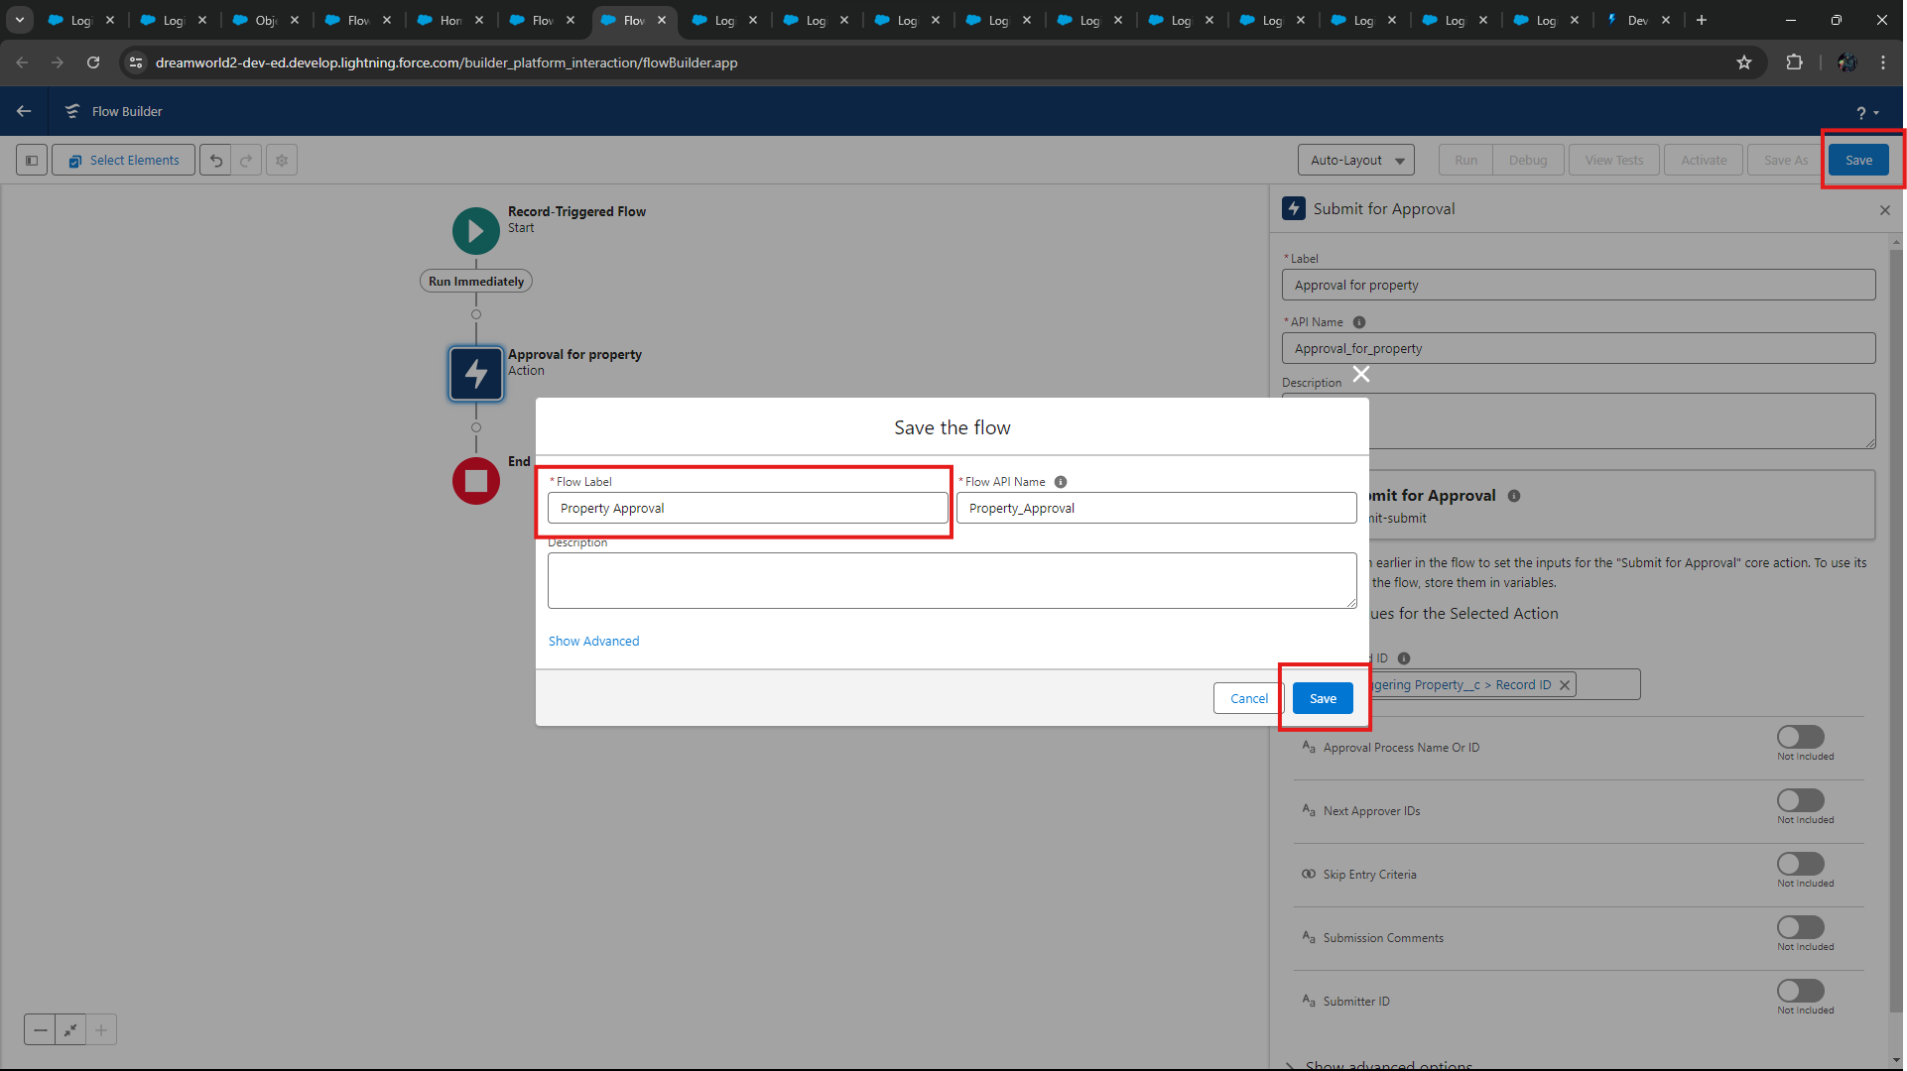

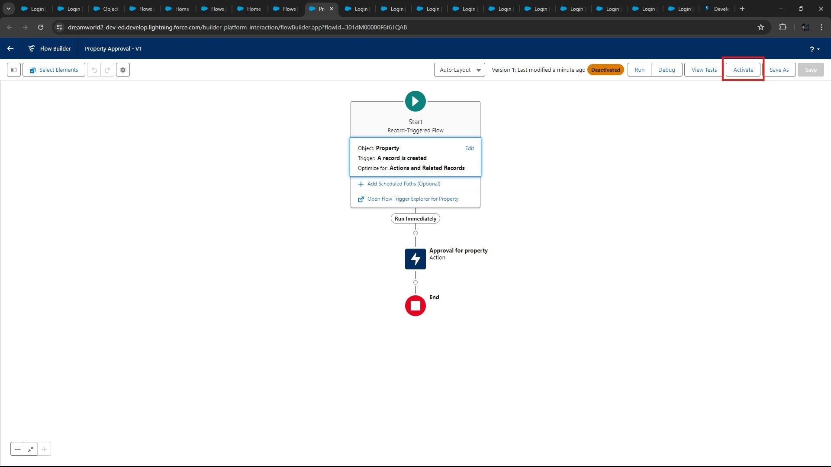

* After creating the flow, the result is shown in below picture.

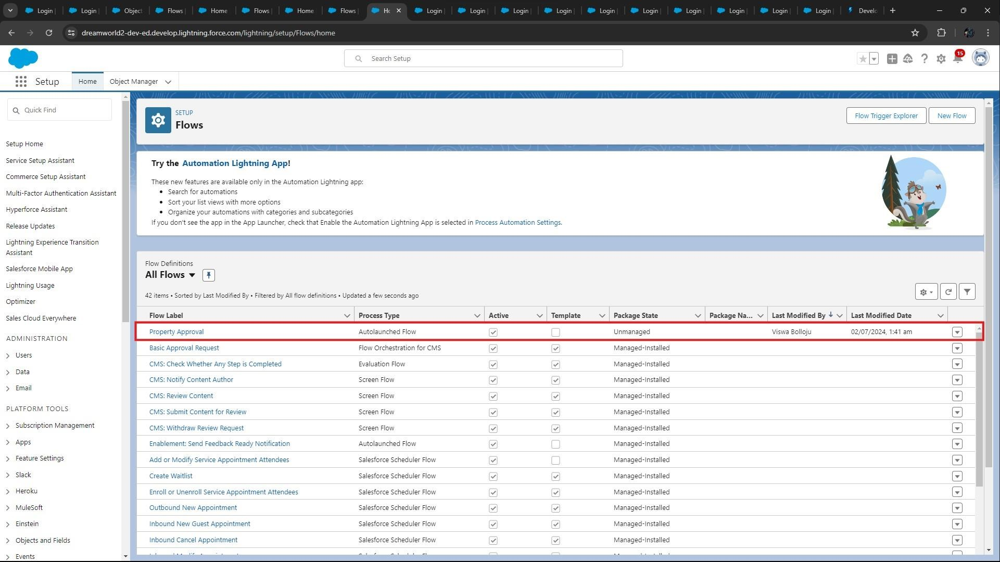

### Step 13: Create an App Page

Create an App Page on the Property details Object named as “**Search Your Property**”.

* From **Setup** → **Go to Lightning App Builder** → Click on **New** → Select **App Page** and Click on **Next**.

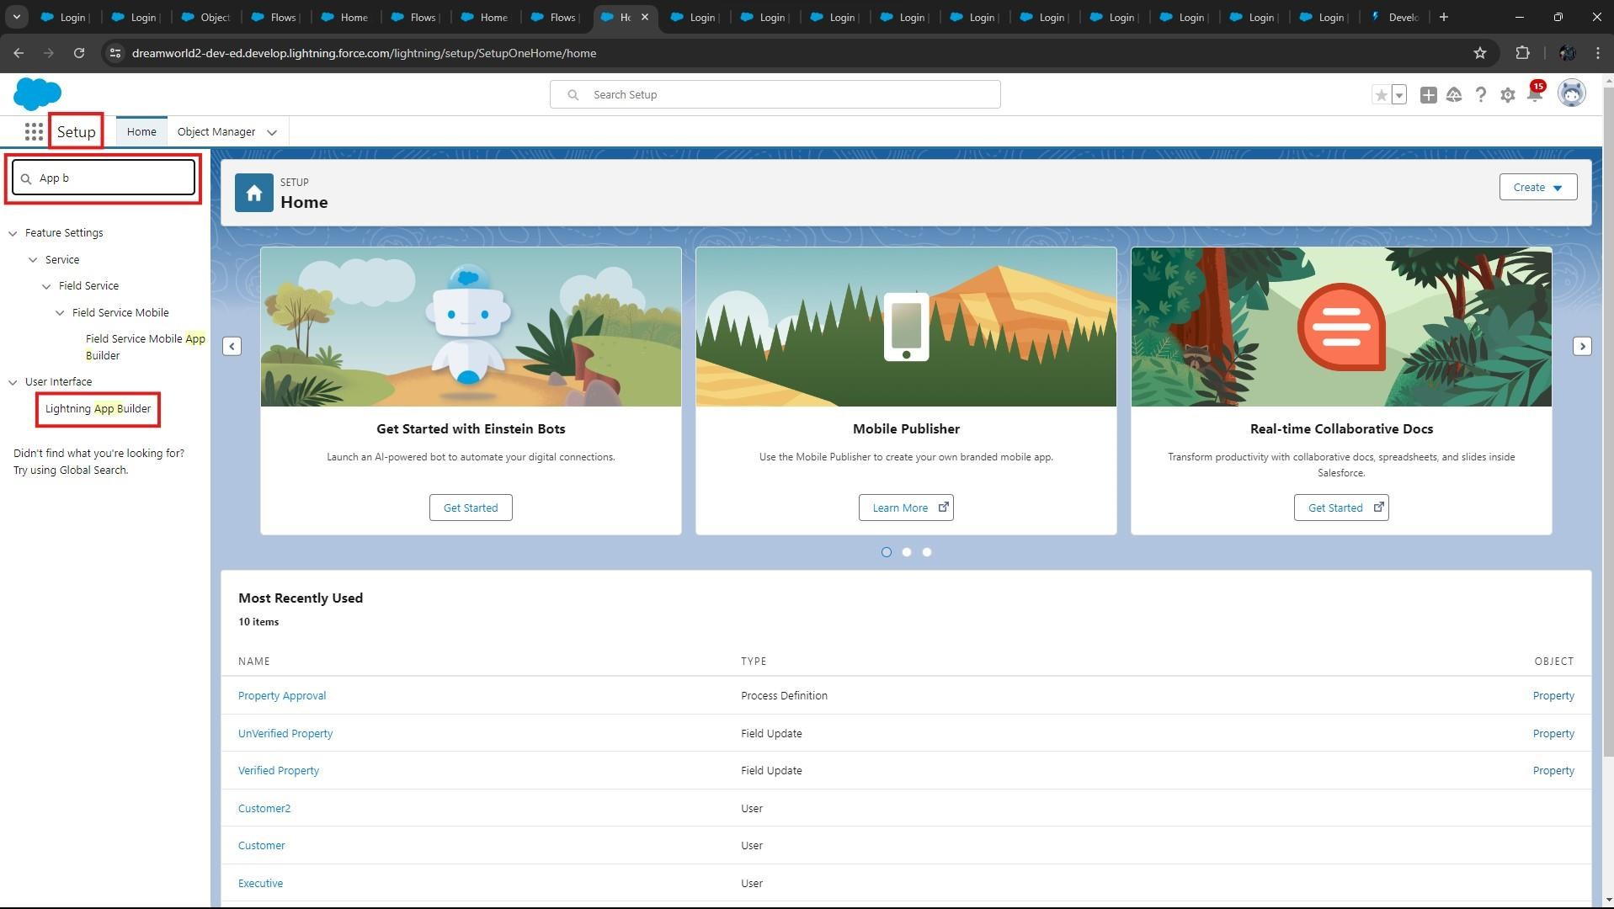

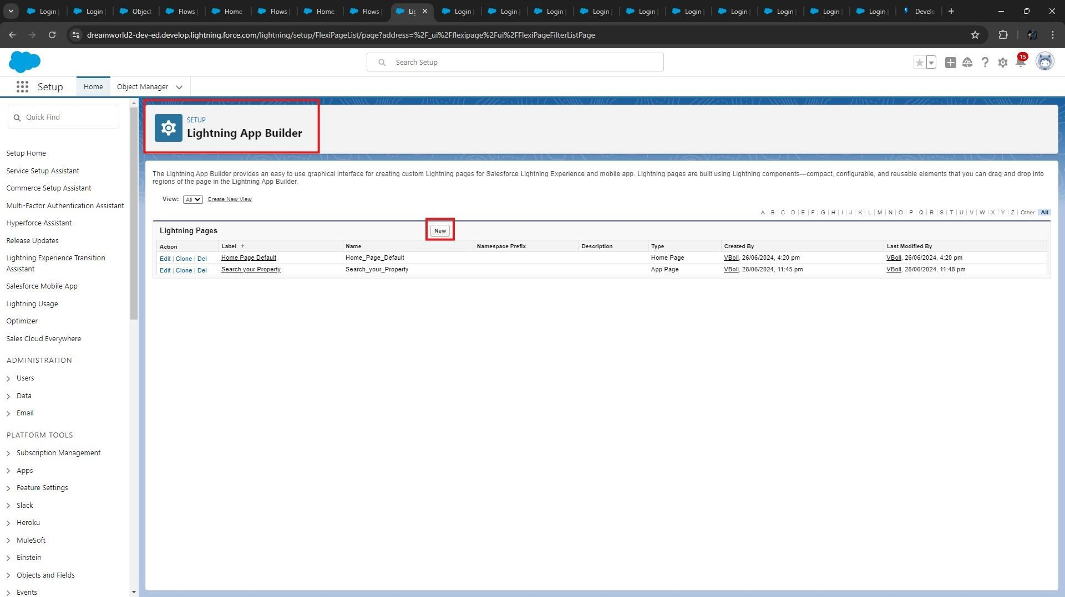

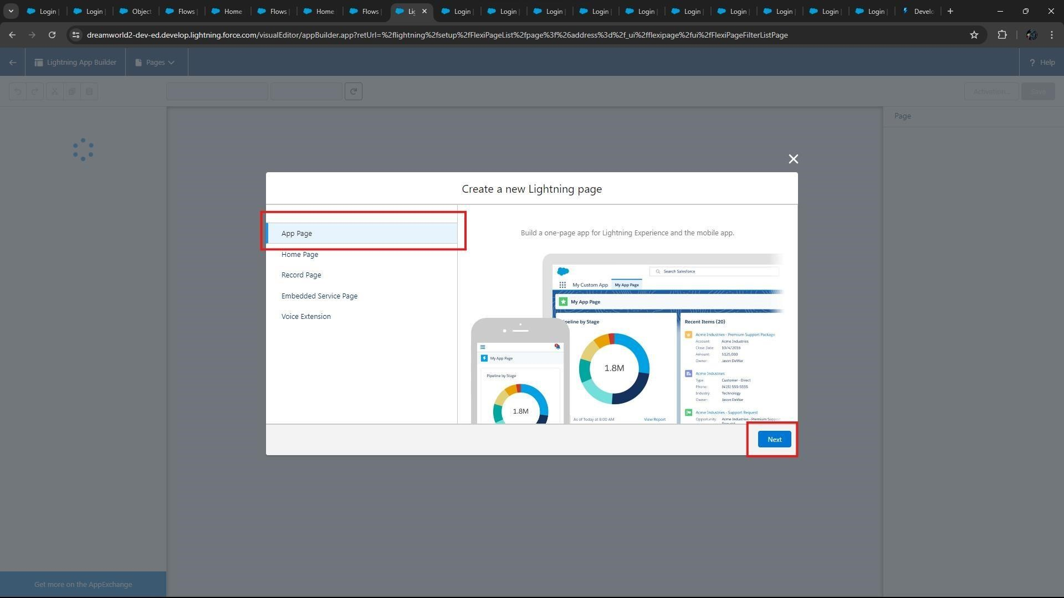

* Give Label as “**Search your Property**” click “**Next**”.

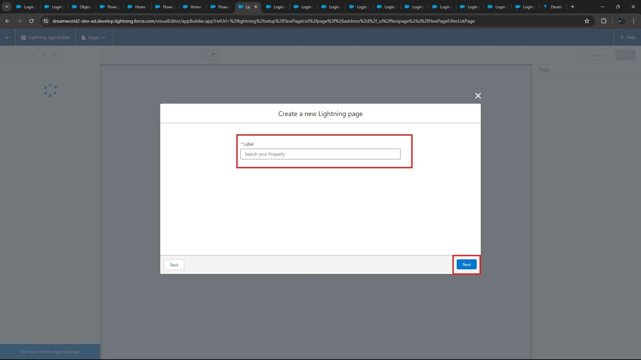

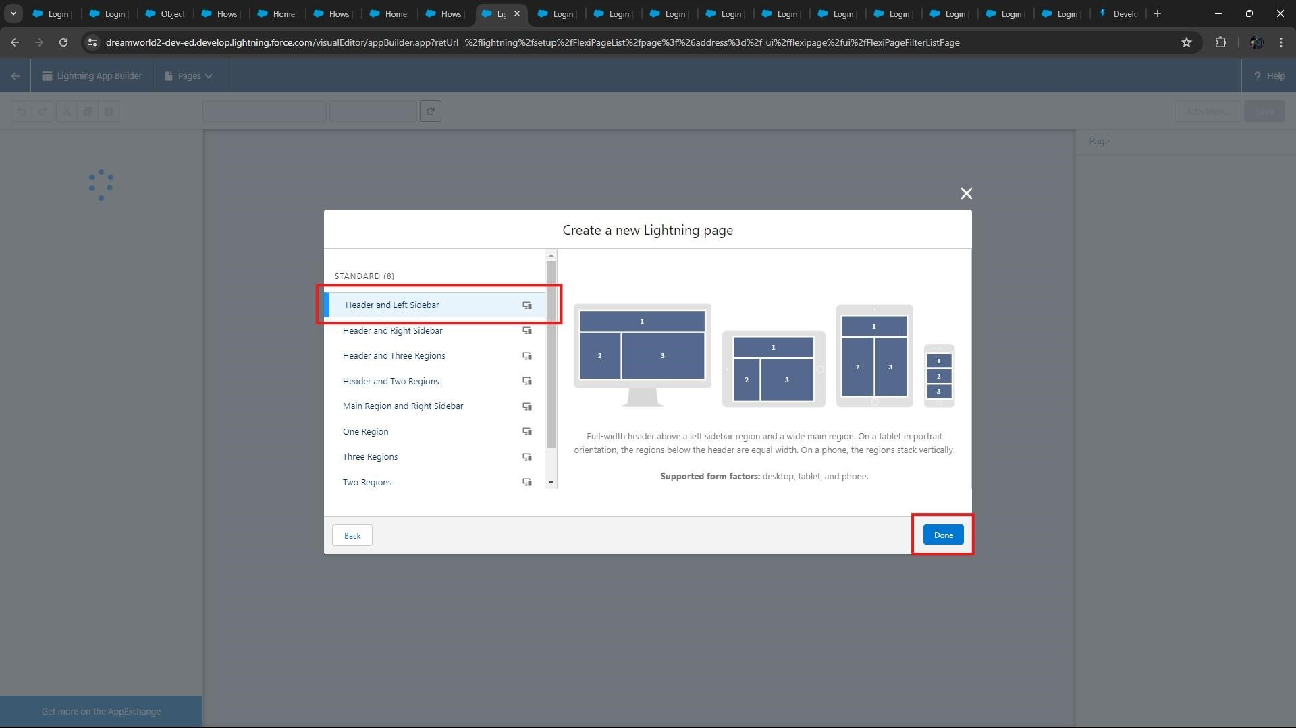

* Click “**Header and Left Sidebar**” and Click on “**Done”.**
* After clicking “Done” below page appears.

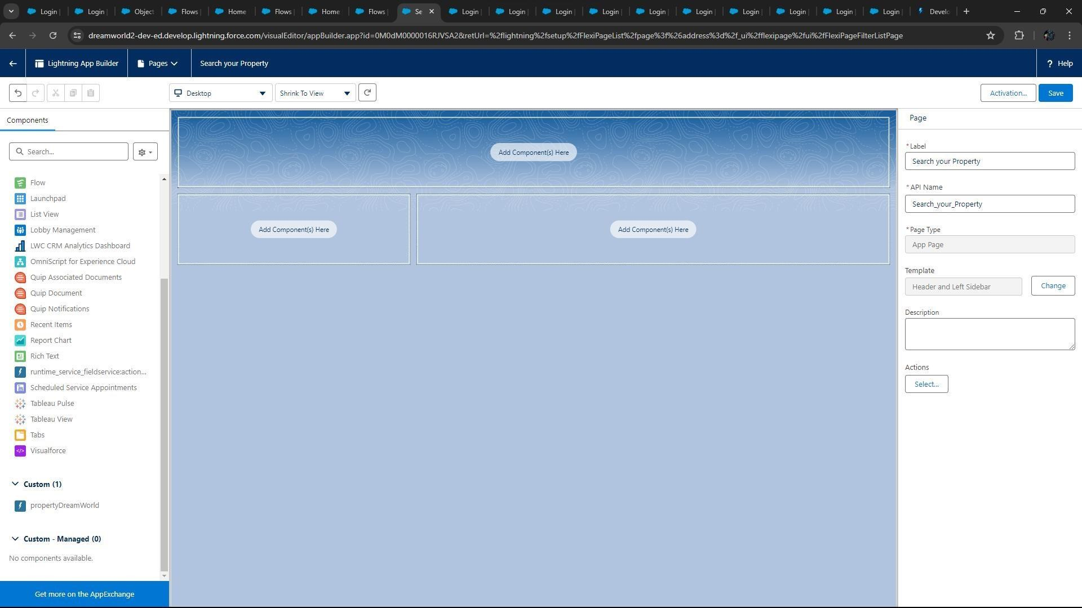

* Click on “**Save**” and then click on “**Activate**”. From Page Setting select page activation as “**Activate for all Users**”.

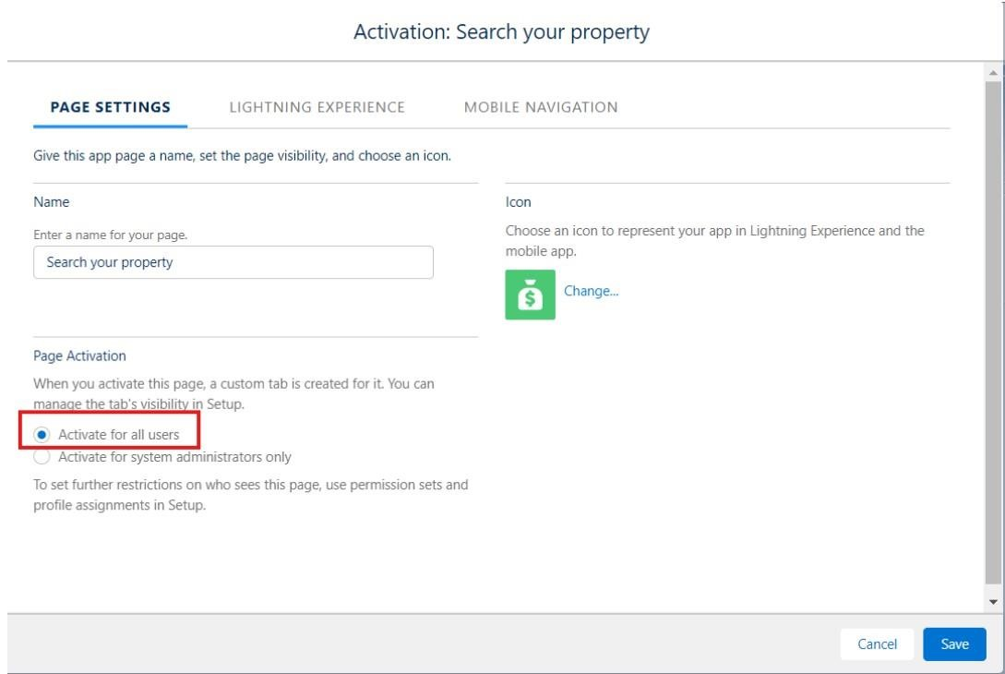

* From Lightning Experience Click on “**Property Details**” and click on “**Add Page**” and then click on “**Save**”.

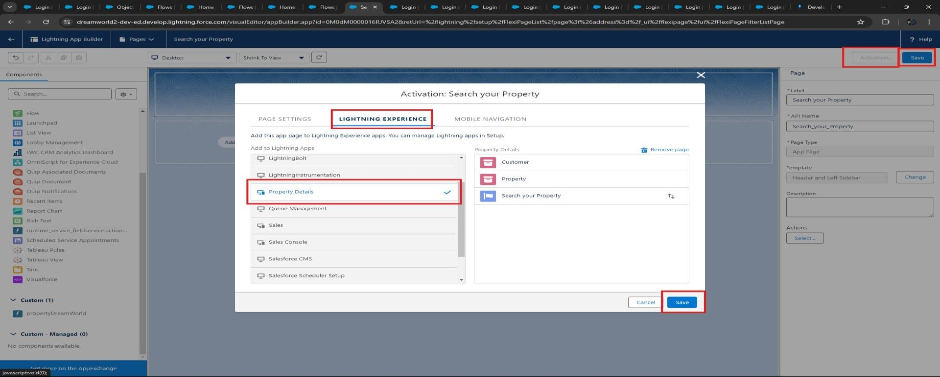

### Step 14: Create a LWC Component

Create an LWC Component for the customers so that only verified customers can access the verified properties

and non-Verified customers can access non verified properties, and deploy it on “**Search your Property Page**”

* Create an Apex Class and make it aura enabled and name it “PropertHandler_LWC”.
* Install Salesforce CLI (Command Line Interface) and VS-Code into your Computer.

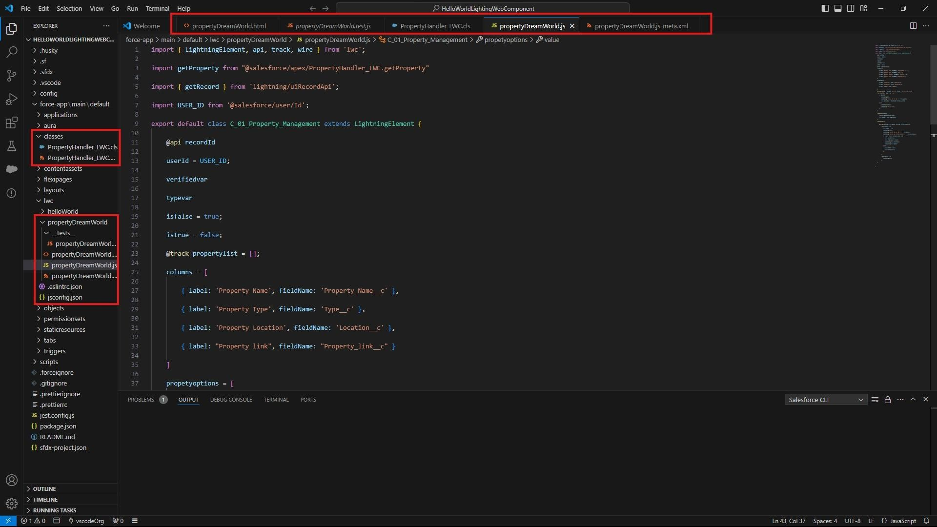

* Create a Lightning Web Component in your VS-Code, and (ctrl+shift +P) and click on authorize an org.
* Enter your login id and password to authorize your org.
* After logging into the Salesforce Developer Org. Again press (ctrl+shift +P) and Select “**Create Apex Class**”.

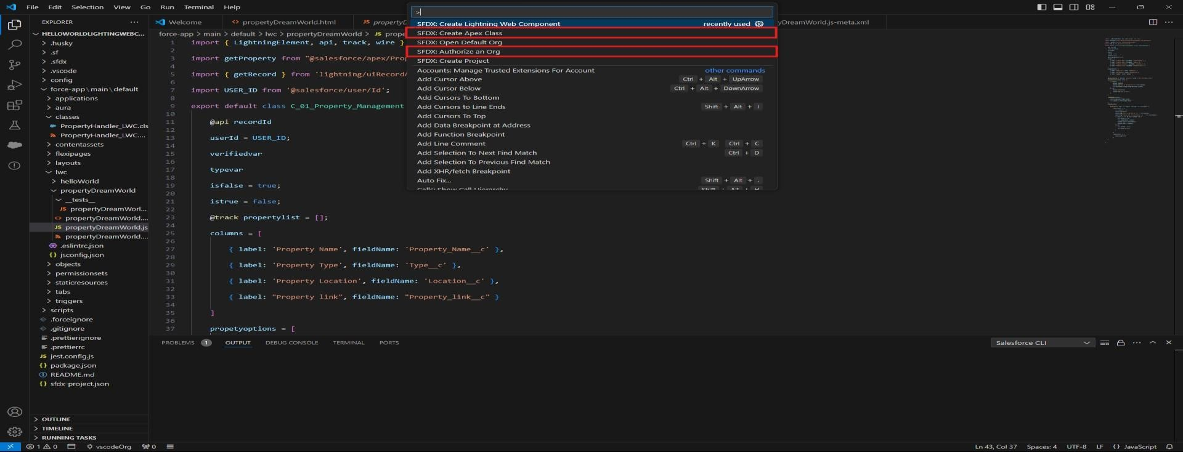

* Write the Apex Code and Save the class.
* Again press (ctrl+shift +P) and Select “**SFDC: Create Lightning Web Component**”. And name it anything you want, Ex: “propertyDreamWorld”.
* Write the “JavaScript” code, “HTML” code and “XML” code and save the code in your local directory.

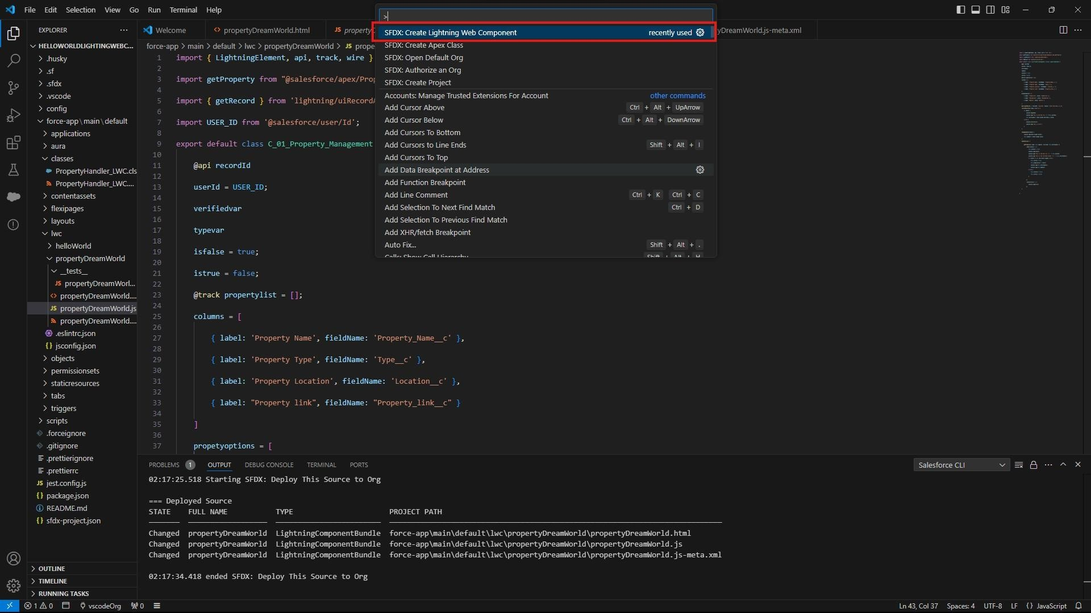

* Right Click on the “**propertyDreamWorld**” file and click on “**SFDC: Deploy this Source to Org**”.
* Exactly do the same thing to Apex Class: “**PropertyHandler_LWC.cls”.**

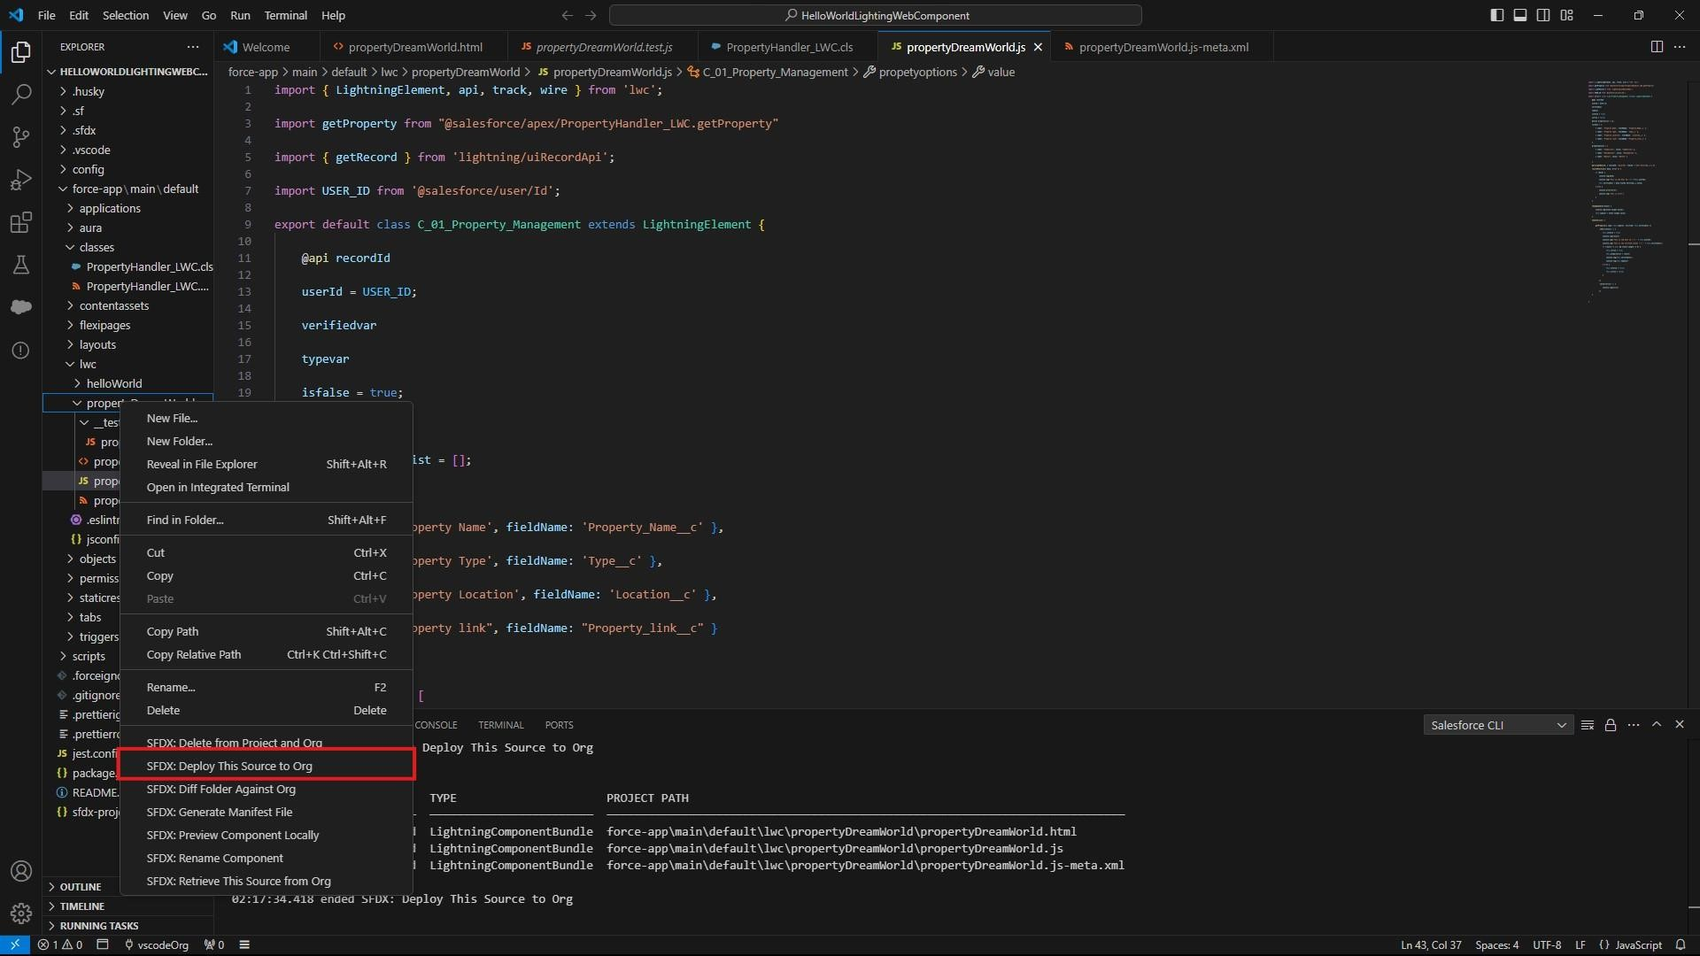

* After deploying it will give you a message that says “**Running SFDC: Deploy this source to Org**”.

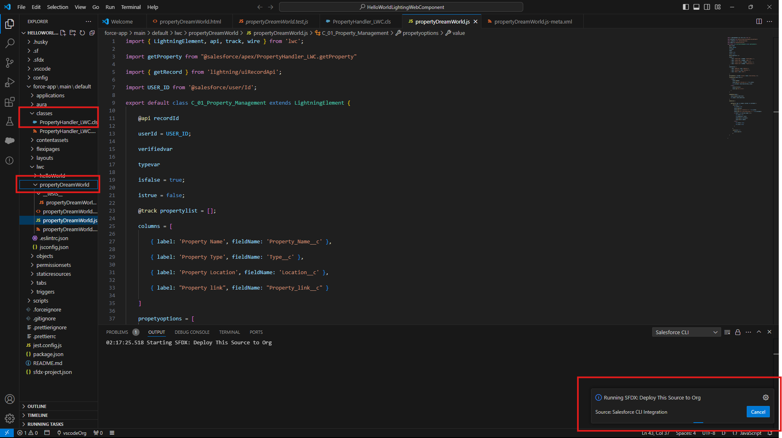

* Success message will appear in the VS-Code if the code deploys correctly without errors.

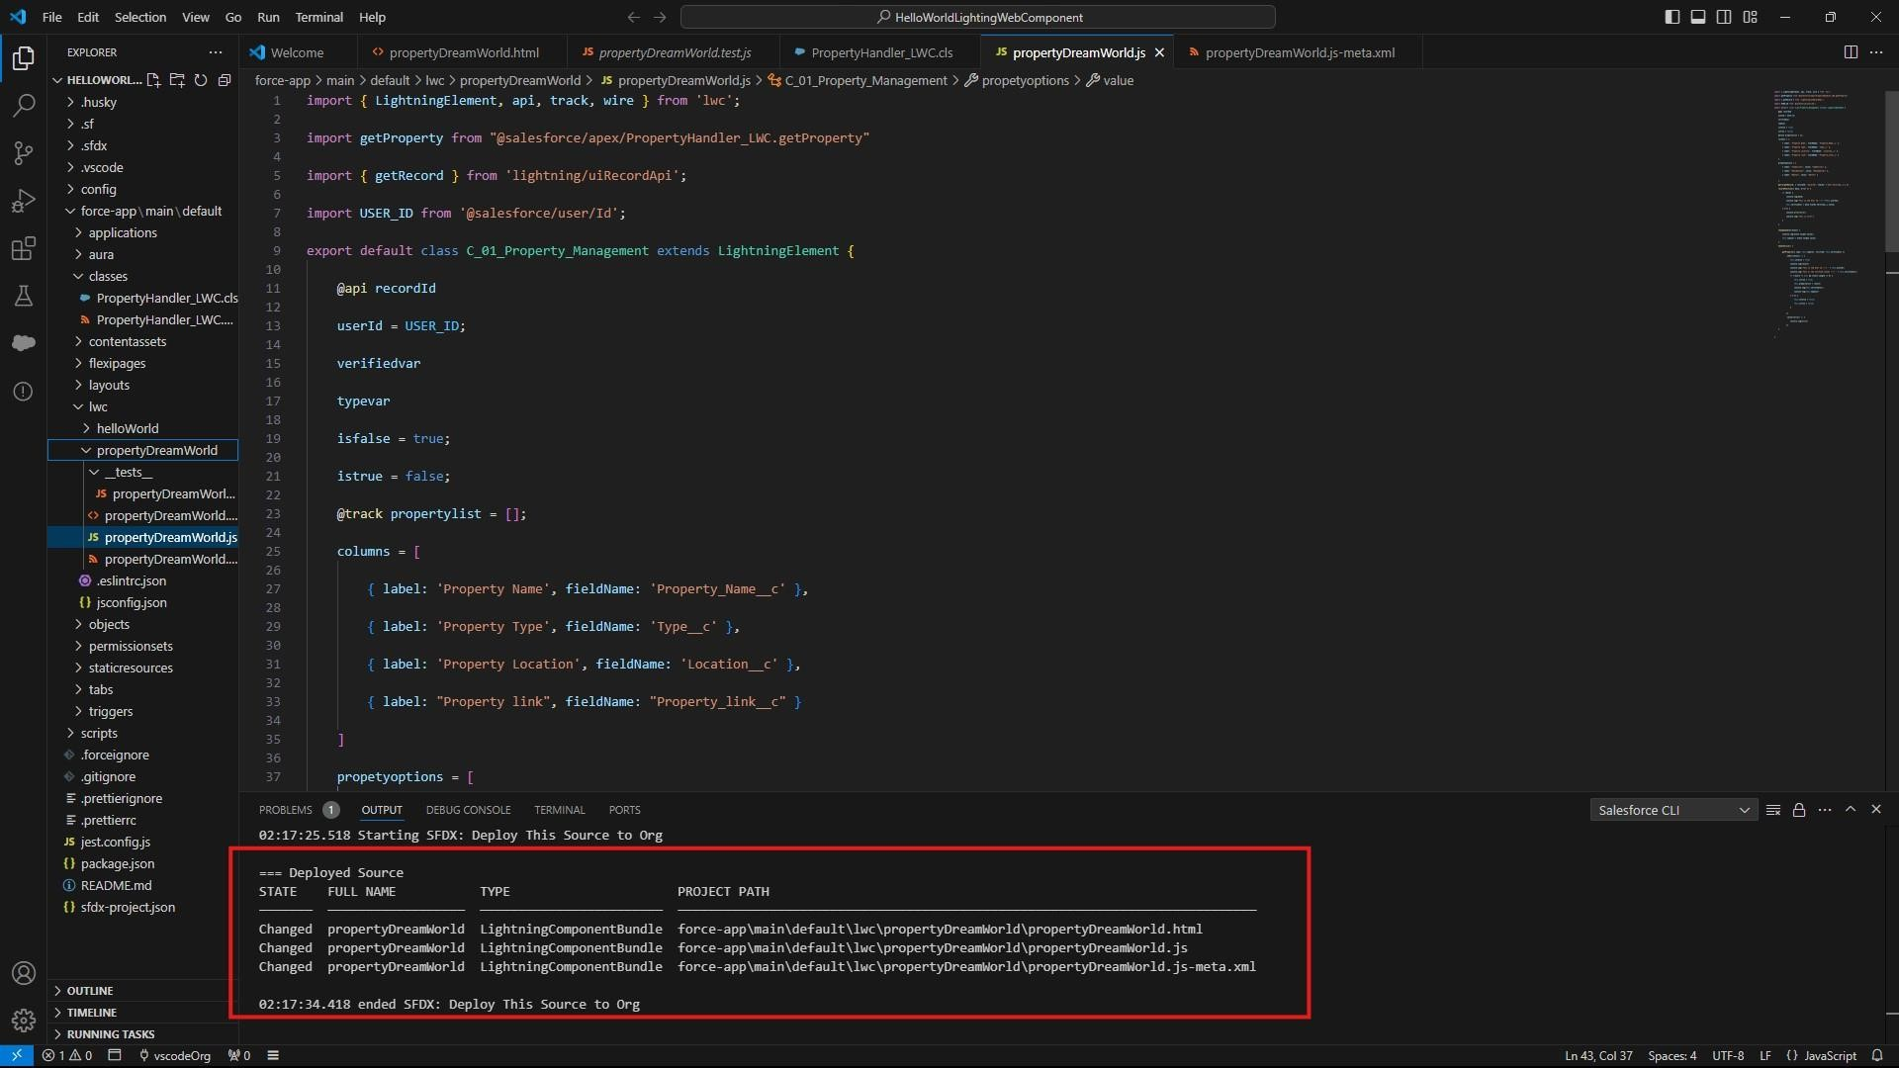

### Step 15: Drag Lightning Web Component to your App Page

* From **Setup** → Go to **App Launcher** → Search for “**Property Details**”.

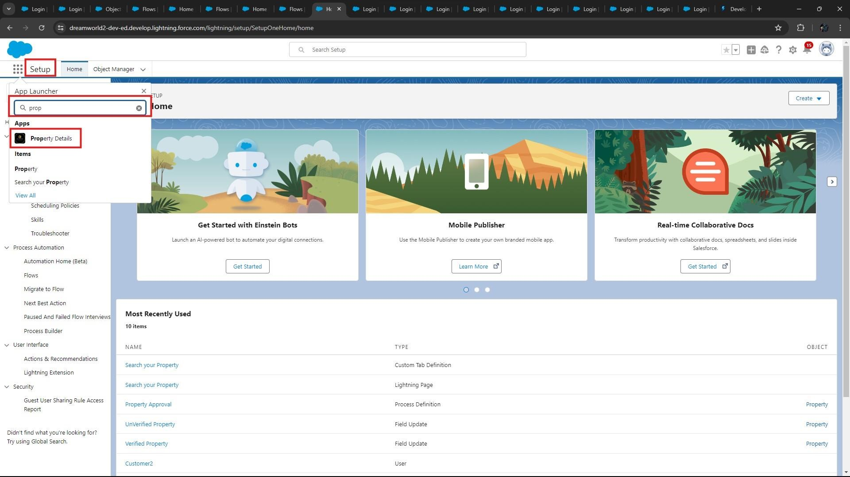

* On this “**Search your Property**” Page click on **gear icon** and click on **Edit Page.**

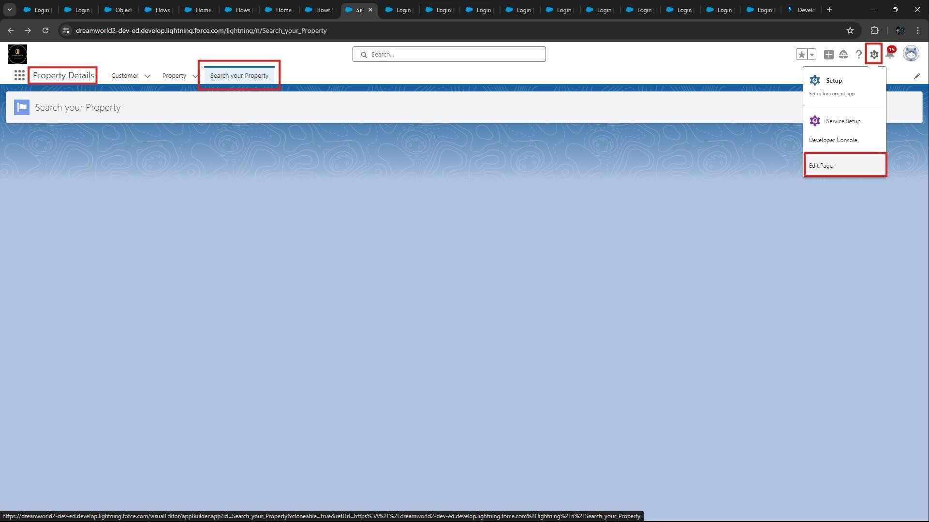

* Drag the Component to your **App Page**.

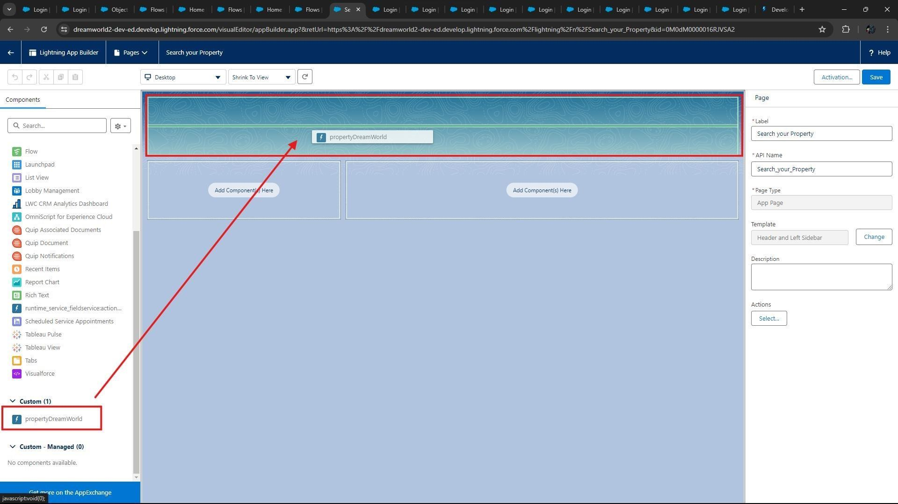

* **Save** the Page.

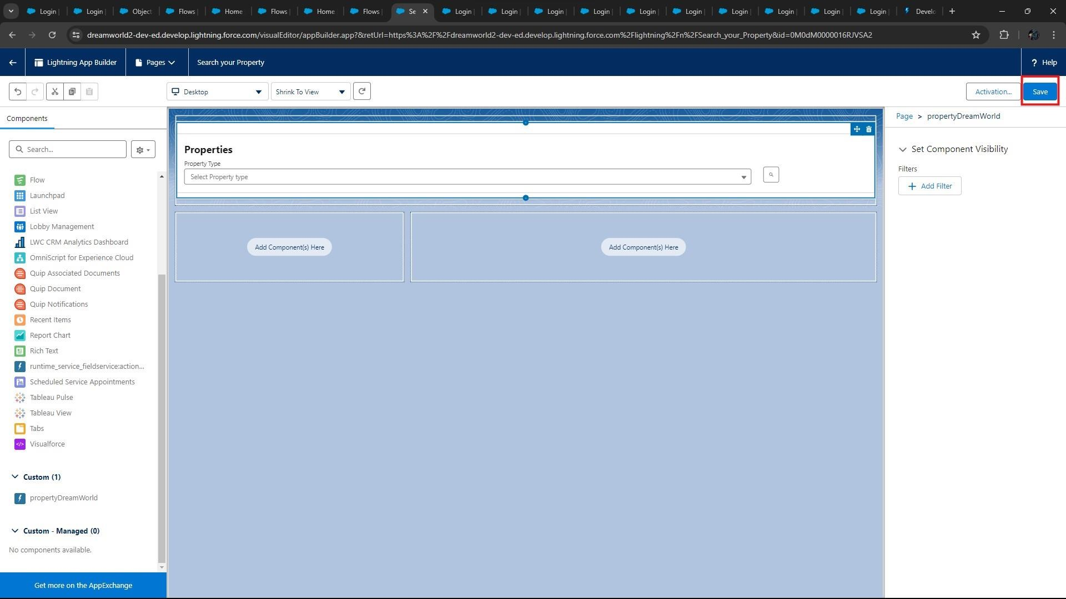

### Step 16: - Give Access of Apex Classes to Profiles

* From Setup → Search for **Apex Classes** → Click on “Security” behind “**PropertyHandler__LWC**”.

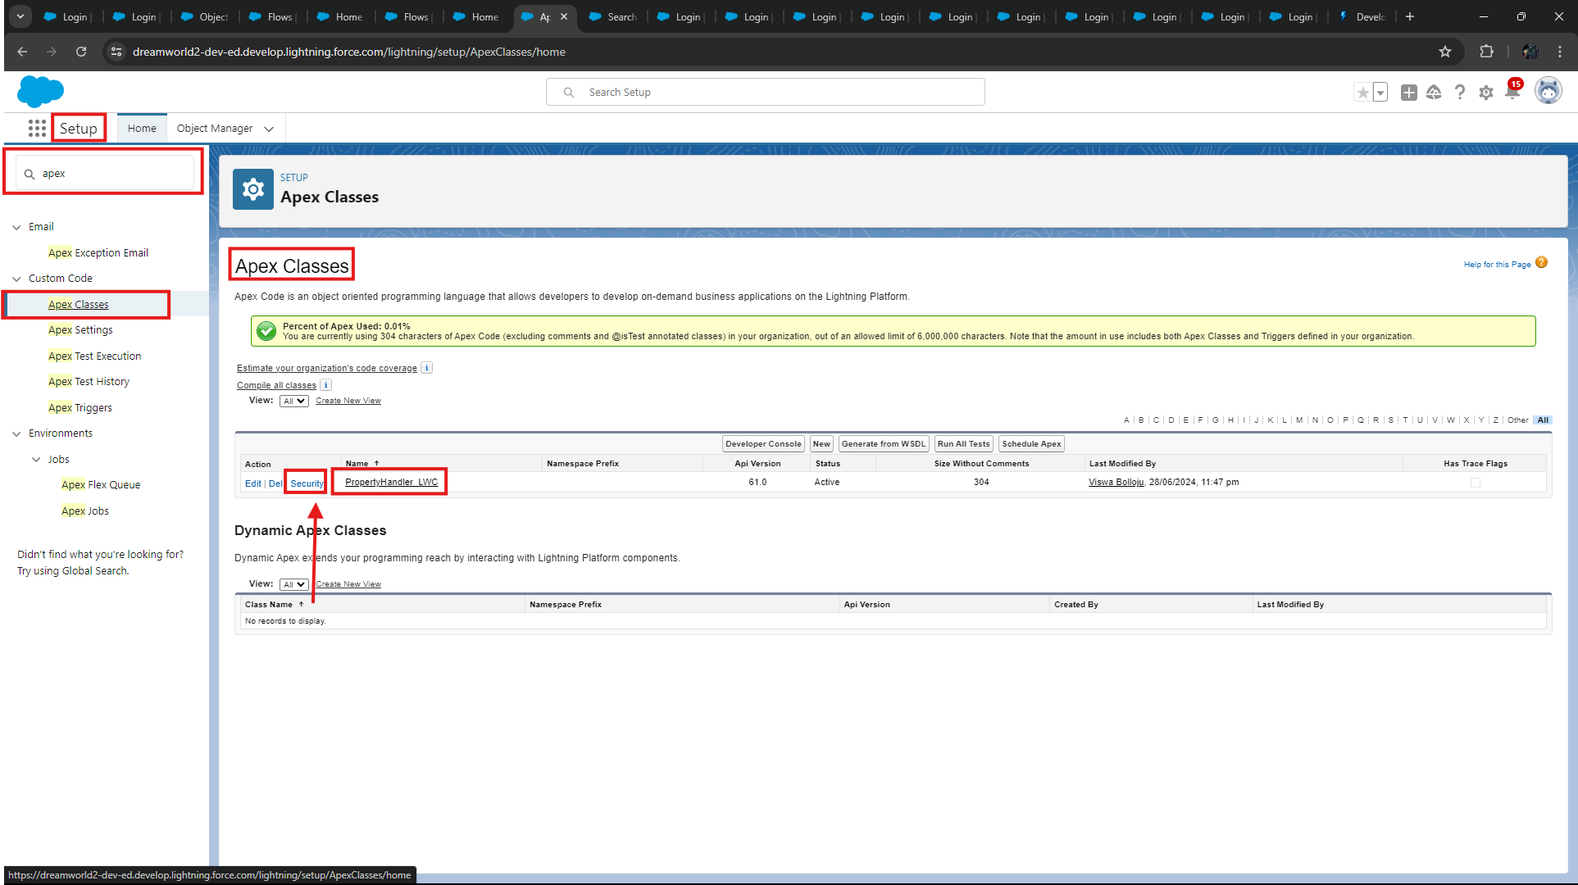

* From Profiles Add “**Manager**” and “**Customer**” and “**Save**”.

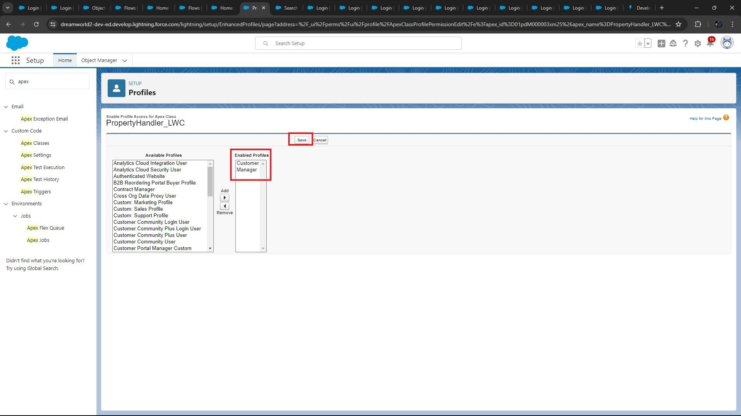

## 7. OBSERVATIONS AND FINDINGS: -

 **Website Integration:**

**Implementation of Form on the website:**

* In the jot form, information captured includes name, phone, email, address, and property interest. This meets the need of capturing essential details.
* This is done by linking the form to Salesforce and then going ahead to map the fields. This will ensure capturing essential details of the Customer which is used by the Company “Dreams World Properties”.

 **Requirements in Setting up Salesforce Configuration:**

**Setting up the Salesforce Objects and Fields:**

* Set up the custom object for customers and property from spreadsheets.
* Set up setup fields for name, contact information, preferences and approval status presumably during the setup of the objects.
* Setting up custom fields and workflows would imply the validation rules and data integrity checks.
* Security settings are configured by creating roles and profiles and controlling access based on approval status.

### Approval Process Requirements

**Define Criteria and Implement Approval Process:**

* Specifically, the approval process for the Property object is defined with criteria and approval steps.
* The field "Verified" gets updated automatically in case of the approved users so that they can directly access curated listings.

### User Experience Requirements

**Design User Interfaces:**

* I have created a Lightning App called "Property Details" where customer records would be maintained along with their property listings.
* LWC component enables both **verified** and **non-verified** users to see applicable property listings thus enhancing the user experience, Steps do not include anything about training and documentation for internal staff hence not fully addressed.

### Integration Testing and Quality Assurance Requirements

* Here in testing part, we have created two Customers users one is “Verified” and Other is “Un-Verified”.

This all works by the Apex class running in the background.

* Normally the scope of the Project is to Show the “Verified” Properties to Verified Customers and

“UnVerified” Properties to Un-Verified Customers.

* As per Business, “Verified” Users are premium users and they get to have premium services. We have designed the Application in such way as per business requirements.

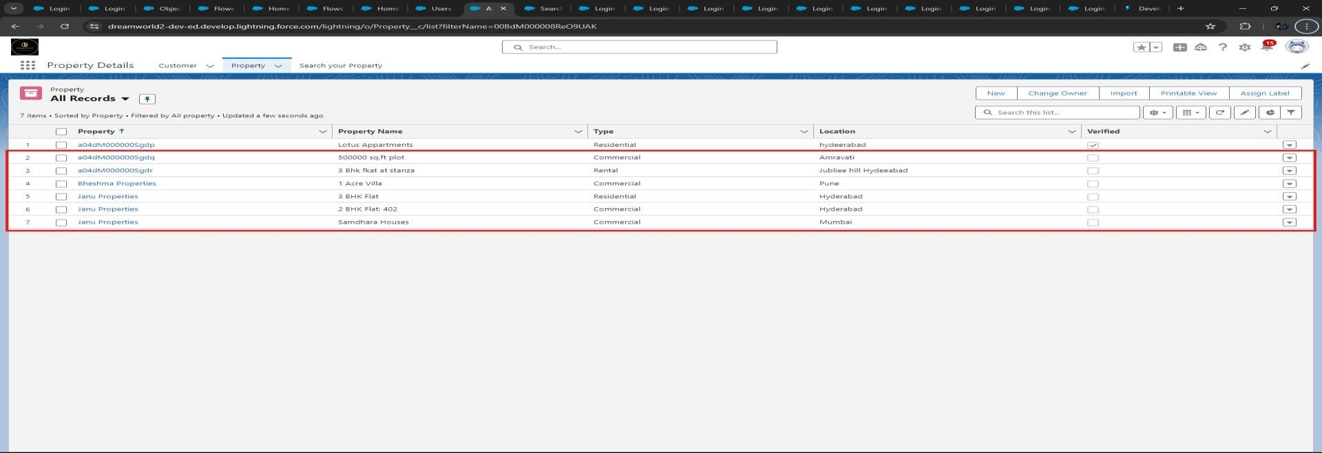

* In testing, I have logged into Verified user to check whether it is showing “Verified Properties” to Verified Users. The testing was successful, and it is displaying the verified properties to verified Users.

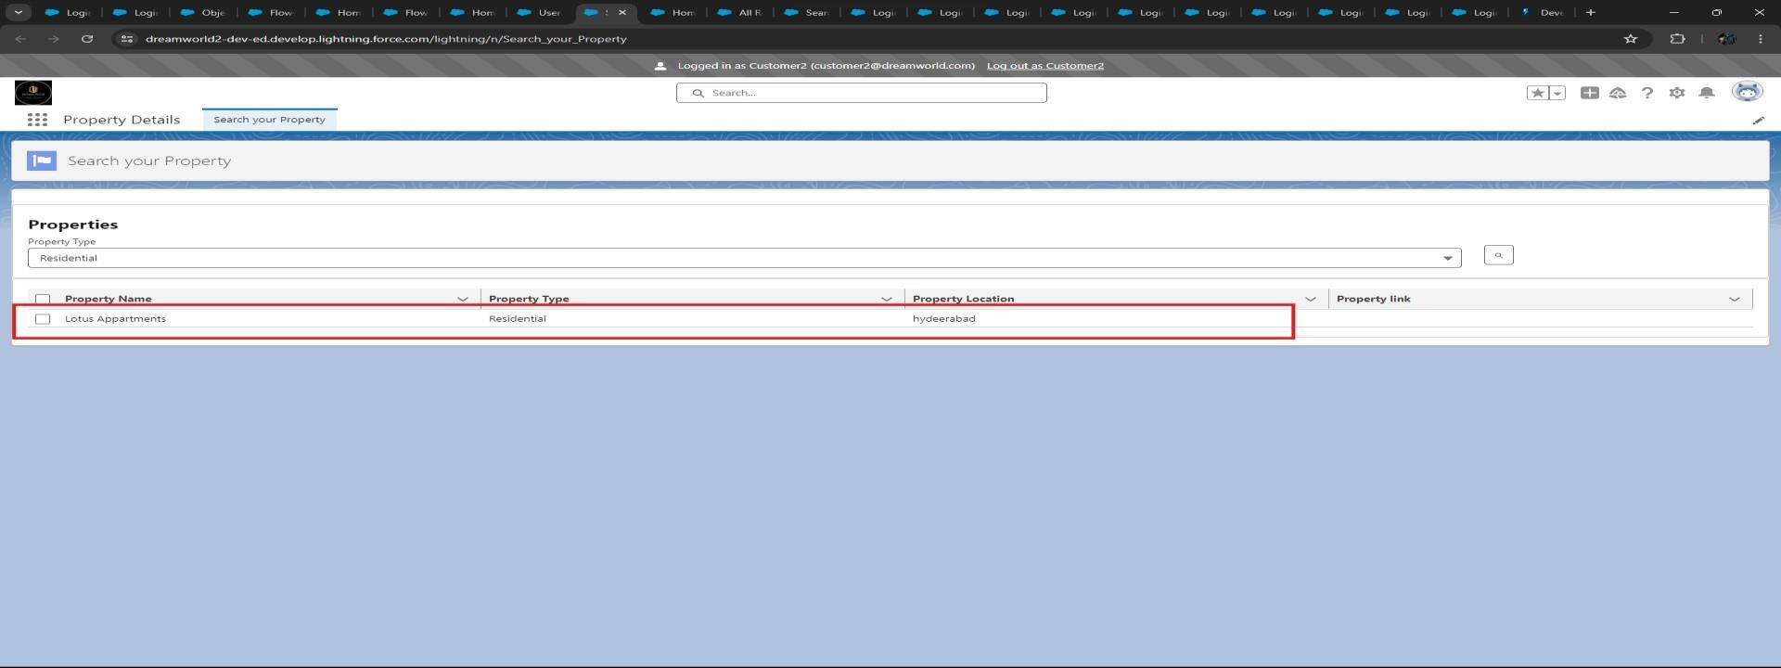

* From the Verified User, when I searched for Residential Properties, it showed only verified Properties to verified user.
* The same way logged into Un-verified user, and it is successfully showing Un-verified properties to UnVerified users.
* As you can see, we have Unverified Properties records in the Property Object. By logging into Unverified user in salesforce, we can see this unverified property as the result when customer searches for different types of properties.



* From the below picture, I have logged into Un-verified user and searched for Commercial Properties, and it showed all unverified properties to the Un-verified user.



•



I



n conclusion, the application is working perfectly.



**Working flow of**

**Property records.**

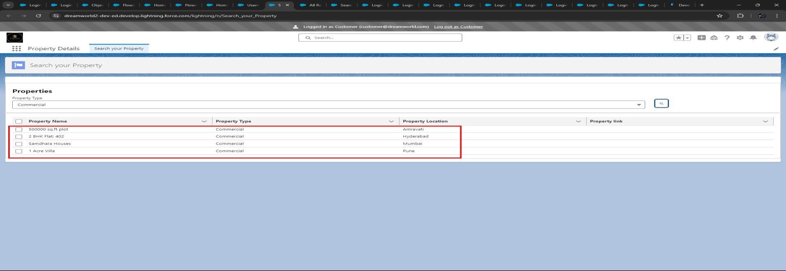

* When we create a record in the property record without “**Verified**” checkbox, automatically the “**Record Trigger Flow**” triggers as per condition. It goes directly to the Approval Process as per conditions.

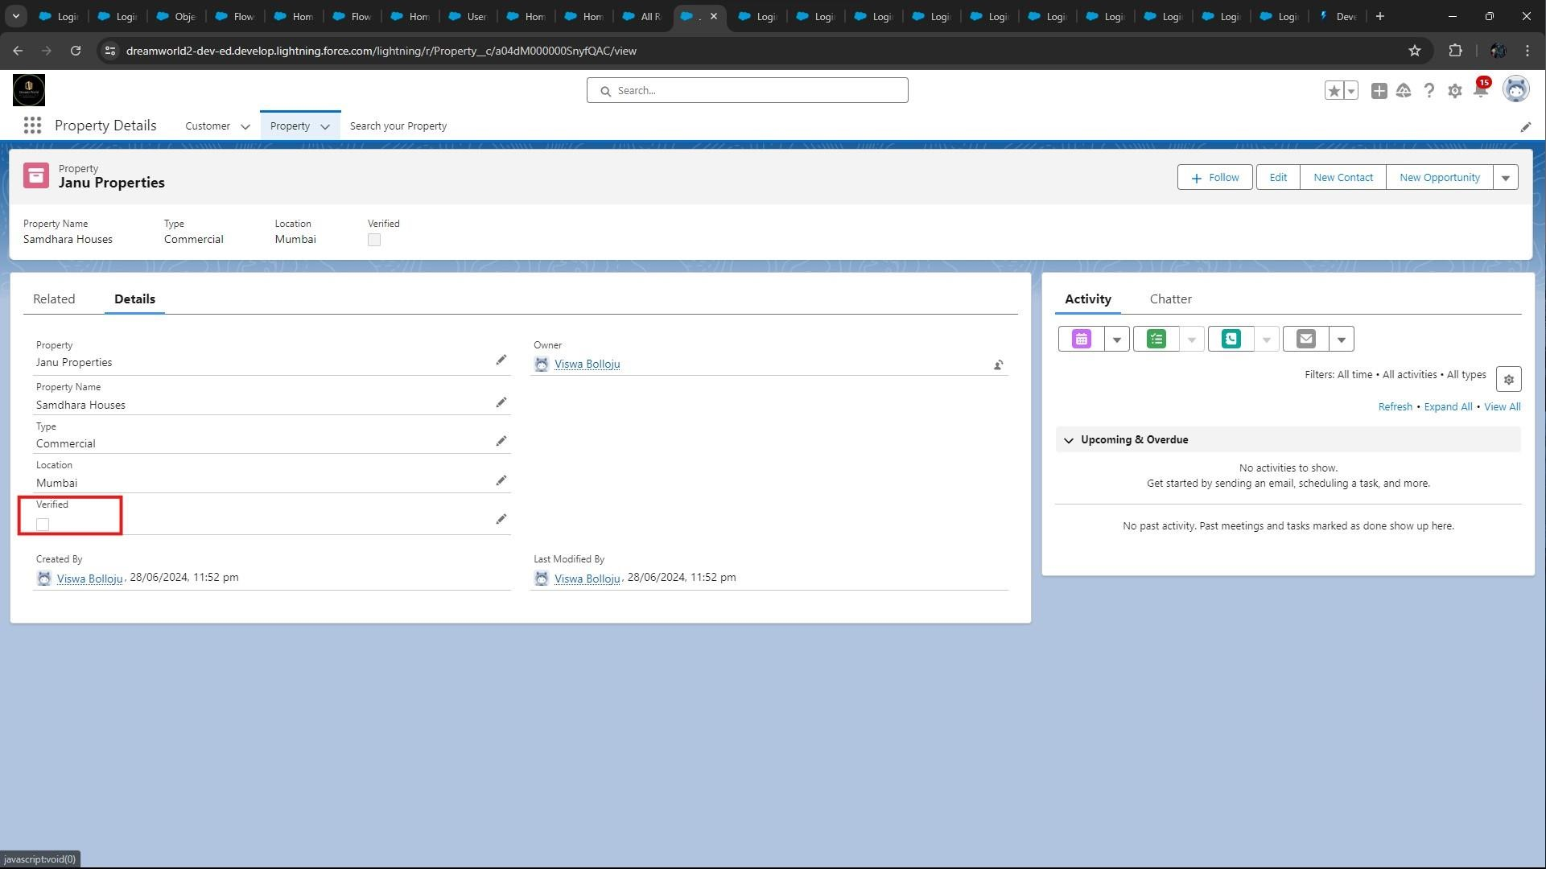

* After a while, the approval request email received to registered email-id of the Executive user, because executive is the only approver.

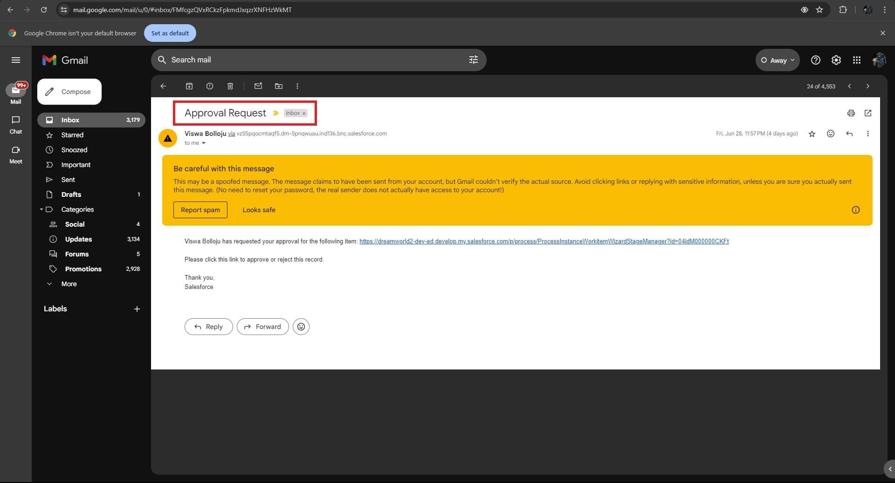

* Below picture shows the pending records that should be approved by the **executive** user.

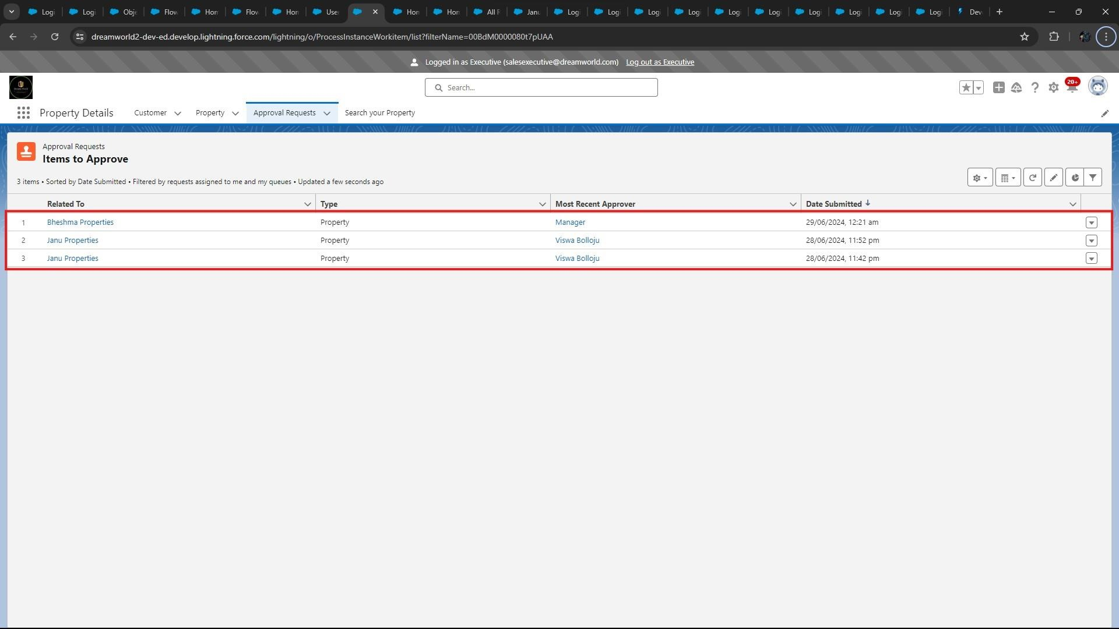

* In conclusion, the working of Approval Process with record flow trigger is working properly.